Attendance at St Bede’s

Thank you for all your support last year. Our whole school attendance was 93.7% This year we are aiming for 97% which is the government’s target for schools.
At St Bede’s we want all of our pupils to be the best they can be and reach their potential. Good attendance and good punctuality are crucial in achieving this.

Why does attendance matter?

- There is a direct link between attendance and how well children do in school (their attainment)
- The more your child comes to school the more likely they are to achieve in life
- If your child is not in school we can’t teach them!

Did you know…?

- School is open for 190 days of the year. This leaves 175 non-school days a year for holidays, cultural experiences and family time.
- 100% attendance offers greater opportunities for a child to be happy and successful in school

• All of our pupils’ attendance is colour-coded based on the number of days that they attend which is then converted into a percentage.
• We expect all of our children to be able to achieve Green or Gold attendance levels.
• We will let you know if we become concerned about your child’s attendance. This will be done either by telephone, a discussion with the Parent Support Advisor or a letter home.
• If your child’s attendance falls below 97% we would like to support you to improve it.
100%
Below 92%
96% 95%, 94%, 93%, 92%
99%, 98%, 97%
Attendance Zones

Punctuality
Being on time is very important! It establishes a positive start to the day and good habits for later life.
Gates open at 8.40am and are locked at 8.50am. Anyone arriving after 8.50am will be considered late and will need to enter school via the office on Howlett Hall Road.
Every minute counts and teaching begins straight away – being on time ensures your child does not miss any learning!

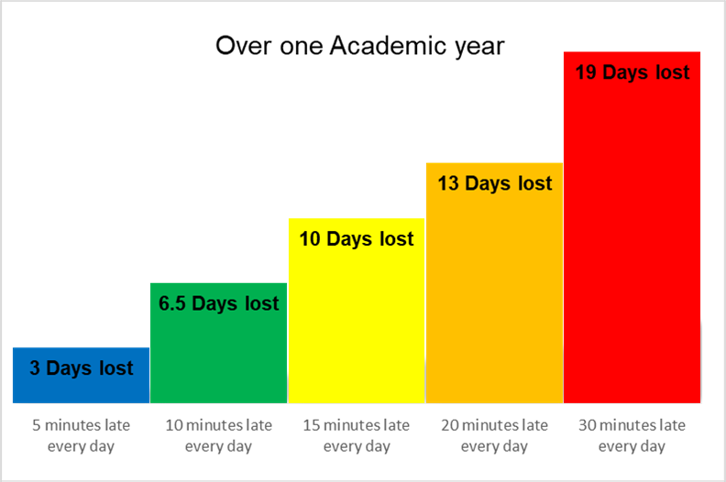

Being absent
Please contact the school office if your child is absent for any reason. You should contact school on each day of absence. If you do not contact school then we will ring you.
Please make routine dental check-ups outside of school hours
Authorised absences Unauthorised absences
Bereavement Holidays
Illness Visiting relatives
Medical appointments Birthdays
Holidays and planned absence during term time

Legislation makes it clear that schools may not authorise a holiday during term time.
A Pupil Absence Holiday Request Form must be completed before any holidays are taken. It is important that school are aware of any planned absences.
The Local Authority are having a strong focus on attendance this year and we will have to refer into the Local Authority where there is persistence absence.

Rewarding attendance
At the end of every term, children who have achieved 97% and above will be rewarded with a book prize.
Any children who achieve 100% attendance for the full academic year will receive a special reward
If you need any support regarding your child’s attendance please contact our Parent Support Advisor, Mrs Howell, on the office number.

