**Literacy**

* Children will be talking about their favourite books (fiction and non-fiction). We will be looking at characters, settings and the structure of a story e.g. beginning, middle and end.
* We will be writing labels for their models and pictures.
* Developing pencil control through pincer grip activities. Dough Disco! Squiggle while you Wiggle!
* Recognising and writing their name.
* Handling books correctly.
* Ascribing meanings to marks, writing for a purpose
* Recognising letter sounds, orally blending, reading simple words and phrases.
* Daily Bug Club Phonics sessions to develop reading and writing skills.
* Vocabulary Ninja developing vocabulary knowledge.

**Personal, Social and Emotional Development**

* The children will be learning new routines in the Reception environment.
* They will be making new friends and talking to their friends and adults.
* Children will be developing independence in choosing activities and putting resources away in the Reception classroom.
* We will be learning to take turns.
* In circle time children will be listening to each other and asking questions.
* We will be discussing what makes us unique, and what our favourite things, people and activities are.
* Children will be talking about what makes our families special? Important? Who belongs to my family?
* Exploring different emotions with the children play ‘pass the feeling’ game.
* Make puzzles with the children’s photos – develop perseverance skills.

new routines

• Communicate needs to peers and adults.

• Work in pairs and small groups.

• Talk to adults and peers in pairs and small groups.

• Develop independence in choosing activities and putting resources away.

• Learn to take turns.

• In circle time - talk, listen, ask questions, contribute own feelings and ideas.

• Discuss what makes me special, what are my favourite things, people, activities etc.

• Discuss what makes our families special? Important? Who belongs to my family?

**Understanding the World**

* We will be learning about our 5 senses and our bodies.
* The children will be exploring celebrations such as Birthdays, Divali, Spooky Time, Bonfire Night, Christmas.
* Looking at how we have changed – baby, toddler, child.
* Using apps on the I Pads and accessing games on the Clever Touch Boards.
* Children will be exploring signs of Autumn/Winter.
* Exploring different textures such as wet/dry sand, shaving foam, gravel, mud.
* To draw family portraits and talk about their families.
* Sharing Summer Holiday Books.
* Exploring light and dark linked to the dark nights.

• Explore textures such as wet

To /dry sand, dough, sand mousse, gravel etc.

• ExplorEe textures such as wet/dry sand, dough, sand mousse, gravel etc.

• Explore textures such as wet/dry sand, dough, sand mousse, gravel etc.

• Explore textures such as wet/dry sand, dough, sand mousse, gravel etc.

• Explore textures such as wet/dry sand, dough, sand mousse, gravel etc.

**Mathematics**

**Maths Mastery**

Subitising within 3

Focus on counting skills

Explore how all numbers are made of 1s Focus on composition of 3 and 4

Subitise objects and sounds

Comparison of sets - ‘just by looking’

Use the language of comparison: more than and fewer than

Focus on counting skills

Focus on the ‘five-ness of 5’ using one hand and the die pattern for 5

Comparison of sets - by matching

Use the language of comparison: more than, fewer than, an equal number

Explore the concept of ‘whole’ and ‘part’

Focus on the composition of 3, 4 and 5

Practise object counting skills

Match numerals to quantities within 10 Verbal counting beyond 20

**White Rose (Shape, Space and Measure)**

Compare size, compare mass, compare capacity, explore simple patterns, cope and continue simple patterns, create simple patterns, identify and name circles and triangles, compare circles and triangles, shapes in the environment, describe position, identify and name shapes with 4 sides, combine shapes with 4 sides, shapes in the environment, my day and night.

**All About Me MTP**

**Autumn Term**

**2023**

**Physical Development**

* We will have climb time on the adventure playground to develop gross motor skills.
* We will learn to ride the bikes and scooters to develop spatial awareness.
* Join in activities that focus on travelling skills (running ,hopping, skipping, jumping), using various body parts and dance.
* Play sending and receiving games with bats and balls, bean bags, quoits, hoops etc.
* Offer different fine motor skills e.g. using tweezers, threading pasta, sewing. twisting, rolling, hammering.
* Modelling with play dough using rolling pins and cutters.
* Talking to the children about the importance of physical activity and good health.

**Expressive Arts and Design**

* Children will be painting using various techniques e.g. finger painting/hand printing, using different sized brushes, using different types of paints on different sized, shaped and textured paper.
* Exploring tools for painting e.g. using toothbrushes, rollers, sponges, corks.
* Children will draw and paint self-portraits.
* Modelling with junk, dough, construction.
* They will recreate and make up new characters and stories through imaginative and small world play.
* We will make music through singing, body sounds, musical instruments.
* Linking music to emotions.
* Drawing chalk outlines on the ground of the children’s bodies.
* Exploring transient art with natural materials.
* A variety of art and craft activities linked to themes.

*Additional Information:*

*We also follow children’s interests throughout topic planning.*

*All About Me Booklet*

*Parent’s Evening*

*Curriculum Evening*

*Tapestry*

**Communication and Language**

* We will be developing listening and attention skills. Children will be following simple instructions and responding.
* Play ‘Guess who?’ with their friends.
* Make puppets of themselves and act out a story.
* Talk about likes and dislikes.

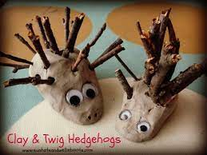

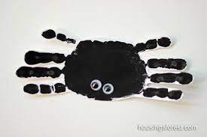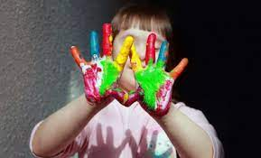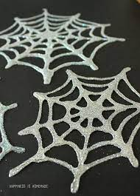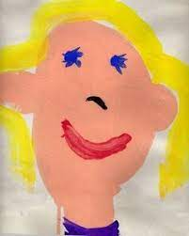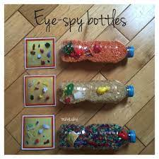

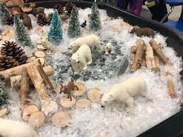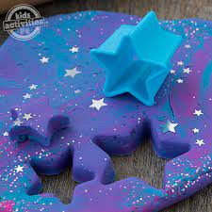

**Suggested Books linked to PSHE and starting school:**

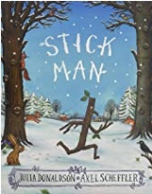 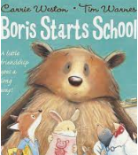 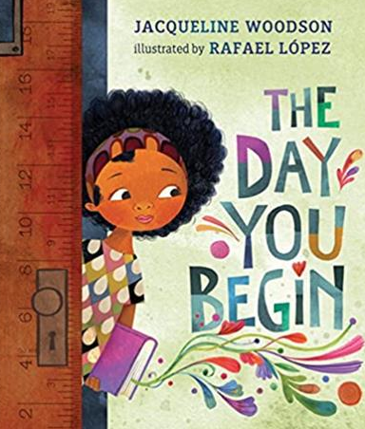

|  |
| --- |
| **Autumn/Spooky Time/Bonfire Night/Diwali Books: Winter/Christmas Books:** |
|  |
| **Mathematics**   * See White Rose Hub Planning SSM and Maths Mastery Planning NCETM. | |

**Literacy**

* Listen and enjoy sharing a range of books. Discuss favourite stories, poems, rhymes.
* Hold a book correctly, handles with care.
* Know that print carries meaning and in English, is read from left to right and top to bottom.
* Know the difference between text and illustrations.
* Enjoy joining in with rhyme, songs, and poems.
* Join in with repeated refrains and key phrases.
* Know the difference between text and illustrations.
* Join in with repeated refrains and key phrases.
* Hear general sound discrimination and be able to orally blend and segment.
* Develop listening and speaking skills in a range of contexts.
* Aware that writing communicates meaning.
* Know some high-frequency words.
* Copies adult writing behaviour e.g., writing on a whiteboard, writing messages.
* Makes marks and drawings using increasing control. Give meaning to their marks.
* Use some recognisable letters and own symbols.
* Write letters, sometimes in clusters like words. Writing simple sentences.
* See Bug Club Phonics Daily Planning.

**Personal, Social and Emotional Development**

* Aware of own feelings, can talk about feelings using words like ‘happy’, ‘sad’, ‘angry’.
* Begin to understand how others might be feeling.
* Can inhibit own actions, welcome distractions when upset.
* Understand behavioural expectations of the setting.
* Can independently organise themselves in the morning e.g., bookbag in tray, coat on peg, water bottle on trolley, name card on board.
* Can manage their own personal hygiene e.g., toileting.
* Interested in others play and starting to join in.

Build constructive and respectful relationships.

* Engage in positive interactions with adults and peers.
* Play with one or more children, extending and elaborating play ideas.

**Physical Development**

* Develop their small motor skills so that they can use a range of tools competently, safely, and confidently. Suggested tools: pencils for drawing and writing, paintbrushes, scissors, cutlery.
* Develop the overall body strength, co-ordination, balance, and agility needed to engage successfully with future physical education sessions and other physical disciplines including sport.
* Revise and refine the fundamental movement skills they have already acquired: rolling, crawling, walking, jumping, running, hopping, skipping, climbing.
* Good health – able to say if they are hungry, tired. Dental hygiene.
* Own personal hygiene – using the bathroom, dressing and undressing.

**Expressive Arts and Design**

* Uses tools for a purpose
* Explores and learns how sounds and movements can be changed.
* Continues to explore moving in a range of ways.
* Enjoys joining in with moving, dancing and ring games.
* Sings familiar songs.
* Engages in imaginative play based on their own ideas or first hand or peer experiences.
* Uses available resources to create props or creates imaginary ones to support play.
* Plays alongside other children who are engaged in the same theme.
* Creates representations of both imaginary and real-life ideas, events, people and objects.

**Understanding the World**

* Shows interest in the lives of people who are familiar to them.
* Recognises and describes special times or events for family or friends.
* Enjoys joining in with family customs and routines.
* Talks about past and present events in their lives.
* Enjoys playing with small world reconstructions, building on first hand experiences, e.g. visiting farms, garages, train tracks, walking by a river/lake.
* Notices detailed features of objects in their environment.
* Knows how to operate simple equipment e.g. can navigate touch-capable technology with support.
* Knows that information can be retrieved from digital devices and the internet.
* Completes a simple program on electronic devices.

**Links to Curriculum**

**Communication and Language**

* Listen to others 1:1, in small groups, whole class.
* Enjoy listening to stories and can remember what happens.
* Understand how to listen carefully and why listening is important.
* Maintain attention in whole class and small group contexts for a short time.
* Use talk to organise themselves and their play.
* Able to follow instructions.
* Understanding why and how questions.