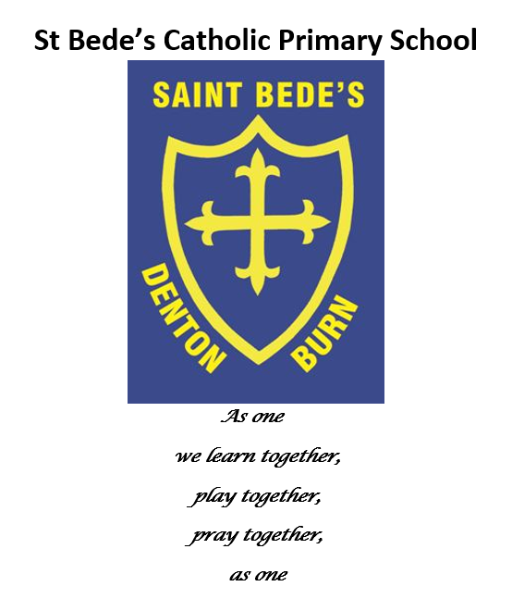
Uniform Policy

Date reviewed: June 2023
Date of next review: June 2024

School Uniform Policy

Safeguarding Statement:

At St Bede’s Catholic Primary School we respect and value all children and are committed to providing a caring, friendly and safe environment for all our pupils so they can learn, in a relaxed and secure atmosphere. We believe every pupil should be able to participate in all school activities in an enjoyable and safe environment and be protected from harm. This is the responsibility of every adult employed by, or invited to deliver services at St Bede’s Catholic Primary School. We recognise our responsibility to safeguard all who access school and promote the welfare of all our pupils by protecting them from physical, sexual and emotional abuse, neglect and bullying.

- Introduction
The Department for Education (DfE) strongly encourages schools to have a school uniform. This policy sets out the school's policy and approach on uniform and confirms the school's commitment to providing value for money to parents and ensuring that no pupil is discriminated against due to their gender, disability, religion or belief, economic circumstances or social and cultural background.
"Your beauty should not come from outward adornment, such as elaborate hairstyles and the wearing of gold jewellery or fine clothes. Rather, it should be that of your inner self, the unfading beauty of a gentle and quiet spirit, which is of great worth in God’s sight." I Peter 3:3-4

The school uniform helps ensure that pupils of all races and backgrounds feel welcome. It helps to protect children from social pressures to dress in a particular way; and nurtures cohesion, promoting good relations between different groups of pupils. Above all, the school uniform supports effective teaching and learning.

This policy follows the DfE statutory guidance 'Cost of school uniforms', published 19 November 2021.
- Aims and objectives
Our policy is based on the notion that school uniform:
- promotes a sense of pride in the school in line with our ethos;
- engenders a sense of identity and belonging towards the school community;
- supports positive behaviour and discipline;
- is practical, affordable and smart;
- makes students feel equal and encourages cohesion;
- has been designed with health and safety in mind; and
- supports sustainability.
- Roles and Responsibilities
The roles and responsibilities of the Local Governing Committee, Head Teacher, teachers, parents and pupils in relation to school uniform are set out in Schedule 2 of this policy.
- School Uniform Cost and Availability
In accordance with the School Admissions Code and the DfE statutory guidance 'Cost of school uniforms', the school ensures that the uniform policy does not discourage parents from applying for a place for their child at the school.
The school is committed to meeting the DfE’s recommendations and guidance on costs and value for money. Care is taken to ensure that school uniforms are affordable for current and prospective pupils, working with multiple suppliers to obtain best value for money and avoiding exclusive single supplier contracts or cash-back arrangements.

The school minimises any changes to the school uniform, taking into account the views of parents and pupils when considering any proposed changes.

The school makes provision for second-hand uniforms to be available, which can particularly benefit parents on low incomes. Parents are encouraged to donate second-hand clothing which is of a satisfactory quality and which is no longer required, so this can be used by other parents. Parents may also wish to access the Community School Clothing Scheme, which provides a free service to assists families in need within the North East.

- Equal Opportunities
The school is committed to promoting equality and ensuring that this policy or the application of this policy does not discriminate unlawfully.
Reasonable adjustments will be made to the uniform policy where it places a disabled pupil under the Equality Act 2010 at a substantial disadvantage compared to pupils who are not disabled.
Reasonable steps will also be taken by the School to ensure that the cost of girls’ and boys’ uniforms are not disproportionate.

The school will ensure that its uniform is as gender neutral and inclusive as possible.

Some religions and beliefs may require their members to conform to a specific dress code. The school does not discriminate against any religion or belief and will endeavour to allow religious requirements to be met where possible, whilst weighing up the needs and rights of individual pupils against the cohesion and health and safety concerns of the entire school community.

Any request by a parent or pupil for any particular religious item to be worn, or any request for a change to the uniform policy, shall be considered on a case-by-case basis by the Head Teacher and Local Governing Committee.

- School Uniform
Schedule 1 sets out the school uniform to be worn at the school, including, for ease of reference, pictures of the uniform to be worn. If parents are in any doubt about any aspect of school uniform, then please check with the Headteacher before proceeding.
- Jewellery
The school does not allow pupils to wear jewellery in school due to health and safety concerns. The exceptions to this rule are (1) a sensible wrist watch/basic fitness tracker that does not allow connection to a smartphone device.
Any jewellery worn which falls outside of this policy will be asked to be removed.
- Hairstyles
The school reserves the right to make a judgement on the suitability of pupils’ hair and appearance.
Extreme hairstyles, such as mohawks, tramlines and patterned or brightly coloured hair, are unacceptable.

Pupils with long hair must ensure that this does not impede their vision, cover their face or provide a health and safety risk. Long hair must be tied up during all practical lessons, for example during science experiments or PE.

Bandana style headbands and flowers/bows or excessive hair accessories are not to be worn; however, plain hair clips or bands are acceptable.

Hair extensions are not permitted.

Some religions and beliefs may require their members to wear their hair in a particular style. The school does not discriminate against any religion or belief and will endeavour to allow religious requirements to be met where possible, whilst weighing up the needs and rights of individual pupils against the cohesion and health and safety concerns of the entire school community. Any request by a parent or pupil for a particular hairstyle to be worn, or any request for a change to the uniform policy, shall be considered on a case-by-case basis by the Headteacher and Local Governing Committee.

- Makeup
Pupils are not allowed to wear makeup, including nail varnish, gel nails and nail extensions.
Pupils wearing make-up are required to remove it or, if appropriate, parents will be asked to collect their child to remove the makeup, before being allowed to return to their lesson.

The Head Teacher may allow makeup in limited circumstances, at their sole discretion, for example a pupil may be permitted to cover heavy scarring/skin damage.

- Monitoring and review
This policy is reviewed every two years by the Chair of Governors and the Headteacher.
The scheduled review date for this policy is September 2024.

- – School Uniform and PE / Swimming Kit
- School Uniform
  - The following school uniform must be worn in school.
  - Royal blue jumper *, royal blue cardigan * or royal blue sweatshirt * (with or without the school logo);
  - Black or dark grey trousers; or black or dark grey skirt. Jeans, tracksuit bottoms and leggings are not considered suitable (leggings or tracksuit bottoms may be worn for PE – see below);
  - Short trousers (optional during the summer term);
  - Skirt length should be on or below the knee. The style of skirt should not hug the figure.
  - Blue / white, or yellow/white checked dresses (optional during the summer term);
  - Yellow or pale blue polo shirt * (with or without the school logo);
  - All black school shoes or all black trainers. Heels are not considered suitable;
  - Socks / tights - white, black, grey or socks (dark socks with trousers); grey or black plain opaque tights.
  - An optional royal blue school book bag * (with or without the school logo).

The Governors request that each child has one jumper or cardigan with the school logo which can be worn for school visits to support safeguarding. Recycled logoed uniform items can be sources from school.

- Swimming Kit
Pupils must come prepared for swimming lessons with the following:-
  - A suitably sized towel
  - Girls – swimming costume (no bikinis)
  - Boys – swimming shorts (not below the knee)
  - Swimming cap – can be purchased through school

- PE Kit
Pupils are expected to wear the following PE kit on their allocated PE day:-
  - Yellow t-shirt * (with or without the school logo) or plain white t-shirt;
  - Dark (navy blue/black) shorts, dark navy / black plain tracksuit bottoms or plain navy blue / black sports leggings (without any "sports" branding or corporate logo);
  - Black plimsolls for indoors;
  - Trainers for outdoors;
  - No football strips are to be worn for PE.
  - An optional royal blue PE bag * (with or without the school logo).

- General points
All items of uniform, footwear and PE / swimming kit should be clearly labelled with your child's name.
No logos or branding (other than the school logo) should be displayed on any uniform.
All children are expected to take part in PE and swimming lessons, which should only be missed in exceptional circumstances with prior written permission of the parent.

- Where to buy
The school takes into account cost and value for money when considering where parents may purchase items of school uniform which contain the school logo.
The items above which are marked with an asterisk (*), which contain the school logo, can be purchased from www.totstoteams.com/school:bedes-rc-primary-school

The school engages with the uniform supplier, to ensure parents get value for money. Alternative suppliers shall be considered if there are concerns regarding the value for money and cost of items.

Plain items without the school logo, (such as trousers, jumpers, skirts, t-shirts, PE kit etc) may be purchased from any major store or supermarket providing that they closely match the colour requirements listed above (photographed examples of which are set out below).
Examples of School Uniform
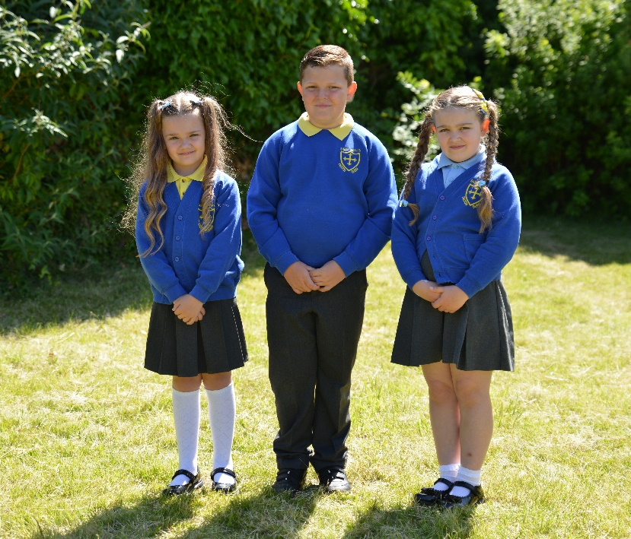

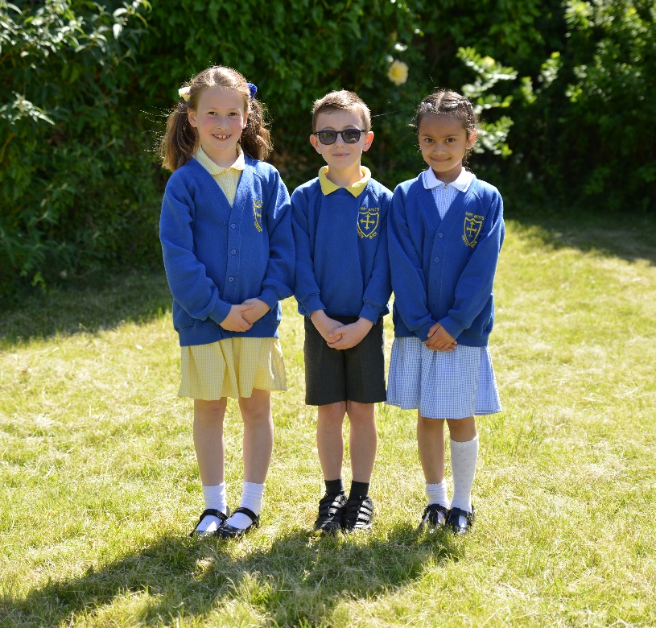
Example of summer uniform

- – Roles and responsibilities
- Roles and Responsibilities
The roles and responsibilities of the Local Governing Committee, Head Teacher, teachers, parents and pupils in relation to school uniform are set out below.
The Local Governing Committee is responsible for:
- establishing, in consultation with the Head Teacher and school community, a practical and smart school uniform that accurately reflects the ethos of the school and its vision and values;
- ensuring that equal opportunities are considered and that no person or group is discriminated against;
- listening to the opinions and wishes of parents, pupils and school community;
- ensuring that the school’s uniform is accessible and affordable and meets the DfE statutory guidance on 'cost of school uniform'.
The Headteacher of the school is responsible for:
- enforcing the school’s uniform on a day-to-day basis;
- ensuring that staff at the school understand this policy and what to do if a pupil is in breach of the policy;
- listening to the opinions and wishes of the school community in regard to the school’s uniform and where appropriate, making any reasonable recommendations to the Local Governing Committee regarding any proposed changes;
- carefully considering any reasonable request from a parent to vary the policy, in particular to meet the needs of any individual pupil, for example to accommodate their disability, religion or belief, or other special considerations; and
- processing and approving all eligible applications for assistance with the cost of school uniforms.
Teachers at the school are responsible for:
- ensuring that pupils dress in accordance with this policy at all times (unless the Head Teacher has granted an exemption on a case by case basis);
- considering disciplinary or behavioural sanctions in respect of any pupil who is in breach of this policy without reasonable explanation; and
- ensuring that pupils understand why having a consistent and practical school uniform is important, including avoiding divisiveness, promoting school identity and a sense of belonging, pride and school community.
Parents of pupils at the school are responsible for:
- providing their children with the correct school uniform as detailed in this policy.
- approaching the Head Teacher if they require any changes to this uniform policy for a period of time, setting out their reasons why; and
- ensuring that their child’s uniform is clean, presentable, the correct size and clearly labelled.
Pupils who attend the school are responsible for:
- wearing the correct uniform at all times, unless the Headteacher has granted an exemption;
- looking after their uniform; and
- understanding and respecting why a school uniform is important to the school.

