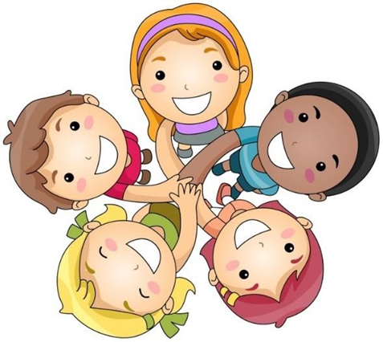

Early Years

Being Happy at School

A Child Friendly Child-on-Child Abuse Policy
Last updated: September 2022
Kind hands and kind feet

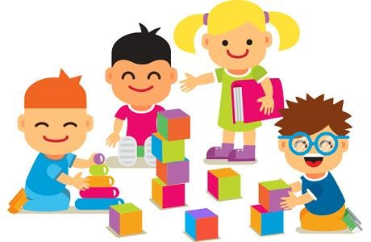

Children come to school to learn to share and take turns. At first children don’t always have the language to communicate what they want.

Talk to your child about sharing and using kind hands and kind feet.

Kind words
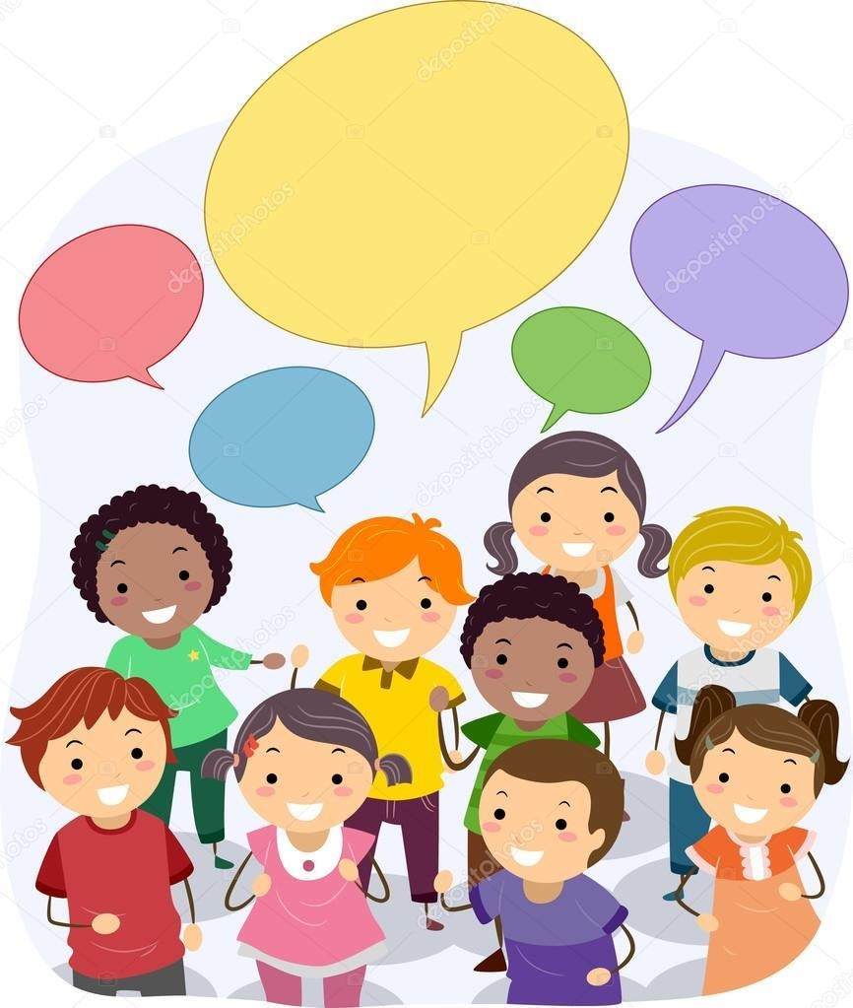

Children will learn to speak kindly if we show them how. Modelling kind and quiet talk will ensure that children can communicate kindly.
This will help their friendships to grow.

Talk to your child about using kind words such as please, thank you and sorry.

Kind heart
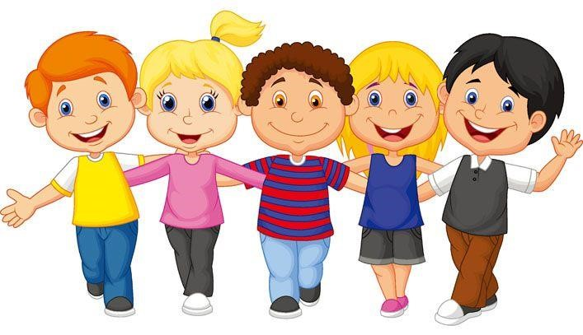

We all love and want to be loved.
Show your child that you expect them to be kind in everything they do. Do not accept poor behaviour as the sooner they learn to be kind the easier it will be for everyone.
Children will learn to be kind and gentle when kindness is shown to them by all adults around them.
Talk to your child about their feelings and how they make others feel with their actions.

Our Statements To Live By …
- We are all special.
- I can say one good thing about myself.
- I can say how I feel.
- I can laugh and have fun.
- I know what to do if I see anyone being hurt.
- I understand that rights match responsibility.
- I try to stand up for myself and others without hurting others.
- I try to be just and fair.
- I can tell you how I look after myself.
- I think before I make choices that affect my health.
- I can work, play, rest and pray each day.
- Simple things can make us happy.
- I try to love others as I love myself.
- I try to follow our school and classroom rules.
- I know I belong in a community that includes my school.
- I know we are happiest when we are united.
- I listen to what you say. I show that I am listening to you.
- I co-operate with others in work and play.
- I try to use words that make the world a better place. (Please, sorry, thank you).
20.I try to appreciate the beauty and the wonder in the world around me
- I know that it is ok for me to make mistakes.
- I can learn from my mistakes and failures.
- I try to keep going when things are difficult and not give up hope.
- I know what humility means.
- I know when to ask for help and who to ask for help from.
- I can recognise comfortable and uncomfortable feelings.
- I know how to help others when they are in trouble.
- I understand what trust means.
- I try to forgive people when they hurt me.
- I try to accept forgiveness from others.
- I know how to show I am sorry.
- I understand the importance of peace.
- I know what human dignity means and I show that I respect others.
- I stand up for people who are being treated unfairly.
- I notice that we are the same and we are different.
- I try to be accepting of others.

