St Bede’s Calculation Policy (updated 2023).
Maths for young children should be meaningful. Where possible, concepts should be taught in the context of real life.
Addition – EYFS guidance/models and images.
Children begin to combine groups of objects using concrete apparatus such as counters, cubes, ten frames and Base 10

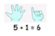
Construct number sentences verbally or using number cards to go with practical activities.
Children make a record in pictures, words or symbols of addition activities already carried out including part-whole models.
Solve simple problems using fingers.

Number tracks can be introduced to count up on and to find one more.
Number lines can then be used alongside number tracks and practical apparatus to solve addition calculations and word problems.

Children will need opportunities to look at and talk about different models and images as they move between representations.
Key vocabulary
Games and songs can be a useful way to begin using vocabulary involved in addition.
Add
More
And
Make
Sum
Total
Altogether
Score
Double
One more, two more, ten more…
How many more to make…?
How many more is…than…?
Addition – Year 1 | Addition – Year 2 | Addition – Year 3
 |  | Addition (expanded column)  331  + 258  500 (200 + 300)  80 (50 + 30)  __9 (8 + 1)  589 (addition is completed mentally)  Moving towards addition –compact column  858  + 347  1205  ¹ ¹
  + = signs and missing numbers
  Children should record addition using the correct symbols. Children need to understand the concept of equality before using the ‘=’ sign. Calculations should be written either side of the equality sign so that the sign is not just interpreted as ‘the answer’.
  2 = 1+ 1
  2 + 3 = 4 + 1
  Missing numbers need to be placed in all possible places.
  3 + 4 =   = 3 + 4
  3 +  = 7 7 =  + 4
  Concrete: combine two parts to make a whole: part- whole model
  Combining two sets of objects (aggregation) which will progress onto adding on to a set (augmentation)
  Use cubes to add two numbers together as a group or in a bar
  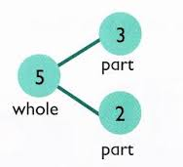
  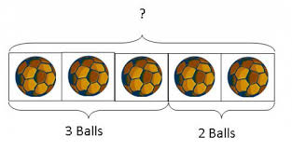
  Pictorial: use pictures to add two numbers together as a group or in a bar.
  8
  1
  Understanding of counting on with a number line (supported by models and images).
  Using a number line to ‘jump’ in steps of 1 or count on, always starting from the largest number.
  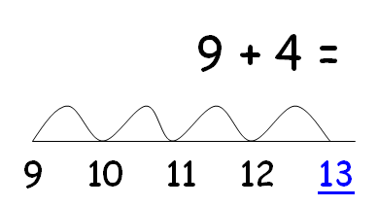
  Missing number problems e.g 14 + 5 = 10 + 
  32 +  +  = 100
  35 = 1 +  + 5
  Use the part-part whole diagram to move into the abstract.
  5
  3
  4 + 3 = 7
  10= 6 + 4
  It is valuable to use a range of representations (also see Y1). Continue to use number lines to develop understanding of:
  Counting on in tens and ones
  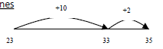
  23 + 12 = 23 + 10 + 2
  = 33 + 2
  = 35
  Partitioning and bridging through 10.
  The steps in addition often bridge through a multiple of 10
  e.g. Children should be able to partition the 7 to relate adding the 2 and then the 5.
  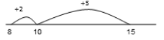
  8 + 7 = 15
  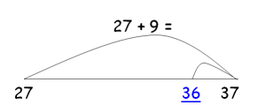
  Adding 9 or 11 by adding 10 and adjusting by 1
  e.g. Add 9 by adding 10 and adjusting by 1
  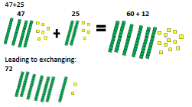
  Towards a Written Method
  Partitioning in different ways and recombine
  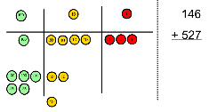
  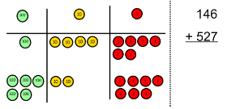
  Addition (partitioning with the expanded column method)
  31
  + 28
  9 (8 + 1)
  _50 (30 + 20)
  59 (addition is completed mentally)
  Some children may begin to use a formal columnar algorithm, initially introduced alongside the expanded method. The formal method should be seen as a more streamlined version of the expanded method, not a new method.

Addition – Year 4 | Addition – Year 5 | Addition – Year 6
Missing number/digit problems:  Mental methods should continue to develop, supported by a range of models and images, including the number line. The bar model should continue to be used to help with problem solving.  Compact Column  ¹ ¹  858  + 347  1205
  Children should be able to make the choice of reverting to expanded methods if experiencing any difficulty.
  Extend to up to two places of decimals (same number of decimals places) and adding several numbers (with different numbers of digits).
  ¹ ¹
  72.8
  + 54.6
  127.4
  Missing number/digit problems:
  Mental methods should continue to develop, supported by a range of models and images, including the number line. Children should practise with increasingly large numbers to aid fluency
  e.g. 12462 + 2300 = 14762
  Written methods (progressing to more than 4-digits)
  As year 4, progressing when understanding of the expanded method is secure, children will move on to the formal columnar method for whole numbers and decimal numbers as an efficient written algorithm.
  ¹ ¹ ¹
  172.83
  + 54.68
  227.51
  Place value counters can be used alongside the columnar method to develop understanding of addition with decimal numbers.
  Missing number/digit problems:
  Mental methods should continue to develop, supported by a range of models and images.
  Written methods
  As year 5, progressing to larger numbers, aiming for both conceptual understanding and procedural fluency with columnar method to be secured.
  Continue calculating with decimals, including those with different numbers of decimal places
  Problem Solving
  Teachers should ensure that pupils have the opportunity to apply their knowledge in a variety of contexts and problems (exploring cross curricular links) to deepen their understanding.

Subtraction – EYFS guidance/models and images.
Children begin with mostly concrete apparatus and pictorial representations.

Concrete apparatus is used to relate subtraction to taking away and counting how many objects are left.
Concrete apparatus models the subtraction of 2 objects from a set of 7.

Construct numbers verbally or using cards to go with practical activities.

Children are encouraged to read number sentences aloud in different ways “five subtract one leaves four” and “four is equal to five subtract one.”

Children make a record in pictures, words or symbols of subtraction activities already carried out. They can use bar models to demonstrate difference.
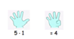
Solve simple problems using fingers

Number tracks can be introduced to count back and to find one less:

What is 1 less than 9? 1 less than 20?

Number lines can be used alongside number tracks and practical apparatus to solve subtraction calculations and word problems. Children count back under the number line.
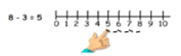
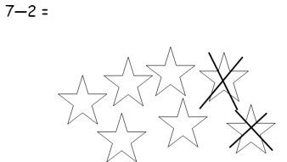
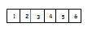
Children will need opportunities to look at and talk about different models and images as they move between representations.
Key Vocabulary
Games and songs can be a useful wat to begin using vocabulary involved in subtraction.

Take (away)
Leave
How many are left/left over
How many have gone?
One less, two less…ten less…
How many fewer is…than…?
Difference between
Is the same as

Subtraction – Year 1 | Subtraction – Year 2 | Subtraction – Year 3
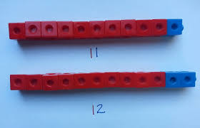  Use concrete objects such as Base 10 to subtract before using pictorial representations.  Use cubes to build towers or make bars to find the difference  Use basic bar models with items to find the difference  If appropriate, progress from using number lines with every number shown to number lines with significant numbers shown.  Understand subtraction as take-away:  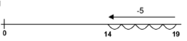  Understand subtraction as finding the difference. Counting on or ’Complimentary Addition’ - in this method you count on from the smaller to the larger number (similar to the way an shop-keeper pays back change)  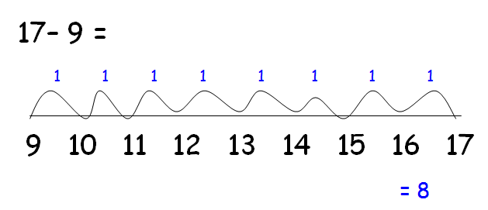  The use of other images is valuable for modelling subtraction e.g. Numicon, bundles of straws, Dienes apparatus, multi-link cubes and bead strings.  Missing number problems e.g. 7 = □ - 9; 20 - □ = 9; 15 – 9 = □; □ - □ = 11; 16 – 0 = □  Link to addition- use the part whole model to help explain the inverse between addition and subtraction.  If 10 is the whole and 6 is one of the parts. What is the other part? 10 - 6 = | Missing number problems e.g. 52 – 8 = □; □ – 20 = 25; 22 = □ – 21; 6 + □ + 3 = 11 using concrete, pictorial and numbers (abstract)  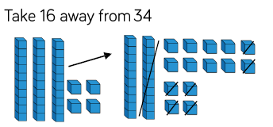  It is valuable to use a range of representations (also see Y1).  Use Base 10 to model subtraction when crossing 10.  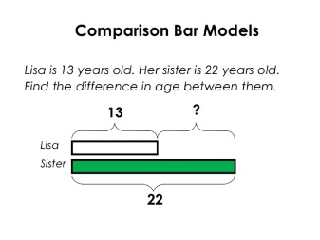  Continue to use number lines to model take-away and difference by counting on. Use knowledge of number bonds to help.  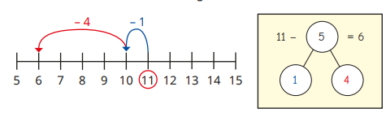  Moving onto 2-digit minus 2-digit  94-77  Initially the children are taught to record this on a number line and count the total they ‘jump on’.  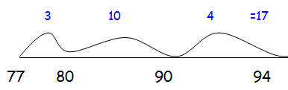  As the children become more skilled, they will reduce the number of ‘jumps’.  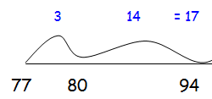  Written methods with compact column progressing to 2-digits  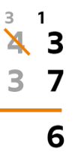  The children move onto compact column with 2 digits. First, with no exchange. Then introduce compact column subtraction with exchange alongside Base 10 (exchange of 10s for 1s)  - | Missing number problems e.g. □ = 43 – 27; 145 – □ = 138; 274 – 30 = □; 245 – □ = 195; 532 – 200 = □; 364 – 153 = □  Mental methods should continue to develop, supported by a range of models and images, including the number line.  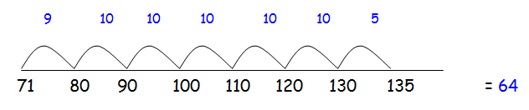  The aim is to reduce the number of ‘jumps’ as this reduces any possible errors when adding the numbers back together. Encourage the children to use an addition method (compact column) to support with counting up the ‘jumps’.  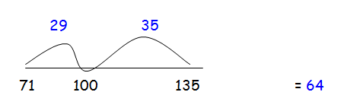  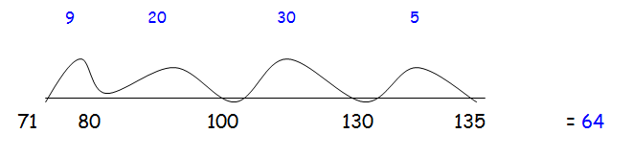  Written methods with compact column progressing to 3-digits  Introduce compact column subtraction with decomposition alongside Base 10  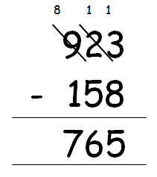

Subtraction – Year 4 | Subtraction – Year 5 | Subtraction – Year 6
Missing number/digit problems: 456 + □ = 710;  1□7 + 6□ = 200; 60 + 99 + □ = 340; 200 – 90 – 80 = □; 225 - □ = 150; □ – 25 = 67; 3450 – 1000 = □; □ - 2000 = 900  Mental methods should continue to develop, supported by a range of models and images, including the number line.  Written methods (progressing to 4-digits)  Expanded column subtraction with decomposition, progressing to calculations with 4-digit numbers. | Missing number/digit problems: 6.45 = 6 + 0.4 + □; 119 - □ = 86; 1 000 000 - □ = 999 000; 600 000 + □ + 1000 = 671 000; 12 462 – 2 300 = □  Mental methods should continue to develop, supported by a range of models and images, including the number line.  Written methods (progressing to more than 4-digits)  Children continue to use column subtraction with decomposition, progress to calculating with decimals, including those with different numbers of decimal places. | Missing number/digit problems: □ and # each stand for a different number. # = 34. # + # = □ + □ + #. What is the value of □? What if # = 28? What if # = 21  10 000 000 = 9 000 100 + □  7 – 2 x 3 = □; (7 – 2) x 3 = □; (□ - 2) x 3 = 15  Mental methods should continue to develop, supported by a range of models and images, including the number line.  Written methods  As year 5, progressing to larger numbers, aiming for both conceptual understanding and procedural fluency with decomposition to be secured.  Continue calculating with decimals, including those with different numbers of decimal places.

Multiplication– EYFS guidance/models and images.
The link between addition and multiplication can be introduced through doubling.
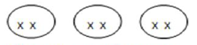
Children begin with concrete resources and then pictorial representations:
How many groups of 2 are there?

Real life contexts and use of practical equipment to count in repeated groups of the same size:


How many wheels are there altogether?


How much money do I have?

Count in twos; fives; tens both aloud and with objects.

Children are given multiplication problems set in a real life context. Children are encouraged to visualise the problem.

How many fingers on two hands? How many sides on three triangles? How many legs on four ducks?

Children are encouraged to read number sentences aloud in different ways “five times two makes ten” “ten is equal to five multiplied by two”
Key Vocabulary
Lots of
Groups of
Times
Multiply
Multiplied by
Multiple of

Once, twice, three times…ten times…

…times as (big, long, wide…and so on)

Repeated addition
double
Year 1 | Year 2 | Year 3
Children will be exposed to many different multiplication based activities in a variety of contexts. Much of this will be repeated addition activities or be linked to counting in 2s, 5s or 10s.  Understand multiplication is related to doubling and combing groups of the same size (repeated addition)  Washing line, and other practical resources for counting. Concrete objects. Numicon; bundles of straws, bead strings  Problem solving with concrete objects (including money and measures.)  Use arrays to understand multiplication can be done in any order (commutative) | Expressing multiplication as a number sentence using x  Using understanding of the inverse and practical resources to solve missing number problems.  7 x 2 =   = 2 x 7  7 x  = 14 14 =  x 7   x 2 = 14 14 = 2 x    x ⃝ = 14 14 =  x ⃝  Children will practise doubling numbers up to 10 + 10  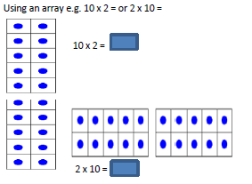  Children will be aware of simple arrays and pictorial representations and understand what they mean. Children will develop the knowledge of how to make their own arrays to solve a problem and also how repeated addition on a number line can get them to a solution. Arrays are used to organise and display number facts and help to reinforce the commutative law (multiplication can be done in either order e.g. 7 x 5 = 35 and 5 x 7 = 35)  Progressing to using a number line  Number lines are used as an informal recording method to assist with multiplication and they support the children when counting in constant steps. Once children have a thorough knowledge of times tables, they will be able to make short-cuts and multiply in fewer steps.  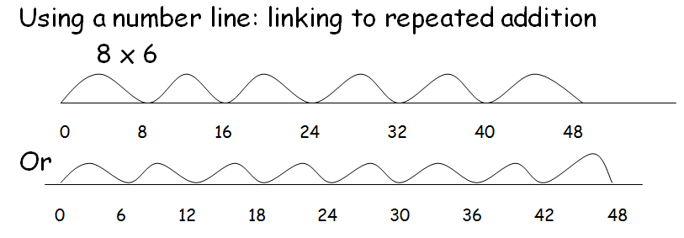 | Missing number problems  Continue with a range of equations as in Year 2 but with appropriate numbers.  Continue using the number line  Mental methods  Doubling 2 digit numbers using partitioning  Demonstrating multiplication on a number line – jumping in larger groups of amounts  13 x 4 = 10 groups 4 = 3 groups of 4  Area grid method (farmer’s field)  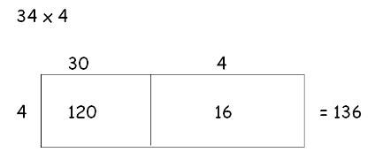  Children will move on from arrays and start using the grid method of multiplication when multiplying 2 digit numbers by 1 digit numbers.  It is essential that before children move onto the grid method, they are completely confident with all previous methods and have a solid grounding with mental methods and partitioning.  This method relies on partitioning (separating a number into its different parts e.g. 34 is the same as 30 and 4), an understanding of place value and the knowledge of the rules related to x and ÷ by 10, 100 and 1000. This method works very well for multiplication of decimals too.  The major error children make when using this method is adding up the numbers at the end, whereas the multiplication is generally the easy part! Children need reminding to use a method for addition to minimise errors caused by an over-reliance on mental methods.  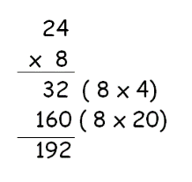  Progressing to expanded column format  This method can be translated easily once confident with ‘farmer’s field’ method. Initially, the children are encouraged to record the different parts of the calculation in brackets at the side of the calculation. This is simply a quick check to ensure all parts have been included. Once confident with this method, reduce the recording towards a more ‘standard’ form.

Year 4 | Year 5 | Year 6
Mental methods  Counting in multiples of 6, 7, 9, 25 and 1000, and steps of 1/100.  Solving practical problems where children need to scale up. Relate to known number facts. (e.g. how tall would a 25cm sunflower be if it grew 6 times taller?)  Written methods (progressing to 3d x 1d)  The children should progress to use the expanded column method to multiply 3 digit numbers by 1 digit. The expanded column format will enable children to correctly set out the ‘standard’ form of written multiplication. It is at this stage that approximation and estimation should become a regular part of classroom practice. Children should approximate an answer before using a method so they know if there answer is accurate or not.  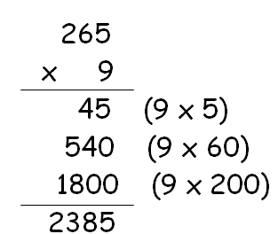  253 x 9 is approximately 250 x 10 = 2500  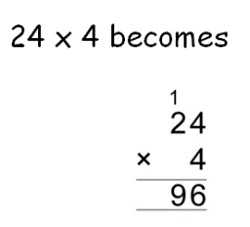  Progress to short multiplication (Summer term)  Both methods can be used to check answers. | Mental methods  X by 10, 100, 1000 using moving digits ITP  Use practical resources and jottings to explore equivalent statements (e.g. 4 x 35 = 2 x 2 x 35)  Recall of prime numbers up 19 and identify prime numbers up to 100 (with reasoning)  Solving practical problems where children need to scale up. Relate to known number facts.  Identify factor pairs for numbers  Written methods (progressing to 4d x 2d)  The children should be able to use a formal written method to multiply a 4 digit number by a 1 digit number and TU by TU.  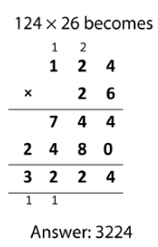 | Mental methods  Identifying common factors and multiples of given numbers  Solving practical problems where children need to scale up. Relate to known number facts.  Written methods  Continue to refine and deepen understanding of written methods including fluency for using long multiplication  Children will consolidate all they know about short and long multiplication and learn the new skill of multiplying decimal numbers to two decimal places.  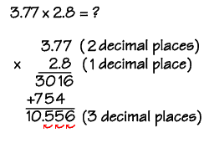

Division – EYFS guidance/models and images.
The ELG states that children solve problems, including doubling, halving and sharing.

Children need to see and hear representations of division as both grouping and sharing.

Division can be introduced through halving.

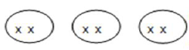
Children begin with mostly pictorial representations linked to real life contexts:

Grouping model.
Mum has 6 socks. She grouped them into pairs. How many pairs did she make?
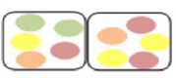
Sharing model.
I have 10 sweets. I want to share them with my friend. How many will we have each?

Children have a go at recording the calculation that has been carried out.

Key Vocabulary
Halve
Share, share equally
One each, two each, three each…

Group in pairs, threes…tens
Equal groups of
Divide
Divided by
Divided into
Left, left over

Division – Year 1 | Division – Year 2 |  | Division – Year 3
Children must have secure counting skills- being able to confidently count in 2s, 5s and 10s.  Children should be given opportunities to reason about what they notice in number patterns.  Group AND share small quantities- understanding the difference between the two concepts.  Sharing  Develops importance of one-to-one correspondence.  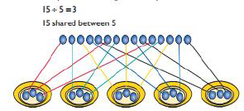  Children should be taught to share using concrete apparatus.  Grouping  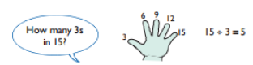  Children should apply their counting skills to develop some understanding of grouping.  Use of arrays as a pictorial representation for division. 15 ÷ 3 = 5 There are 5 groups of 3.  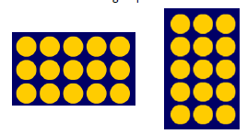  15 ÷ 5 = 3 There are 3 groups of 5. |  | ÷ = signs and missing numbers  6 ÷ 2 =   = 6 ÷ 2  6 ÷  = 3 3 = 6 ÷    ÷ 2 = 3 3 =  ÷ 2   ÷  = 3 3 =  ÷   Know and understand sharing and grouping- introducing children to the ÷ sign.  Children should continue to use grouping and sharing for division using practical apparatus, arrays and pictorial representations.  Grouping using a number line.  Group from zero in jumps of the divisor to find our ‘how many groups of 3 are there in 15?’  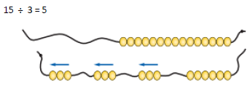  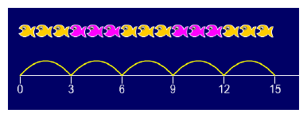  Continue work on arrays. Support children to understand how multiplication and division are inverse. Look at an array – what do you see? | ÷ = signs and missing numbers  Continue using a range of equations as in year 2 but with appropriate numbers.  Use of a number line:  Initially this should be used with no remainder and link to inverse operation of multiplication and repeated addition  Children should divide using x2, x5, x10, x3, x4, x6 and x8 table facts.  They should experience a logical progression in the numbers they use, for example:  1. Multiplication and division inverses using single jumps on a number line.  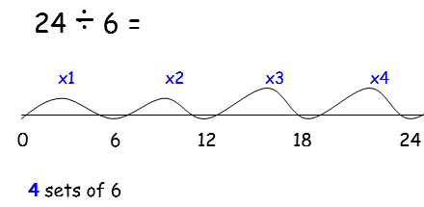  2. Dividend just over 10x the divisor, e.g. 39 ÷ 3  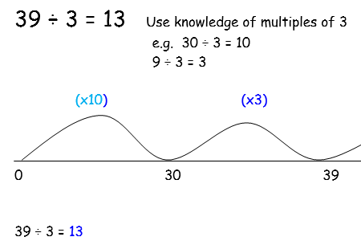  Children need to be able to partition the dividend in different ways using x10 as the first step.
Division – Year 4 | Division- Year 5 | Division – Year 6
÷ = signs and missing numbers  Continue using a range of equations as in year 3 but with appropriate numbers.  Use of a number line:  Continuing with methods from Year 3, the children should divide using table facts to 12 x 12.  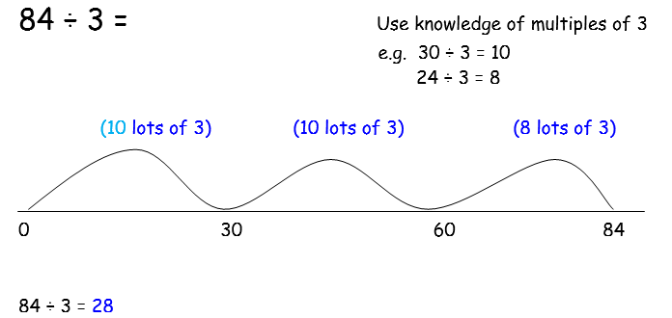  1) The children should recognise multiples jumps of 10.  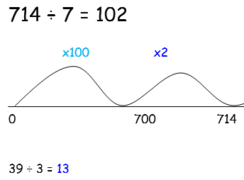  2) This should progress to using a dividend over 100x the divisor, e.g. 714 ÷ 7  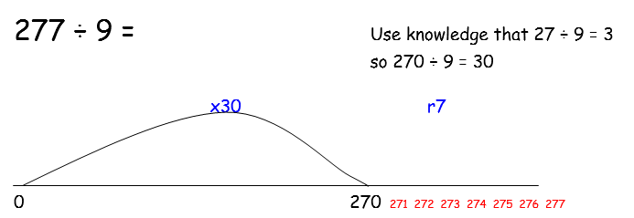  3) Once children are confident with times tables, they will be able to use the knowledge to derive facts using chunking.  All of the above stages should include calculations with remainders as well as without.  Remainders should be interpreted according to the context. (i.e. rounded up or down to relate to the answer to the problem)  Formal Written Methods (Calculations with 2 and 3-digit dividends).  Formal short division should only be introduced once children have a good understanding of division, its links with multiplication and the idea of ‘chunking up’ to find a target number (see use of number lines). Children use place value counters alongside the box method to aid understanding. | ÷ = signs and missing numbers  Continue using a range of equations as in year 3 but with appropriate numbers.  Formal Written Methods  Continued as shown in Year 4, leading to the efficient use of a formal method of short division. Both methods could be used in conjunction with one another as a way of checking answers.  E.g. 876 ÷ 7  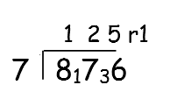  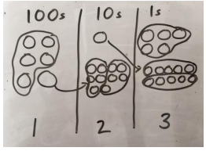  Represent the place value counters pictorially.  Children begin to practically develop their understanding of how express the remainder as a decimal or a fraction. Ensure practical understanding allows children to work through this (e.g. what could I do with this remaining 1? How could I share this between 4 as well?) | ÷ = signs and missing numbers  Continue using a range of equations but with appropriate numbers  Formal Written Methods – long and short division  Quotients should be expressed as decimals and fractions.  Use of long division method: this links very closely to the chunking method but is recorded vertically. The children should this method when the divisor is two digits or more. It also requires an understanding of subtraction. Once again, when the children are skilled and confident with multiplication tables, they will begin to derive facts which will make their calculations more compact.  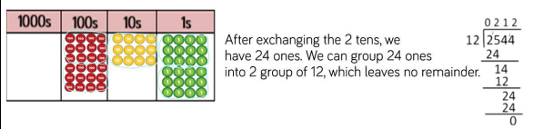  E.g. 9675 ÷ 15 = 643  15  30  45  60  75  90  643  15 9675 -  9000 (x600)  675  600 (x40)  75-  75 (x3)

