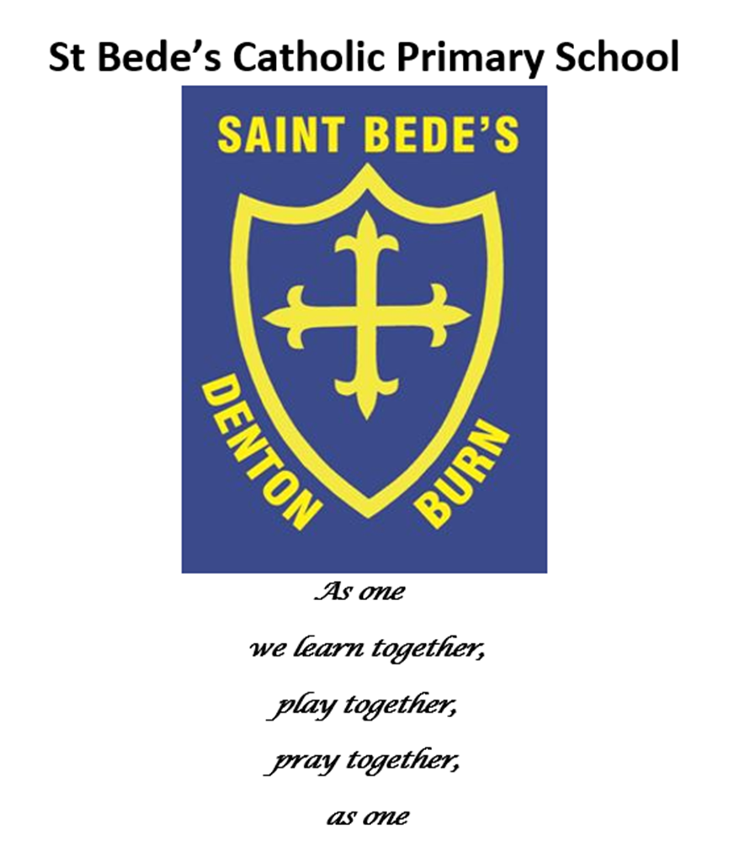
Music Policy

Date reviewed: May 2022
Date of next review
St Bede’s Primary School Music Long Term Plan

Music is a spiral subject. Throughout school life the concepts remain the same but get progressively more difficult and challenging for the students. Key components include rhythm, pulse, singing, playing, composing, performing, listening, appreciating, music history, musical instruments, reading, writing, and language. None of these elements are taught in isolation, they work together. These key components are explored and taught from Reception through to Year 6, becoming increasingly more complex as the children deepen their understanding.
Our music curriculum is broad in its approach, with no hierarchy of genre. Instead children are exposed to high quality music from all around the world and from throughout history. Our lessons are planned so that each session includes an element of reading, writing, singing / instruments and exploration of musical vocabulary. In addition to this, each half term we study a different genre of music to listen to, appreciate and analyse. Music genres will be mirrored throughout the school with the primary focus being to explore the style of the music, examples of other genres will also be used to draw comparisons and highlight key features.

 | Early Years  30-50 months:  - Creates movement in response to music.  - Sings to self and makes up simple songs.  - Makes up rhythms.  - Captures experiences and responses with a range of media, such as music.  ELG: They represent their own ideas, thoughts and feelings through music. | Key Stage 1  Pupils should be taught to:  - use their voices expressively and creatively by singing songs and speaking chants and rhymes.  - play tuned and untuned instruments musically.  - listen with concentration and understanding to a range of high-quality live and recorded music  - experiment with, create, select and combine sounds using the inter-related dimensions of music. |  | Key Stage 2  Pupils should be taught to sing and play musically with increasing confidence and control. They should develop an understanding of musical composition, organising and manipulating ideas within musical structures and reproducing sounds from aural memory.  Pupils should be taught to:  - play and perform in solo and ensemble contexts, using their voices and playing musical instruments with increasing accuracy, fluency, control and expression.  - improvise and compose music for a range of purposes using the inter-related dimensions of music.  - listen with attention to detail and recall sounds with increasing aural memory  - use and understand staff and other musical notations.  - appreciate and understand a wide range of high-quality live and recorded music drawn from different traditions and from great composers and musicians.  - develop an understanding of the history of music.
 | Reception | Year 1 | Year 2 | Year 3 | Year 4 | Year 5 | Year 6
Vocabulary  and Musical Language | Musical Language is cumulative. Language is acquired by practise. It is our intent that by the end of KS1 the vast majority of children working at greater depth will be able to define most of the musical words of Key Stage One.
 | Loud, quiet, fast, slow, music, instrument, play, song, sing, | loud, quiet, fast, slow, low, high, speed, volume, write music, compose, composer, conductor, pitch, rhythm, guitar, ukulele, penny whistle, violin, trumpet, piano, drums, names of untuned percussion instruments, bar, barline, orchestra, tune | dynamics, forte, fortissimo, pianissimo, piano, mezzo forte, tempo, violin, viola, ‘cello, double bass, trumpet, trombone, cornet, horn, tuba, piccolo, flute, clarinet, oboe, bassoon, crotchet, crotchet rest, note, tied crotchet, minim, quaver, quaver rest, semibreve, semiquaver | string, brass, wind, percussion, orchestra, tune, instrumental, vocal, notation, stave, treble clef, dotted notes, performance, choir, ensemble, crescendo, diminuendo, decrescendo | melody, harmony, genre, opera, pop music, jazz, folk and traditional, rock music, classical music, acapella, lento, adagio, tutti, dotted notes | time signature, rhythm (a deeper definition), scale, major, minor, pentatonic, mode, soprano, alto, tenor, bass | fine, legato, chord, block chord, arpeggio, glissando, ostinato, riff, bass clef, timbre
Singing / Instruments | Children are given the opportunity to play untuned percussion instruments. They learn turn-taking and playing together. Children are taught discipline with instruments, learning when to play and when to stop. Children learn songs of increasing complexity. Children focus on pitch, motor skills, listening, and language. | Singing and games are the main focus of music lessons. It is our intention that by the end of KS1 children can sing musically, feel the pulse and be able to clap along in time, use and understanding simple rhythms.  Repertoire chosen includes appropriate seasonal songs. Example repertoire covered: |  | Children are taught how to play the Penny Whistle or Recorder as well as furthering their vocal skills.  Children learn to sing musically in a group. By the end of KS2, children will be able to sing in 2, 3, and 4-part rounds. They will also be taught to sing in at least 2-part harmony.  Children will be taught increasingly complex repertoire with progressive length and difficulty across KS2.
 |  | - The Big Ship Sails  - Three Jolly Fishermen.  - Head and Shoulder  - Baby, one, two, three  - Cobbler, Cobbler.  - Walking Through the Jungle.  - This is My Trunk.  - I’ve Got A Grumpy Face. | - Throw, Catch.  - I Like the Flowers  - Jumping Up and Down  - When I was One  - Put Your Finger on your Nose  - Bobby Shafto  - Keel Row  - Happy Sun High  - When My Aunt Came Back  - Swimming, Swimming | Children are introduced to play the Penny whistle or Recorder. They are introduced to the mechanics of playing and build a repertoire of tunes including:  - Mary Had A Little Lamb  - Twinkle Twinkle  - Happy Birthday  - The Skye Boat Song.  Across Year 3 and 4 children learn instrument specific skills. For example, breath control, finger placement, octaves, note separation, and tonguing. |  | Children learn tunes in different time signatures. E.g. 6/8 jigs.  Children can play a tune by reading standardised notation.  Children continue to learn instrument specific skills. For example, ornamentation, increasing control over upper octave, improved phrasing.  Example repertoire might include:  - John Ryan’s Polka  - Spootiskerry  - My Grandfather’s Clock  - Hundred Pipers.
Performing | Children are given the opportunity to perform as a group throughout the school year. | Children are introduced to untuned percussion instruments, taught how to play them, and what the names are.  Children are encouraged to improve self discipline and patience as part of playing musical instruments.  Children will be given opportunities to perform singing to each other and to audiences, for example school assemblies and seasonal productions. |  | Children are given the opportunity to perform to each other in small groups. Some children will perform solo to the class. |  | Children are given the opportunity to perform to each other solo or in small groups. Some children are given the opportunity to perform solo to an audience during seasonal and ad-hoc performances.
Composing | Children are guided to create their own rhythms on the untuned percussion. | Children are taught the purpose of a conductor.  Children will compose their own rhythms and play the rhythms composed by classmates. |  | Children are guided in using their previously learnt knowledge to work in a group to create their own song on a subject of their choice. Children will compose rhythms and both perform and write them down. |  | Children use their previously learnt knowledge to work in a group to create their own song on a subject of their choice with increasing independence.  Children will use taught knowledge of playing the penny whistle and composition to create their own pieces. They will attempt to notate their piece using standard notation.
Listening and Appraising | Children will listen to a wide variety of recorded and live music including live musicians in school, YouTube and Spotify. Music genres covered will include folk, jazz, instrumental orchestral, opera, pop, gospel, musical theatre, and rock.  Children are given the opportunity to appreciate the music. They will encouraged to share their opinions and thoughts of the music heard/ musicians seen with increasing detail and musical vocabulary. A KS1 example might be ‘because it is fast,’ where as a upper KS2 example could be ‘because I liked the harsh brass timbre in the beginning.’
 |  | By the middle of Y2 children will understand that as a subjective subject it is absolutely allowed to not like the music but they must be able to explain why.  Children learn about a variety of musical instruments and look at each of the orchestral families. |  | Children will develop their listening and aural skills during all areas of musical tuition. Particularly when they are learning the Penny Whistle/ Recorder. Children will be able to describe changes and movements in pitch, rhythm, mood, tempo and dynamics in increasing detail.
Musical Notation |  | Children are introduced to fundamentals of standard western notation.  Children will be taught the shapes and values of crotchet, crotchet rest, quaver, quaver rest, groups of 4 semiquavers, and tied crotchets.  They will focus on 4/4 and 3/4 time. They will use their bodies to create the notes. Children will be able to read many combinations of the above notes. | Children will read quaver rests and semibreves. In key stage one children will predominantly work in 4/4 and 3/4 time signatures. | Children will read notation of increasing complexity including ties across the bar.  Children will be able to transcribe basic rhythms of one or two bars in length.  Children will be able to draw a treble clef.  Children compose using a graphic score. | Children will be introduced to pitch on the stave. ‘Every Good Bunny Deserves Food’ and FACE in the space’.  Children will start to pair up their notation reading and their instrumental skills.  Children will learn the basics of intervals and be able to identify a third, fifth, and octave. | Children are introduced to time signatures and understand what the top and bottom numbers mean.  Children will be able to explain both common time and compound time signatures.  Children will be able to sing songs and identify intervals within them.  Children will have an ‘interval song’ that they can sing to identify major scale intervals | Children are able to read notation for their instrumental lessons. They are able to fluently read basic notation in multiple keys and time signatures and play them.  Children are able to sight-sing basic songs when given a starting note.
Music History |  | Children are introduced to the concept of the orchestra, and through listening and appraising music gain an understanding of genre and historical context. |  | During each half term children will look at different musical eras including the composers and instruments of note. Children will also look beyond the famous composers to the more diverse history of women and composers outside of the euro-centric canon such as Wynton Marsalis and Florence Price.
Musical Development Matters
https://www.early-education.org.uk/musical-development-matters

National Curriculum
https://assets.publishing.service.gov.uk/government/uploads/system/uploads/attachment_data/file/239037/PRIMARY_national_curriculum_-_Music.pdf

