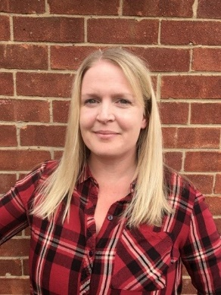

Name | Louise Fairless
Category of governor | Community Governor
Term of office | 05/09/2022 - present
Business / work | Nursery Practitioner (Private Nursery)
Governance experience | I began my governing experience as a staff governor for ST Bede’s prior to 2022. My previous role being class teacher at St Bede’s Catholic Primary School. Since leaving this role at St Bede’s, I have been granted a community governor role.
Hobbies and interests | As a mother of two young children, my hobbies and interests have changed and developed as they have. I love exploring new places across the UK with my family and have enjoyed many caravanning holidays or mini road trips both in country and by the coast.  When I get the opportunity, I love reading fiction, singing in the car and frequenting doughnut shops and ice cream parlours!
Links to the school/area | My link to the school and area comes from my previous career role as class teacher since 2013. Since leaving, I still feel like I am part of the school community.
Why did you become a governor? | I became a governor because I am invested in the school and its future developments. St Bede’s offered me a wonderful opportunity in teaching for which I am forever grateful and I want to give something back. St Bede’s is a wonderful school with equally wonderful staff and children and strives to deliver the best education and support for its pupils and their families. I want to support the Headteachers vision and maintain links with the school and I can do this through being part of the governing body.

