Pupil premium strategy statement – St Bede’s Catholic Primary School 2025 / 2026
This statement details our school’s use of pupil premium (and recovery premium) funding to help improve the attainment of our disadvantaged pupils.
It outlines our pupil premium strategy, how we intend to spend the funding in this academic year and the outcomes for disadvantaged pupils last academic year.

School overview
Detail | Data
Number of pupils in school | 205
Proportion (%) of pupil premium eligible pupils | 36.1% (74 pupils)
Academic year/years that our current pupil premium strategy plan covers (3 year plans are recommended – you must still publish an updated statement each academic year) | 2025 – 2026 (Current year) – 2028 / 2029
Date this statement was published | December 2025
Date on which it will be reviewed | December 2026
Statement authorised by | Leigh-anne Young  (Headteacher)
Pupil premium lead | Leigh-anne Young  (Headteacher)
Governor / Trustee lead | Clare Casson - Chair of Governors  Joanna Lompart-Chlasciak – Link Governor for Safeguarding and Vulnerable Pupils

Funding overview
Detail | Amount
Pupil premium funding allocation this academic year | £106,051
Recovery premium funding allocation this academic year | £0
Pupil premium funding carried forward from previous years (enter £0 if not applicable) | £0
Total budget for this academic year  If your school is an academy in a trust that pools this funding, state the amount available to your school this academic year | £106,051

Part A: Pupil premium strategy plan

Statement of intent
Context: (Taken from Ofsted IDSR)
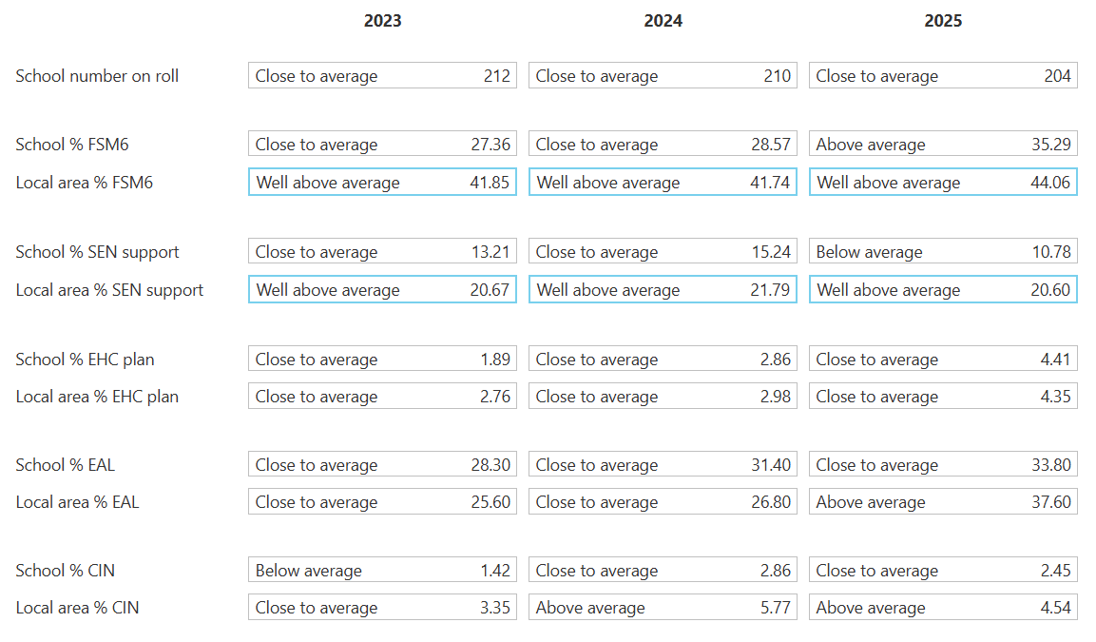
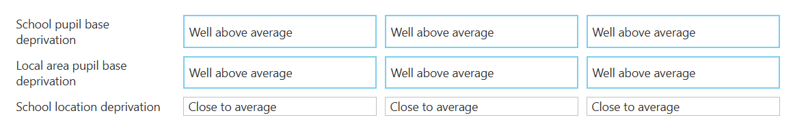
Our key objective in using the Pupil Premium Grant is to diminish the differences between pupil groups and ensure that all pupils reach their full potential in all aspects of their lives.
It is our intention that all pupils, irrespective of their backgrounds or the challenging circumstances that they face, make good progress in all areas of their learning, achieving high standards across all curriculum areas and indeed in all areas of their development. The focus of our Pupil Premium Strategy is to support our disadvantaged pupils to further raise attainment through accelerated progress to narrow the attainment gap between disadvantaged and non-disadvantaged pupils.
We acknowledge the individual barriers to learning encountered by our pupils and seek to provide the relevant intervention (academic or nurture) in each case to support vulnerable pupils in achieving their goals. Challenges such as special educational needs, living in poverty and family involvement with social care are amongst the factors which we know can impact on academic achievement along with other factors such as being a young carer or English being a second language.
The ongoing effects of COVID continue to have an impact, particularly for some of our youngest pupils. Restricted access to social opportunities and pre-school experiences has impacted school readiness, language and communication skills and personal and social development.
Pupil Premium numbers are increasing year on year (22-23: 46 pupils, 23-24: 55 pupils, 24-25: 65 pupils, 25-26 Dec 74 pupils)’ and the number of families who just fall below the threshold is also increasing significantly.
Quality-First Teaching is at the heart of our approach, with a focus on areas in which disadvantaged pupils require most support – in our particular case this focuses predominately on English and maths teaching and learning. High quality teaching is proven to have the greatest impact on closing the attainment gap for disadvantaged pupils whilst simultaneously benefitting our non-disadvantaged pupils. Implicit in the intended outcomes outlined below, is the intention that non-disadvantaged pupils’ attainment will be sustained and improved alongside progress for their disadvantaged peers.
Relationships are also key to supporting our vulnerable pupils as pupils must feel secure and a sense of belonging in order to thrive. Significant time and training is devoted to this element of school life.
Our strategy is also integral to the wider school planning focusing on the recovery curriculum, the targeted support through the National Tutoring Programme will support both our disadvantaged and non-disadvantaged pupils who have been worst affected by the challenging times that we have faced due to the pandemic.
Our strategy is based on a thorough knowledge of our pupils, and their individual needs and barriers to learning and engagement, we aim to provide support / intervention in various forms from quality-first teaching to 1:1 interventions, where appropriate. Our approach is founded on a whole school approach in which all staff take responsibility for disadvantaged pupils’ outcomes and raise expectations of what they can achieve through a fully inclusive approach.

Challenges
This details the key challenges to achievement that we have identified among our disadvantaged pupils.
Challenge number | Detail of challenge
1 | A large proportion of our disadvantage pupils come from homes that are unable to support a positive reading culture and do not have easy access to quality reading materials – impacting on the development of our pupils as readers but also impacts on their attainment in all curriculum areas
2 | A proportion of our families live in deprivation and poor living conditions; this can impact on pupil’s self-esteem and resilience and often on their ability to access enrichment activities
3 | A large proportion of our pupils do not come to school ‘ready to learn’ this is linked to many different reasons including those linked to more challenging homelife circumstances which impact on routines such as sleep and mealtimes.
4 | Lower level of parental support and engagement / understanding of curriculum expectations, this can lead to limited aspirations for our disadvantaged pupils and a lack of inspiration and motivation for learning
5 | Observations and discussions with pupils indicate underdeveloped oral language skills and vocabulary gaps – evident across all age groups
6 | Limited life and cultural experiences mean that some children’s narrow breadth of experiences not only creates a limited understanding of the outside world but also create difficult to relating to texts or understanding vocabulary – this is significantly evident for our disadvantaged pupils
7 | Observations and discussions have identified social and emotional issues for a proportion of our pupils with the additional ongoing impact of the aftermath of COVID 19 pupil’s negatively affecting emotional health and well-being – this can impact on self-esteem, confidence in learning and resilience  These challenges have impacted more significantly on our disadvantaged pupils - findings are supported by national studies.
8 | Disadvantaged pupils’ attendance:  52% of our disadvantaged pupils’ attendance last academic year (24/25) was below 95% (24% of the group being below 90%)

Intended outcomes
This explains the outcomes we are aiming for by the end of our current strategy plan, and how we will measure whether they have been achieved.
Intended outcome | Success criteria
Improve oral language skills and vocabulary among disadvantaged pupils | Assessments and observations indicate significant improvements to oral language among our disadvantaged pupils – greater engagement in lessons, progress within lessons and attainment in ongoing assessments.  End of EYFS outcomes and end of Key Stage outcomes (1 and 2)
Improve reading attainment and progress among disadvantaged pupils  (In-house data shows progress in reading in all year groups and a closing of the gap between disadvantaged and non-disadvantaged pupils – continue to build on this) | Phonics Screener outcomes show that the gap is closing between attainment and progress between our disadvantaged and non-disadvantaged pupils  End of Key Stage 2 reading outcomes show that the gap is closing between attainment and progress between our disadvantaged and non-disadvantaged pupils
Reduce the achievement gap between disadvantaged and non-disadvantaged pupils | End of Key Stage 2 assessment outcomes show that the gap is closing between attainment and progress between our disadvantaged and non-disadvantaged pupils
Ensure disadvantaged pupils make progress in English and maths at a similar rate to non-disadvantaged pupils | End of Key Stage 2 assessment outcomes show that the gap is closing between attainment and progress between our disadvantaged and non-disadvantaged pupils
To promote positive attendance and support families in need to achieve and sustain improved attendance, particularly for disadvantaged pupils | Overall attendance rate improved and sustained, particularly for our disadvantaged pupils
To promote positive attitudes and well-being, particularly for disadvantaged pupils, raising aspirations, motivation and engagement | Increased participation and involvement in enrichment activities, particularly for our disadvantaged pupils

Activity in this academic year
This details how we intend to spend our pupil premium (and recovery premium) funding this academic year to address the challenges listed above.

Teaching (for example, CPD, recruitment and retention)
Budgeted cost: £60,000
Activity | Evidence that supports this approach | Challenge number(s) addressed
Further embed the validated Systematic Synthetic Phonics Programme to secure stronger phonics teaching for all pupils.  Embed a more consistent phonics intervention programme to support older pupils who did not pass the screener.  Training all staff to support interventions higher up the school. | Teaching a phonics approach has a positive impact overall (+5 months) with very extensive evidence and is an important component in the development of early reading skills, particularly for children from disadvantaged backgrounds.  (Education Endowment Foundation – Phonics Guidance) | 1,4,5
Enhance teaching and learning by accessing high quality CPD and resources – teachers and teaching assistants  Introduction of a Language Champion to lead on speech and language intervention and support including Language Link and specific speech and language intervention programmes | Supporting high quality teaching is pivotal in improving children’s outcomes. Indeed, research tells us that high quality teaching can narrow the disadvantage gap….A growing consensus that promoting effective professional development plays a crucial role in improving classroom practice and pupil outcomes….Ensuring that teachers are provided with high quality PD is therefore crucial in improving pupil outcomes.  (Education Endowment Foundation – Effective Professional Development Guidance)  TAs should add value to what teachers do, not replace them – the expectation should be that the needs of all pupils are addressed, first and foremost through high quality classroom teaching……. Research on TAs delivering targeted interventions in one-to-one or small group settings shows a consistent impact on attainment of approximately three to four additional months’ progress (effect size 0.2 – 0.3). Crucially, these positive effects are only observed when TAs work in structured settings with high quality support and training.  (Education Endowment Foundation – Making the Best Use of teaching Assistants Guidance) | 1,4,5,6
Reduce adult to pupil ratio and increase high quality adult support in all year groups – employ a TA full time and a pupil support worker full time to reduce class sizes and facilitate small group teaching and deliver bespoke teaching packages to build on attainment and progress.  Enhancing Quality First Teaching.  Consolidate MITA / MAPTA Trust work – maximising the impact of teaching assistants |  | 1,4,5,6
Embed dialogic activities across the school curriculum, supporting pupils to articulate ideas and consolidating understanding and extending vocabulary – purchase relevant resources  (Language Links, Same Day Interventions, Vocabulary Ninja)  Embedding the research and actions linked to the Oracy project Voice 21 | Language provides the foundation of thinking and learning and should be prioritised. High quality adult-child interactions are important and sometimes described as talking with children rather than just talking to children. Adults have a vital role to play in modelling effective language and communication.  (Education Endowment Foundation – Preparing for Literacy Guidance, Improving Literacy in Key Stage 1 Guidance and Improving Literacy in Key Stage 2 Guidance)  Speaking and listening skills are critical foundations for reading and writing (Education Endowment Foundation – Literacy in KS1 Guidance Report)  Children who are supported with communication approaches make approximately 6 months additional progress over the course of a year (Educational Endowment Foundation – Early Years Toolkit) | 1,4,5
Review educational visits offer and schedule a comprehensive programme of visits / visitors directly linked to the curriculum | “Tell me, and I will forget. Show me, and I may remember. Involve me, and I will understand” | 2, 3, 4, 5, 6

Targeted academic support (for example, tutoring, one-to-one support, structured interventions)
Budgeted cost: £20,000
Activity | Evidence that supports this approach | Challenge number(s) addressed
Build on School-Led Tutoring model introduced last academic year – focused intervention programme  Deployment of Intervention Lead plus one additional member of staff (equivalent to 0.6 role between two members of staff) | High quality targeted support can ensure that children falling behind catch up as quickly as possible.  Small-group support is more likely to be effective when children with the greatest needs are supported by the most capable adults; adults have been trained to deliver the activity being used; and the approach is evidence-based and has been evaluated elsewhere.  (Education Endowment Foundation – Preparing for Literacy Guidance, Improving Literacy in Key Stage 1 Guidance and Improving Literacy in Key Stage 2 Guidance) | 1,4
Provide 1:1 or small group focused intervention for all pupils  (Reading interventions – Language Links, Reading Plus and reading miles, writing interventions – Write Away, phonics / spelling input, Rapid Phonics, maths intervention – Vocabulary Ninja, Dreambox Maths, Times Table Rock Stars and basic number facts) | Research on TAs delivering targeted interventions in one-to-one or small group settings shows a consistent impact on attainment of approximately three to four additional months’ progress (effect size 0.2 – 0.3). Crucially, these positive effects are only observed when TAs work in structured settings with high quality support and training.  (Education Endowment Foundation – Making the Best Use of teaching Assistants Guidance)  High quality targeted support can ensure that children falling behind catch up as quickly as possible.  Small-group support is more likely to be effective when children with the greatest needs are supported by the most capable adults; adults have been trained to deliver the activity being used; and the approach is evidence-based and has been evaluated elsewhere.  (Education Endowment Foundation – Preparing for Literacy Guidance, Improving Literacy in Key Stage 1 Guidance and Improving Literacy in Key Stage 2 Guidance) | 1,4,5,6
Purchase resources to enhance teaching and learning and improve levels of engagement – improve listening, narrative and vocabulary skills  (High quality reading materials to supplement existing books, Reading Plus, Testbase, Language Links Subscriptions) |  | 1,4,5,6

Wider strategies (for example, related to attendance, behaviour, wellbeing)
Budgeted cost: £25,000
Activity | Evidence that supports this approach | Challenge number(s) addressed
Family Support – Employment of PSA / SEMH Lead to work with families in need and to monitor and promote good attendance  (0.5 of salary funded through PP spending – 12hrs per week) | Parents play a crucial role in supporting their children’s learning, and levels of parental engagement are consistently associated with better academic outcomes. Evidence suggests that effective parental engagement can lead to learning gains of +3 months over the course of a year…. Offering more structured, evidence-based programmes can help to develop positive behaviour and consistency where needs area greater.  (Education Endowment Foundation Working with Parents to Support Children’s Learning Guidance) | 2,3,4,7,8
THRIVE Approach – purchase online THRIVE resource package to support pupil wellbeing and social and emotional development | ‘Social and Emotional Skills’ are essential for children’s development, support effective learning, and are linked to positive outcomes in later life. When carefully implemented, social and emotional learning can increase positive pupil behaviour, mental health and well-being, and academic performance. It is especially important for children from disadvantaged backgrounds, and other vulnerable groups, who on average have weaker social and emotional skills than their peers.  (Education Endowment Foundation – Social and Emotional Learning Guidance)  Self-regulated learners are aware of their strengths and weaknesses, and can motivate themselves to engage in, and improve, their learning.  Developing pupil’s metacognitive knowledge of how they learn – their knowledge of themselves as a learner, of strategies, and of tasks – is an effective way of improving pupil outcomes.  (Education Endowment Foundation – Metacognition and Self-Regulated Learning Guidance) | 2,3,4,7
THRIVE Approach – develop an additional break out THRIVE space for 1:1 and small group work (nurture group space) |  | 2,3,4,7
Counselling Service / SEMH Support – fund a school counsellor to work in school for one morning each week to support some of the most vulnerable pupils |  | 7
Enrichment of opportunities beyond the normal school curriculum – subsidise extra-curricular activities to ensure that disadvantaged pupils are able to access the opportunities (after school activities, individual musical instrument lessons, year group Forest School, SEN Forest School target group) |  | 2,6,7
Subsidise activities and visits for disadvantaged pupils to ensure that access for all pupils (subsidise by 50%) |  | 2,6,7
Enhance the school environment – further develop ‘nurture’ spaces within school to meet with the changing demographic of the pupils |  | 7
Enhance the school environment – purchase additional outdoor equipment / activities to support structured, safe and engaging outdoor time and improving behaviour, motivation and engagement |  | 7

Total budgeted cost: £105,000
(Contingency £1,051)

Part B: Review of the previous academic year

Outcomes for disadvantaged pupils
Attendance for all pupils remains consistent and slowly improving (24/25 slightly above the national average). Positive attendance data indicates that all pupils feel a sense of belonging at St Bede’s. We continue to work closely alongside those families of pupils whose attendance is significantly below (persistent absentees)

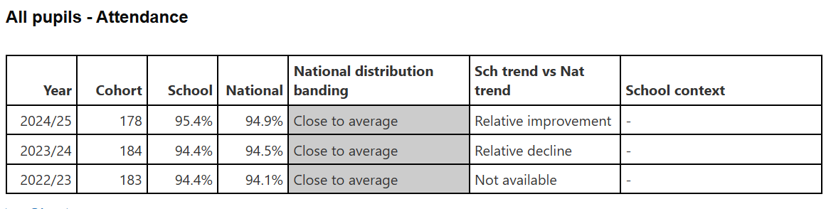

Attendance for FSM6 pupils in school remains above the national average (3-year trend)

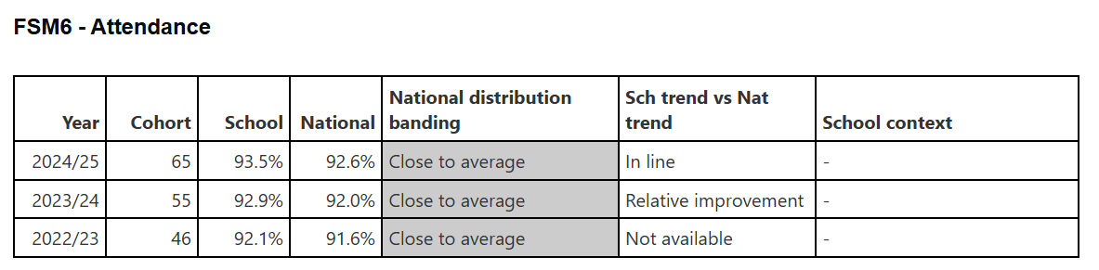

Attendance for SEN pupils in school remains above the national average (3-year trend)

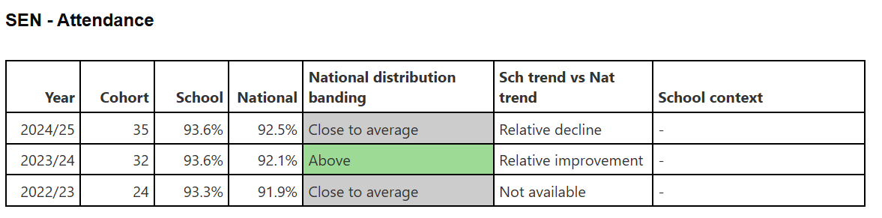

Suspensions and exclusions in school remain below the national average (for all pupils including disadvantaged)
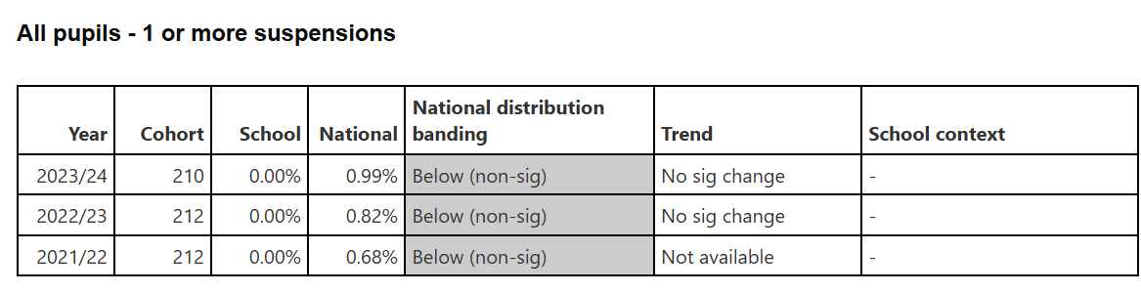

Year 6 data

Combined data for reading, writing and maths is close to the national average and shows an increase in outcomes from 2024 to 2025. (2024 year dip – cohort related)
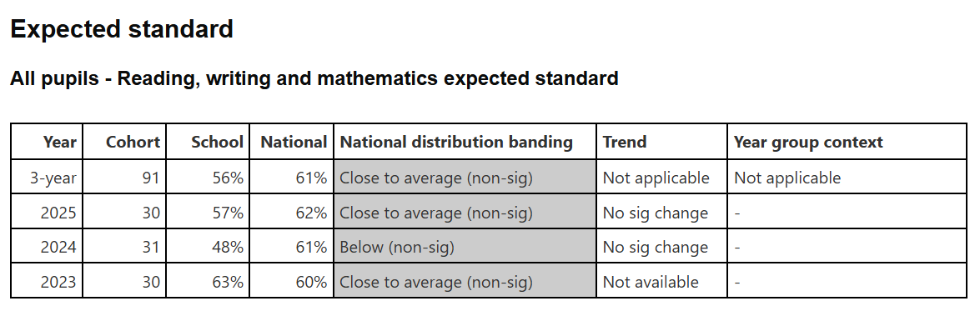

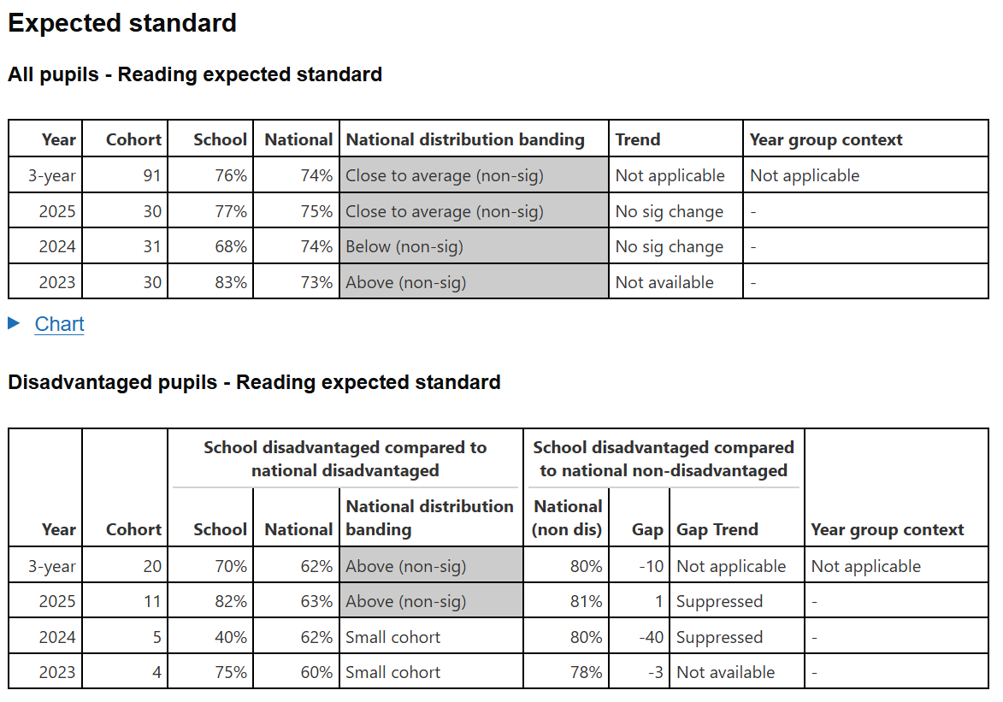
Reading outcomes for all pupils in 2025 were above the national average. The three-year trend is also slightly above the national average. Outcomes for disadvantaged pupils also shows that in 2025 pupils performed well above the national average – there is a positive three-year trend.

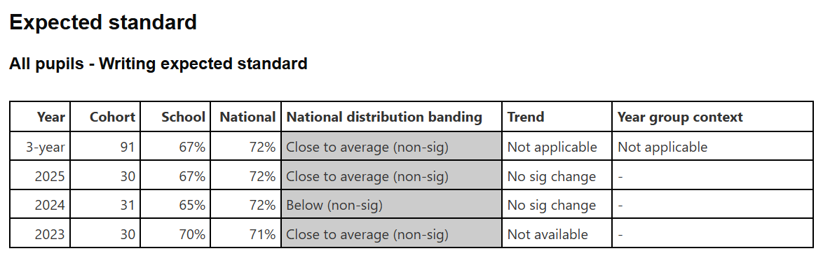

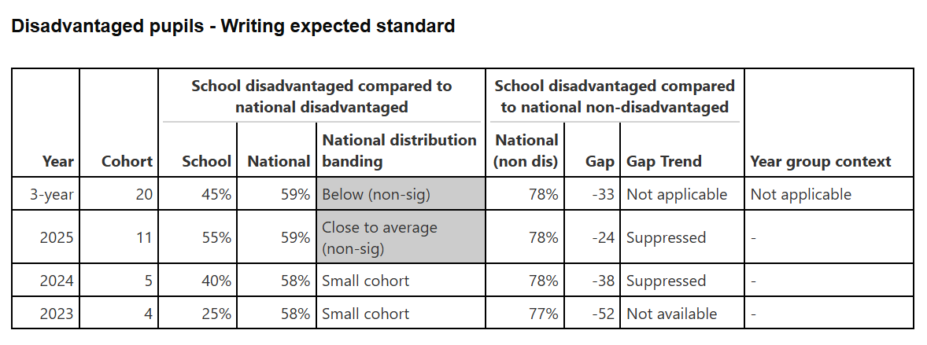

Writing outcomes for all pupils are close to the national average and the three-year trend is also close to the national average. Outcomes for disadvantaged pupils was close to the national average in 2025. The three-year trend shows outcomes are slightly below the national average however outcomes for the school show that pupil outcomes are improving year on year.

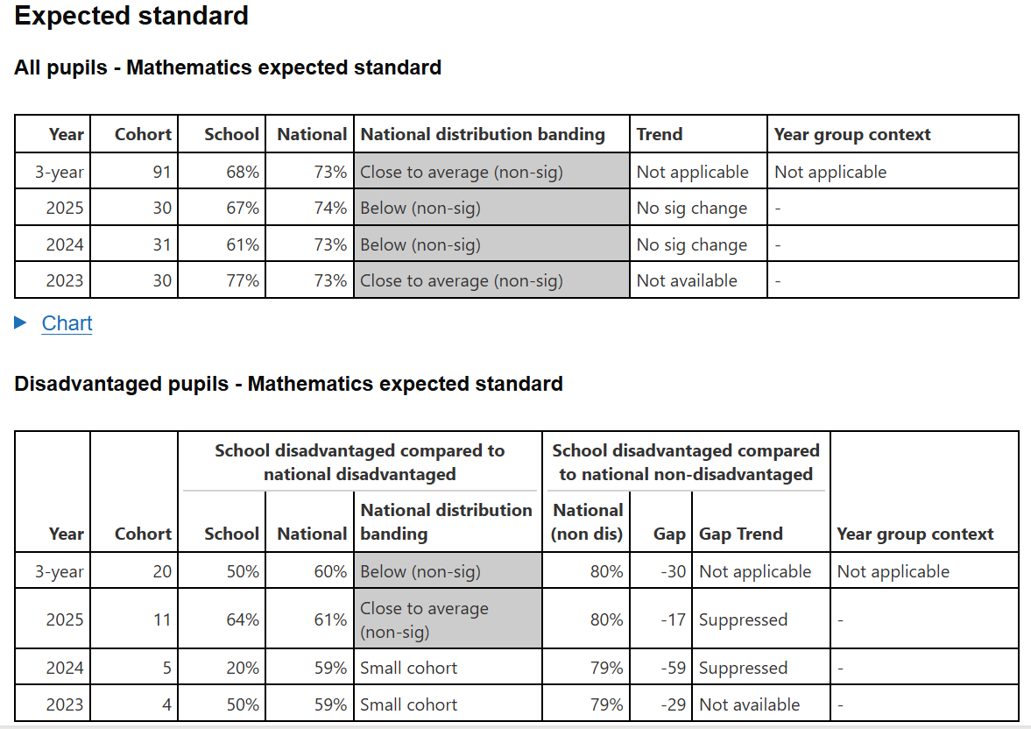

Outcomes in maths for all pupils over the last two years has been below the national average – this is an area of increased focus for 2025 / 2026. Outcomes for vulnerable pupils in 2025 were slightly above the national average however the three-year trend is below the national average.

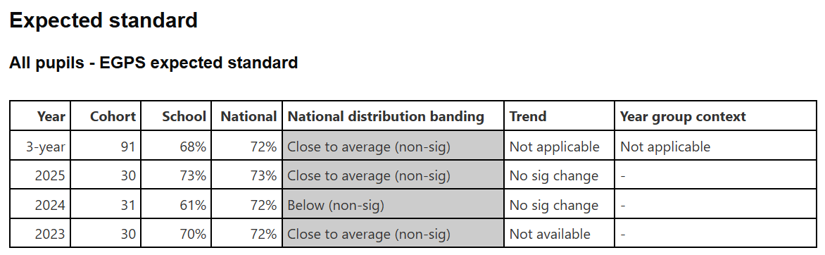

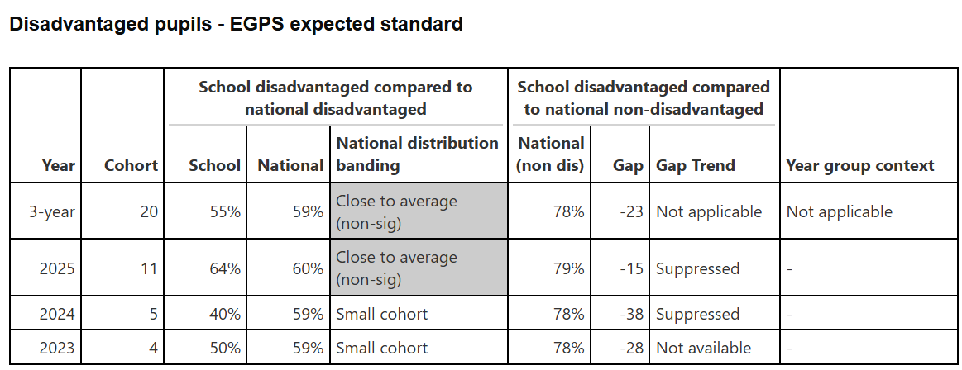

Outcomes in EGPS for all pupils in 2025 were in line with the national average – there is an upward trend from the previous year. Outcomes for vulnerable pupils in 2025 were slightly above the national average – upward trend from the previous year.

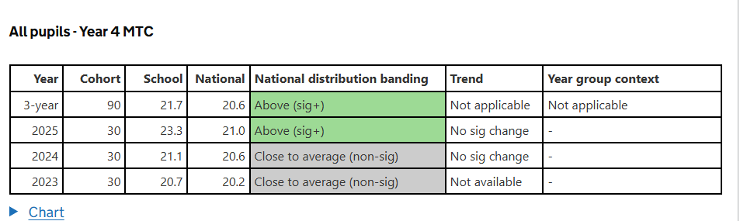

Outcomes from MTC show a positive upward trend for all pupils including vulnerable pupils. Outcomes in 2025

Academic Outcomes

EYFS

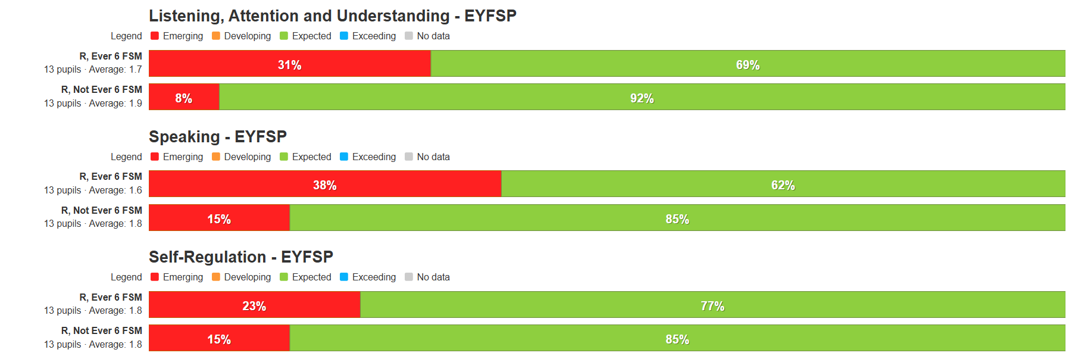

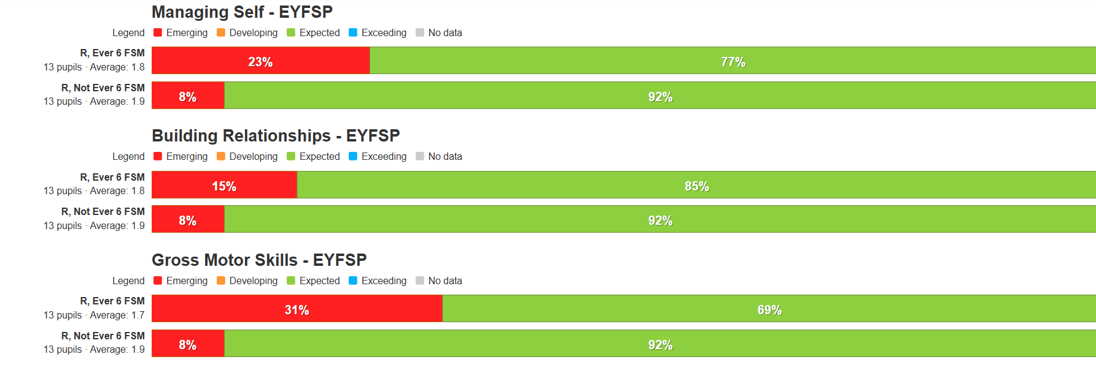

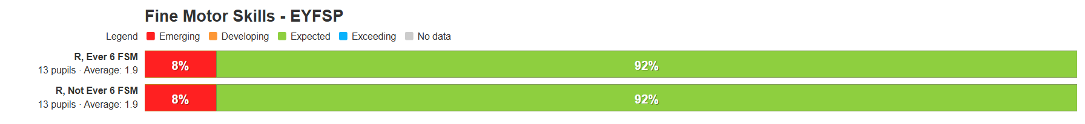

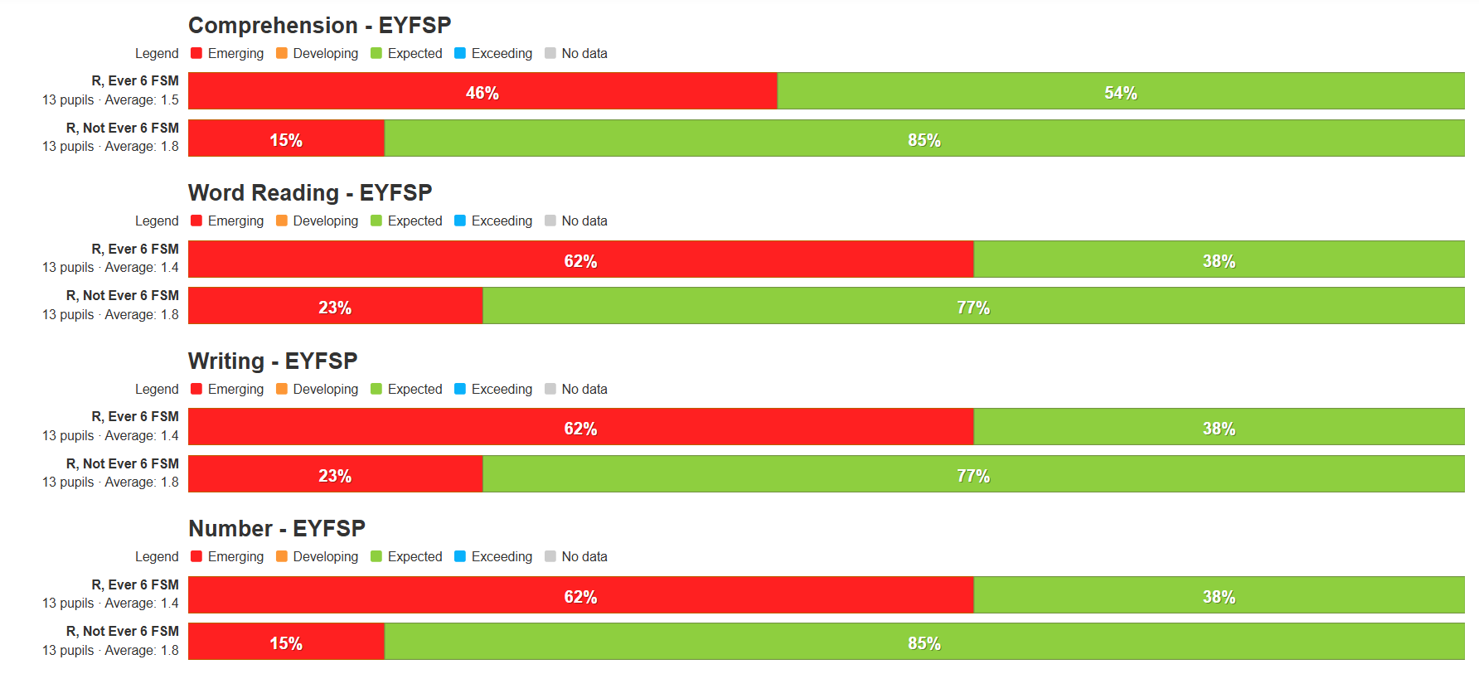

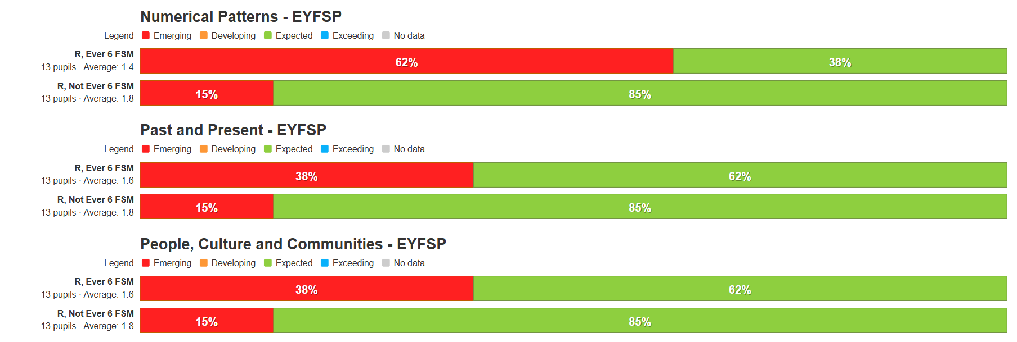

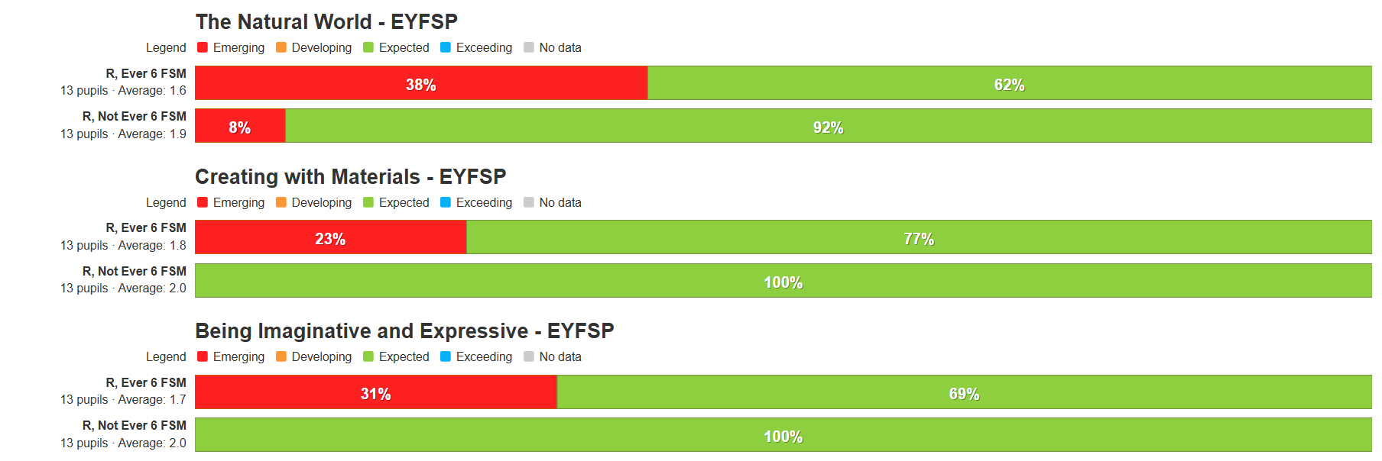

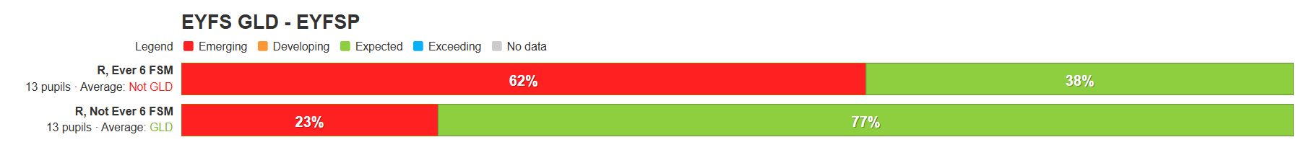

Year 1

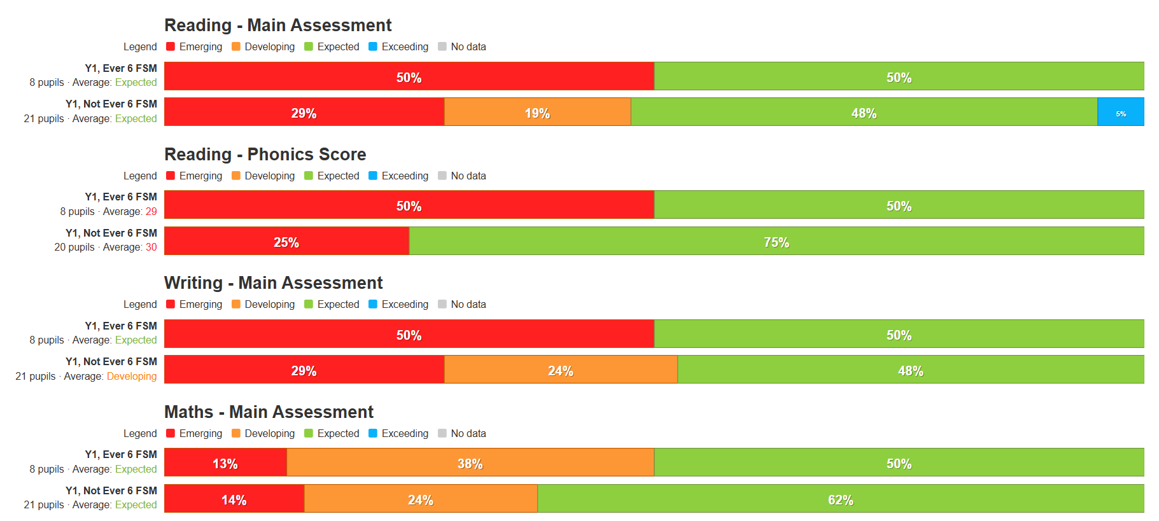

Year 2

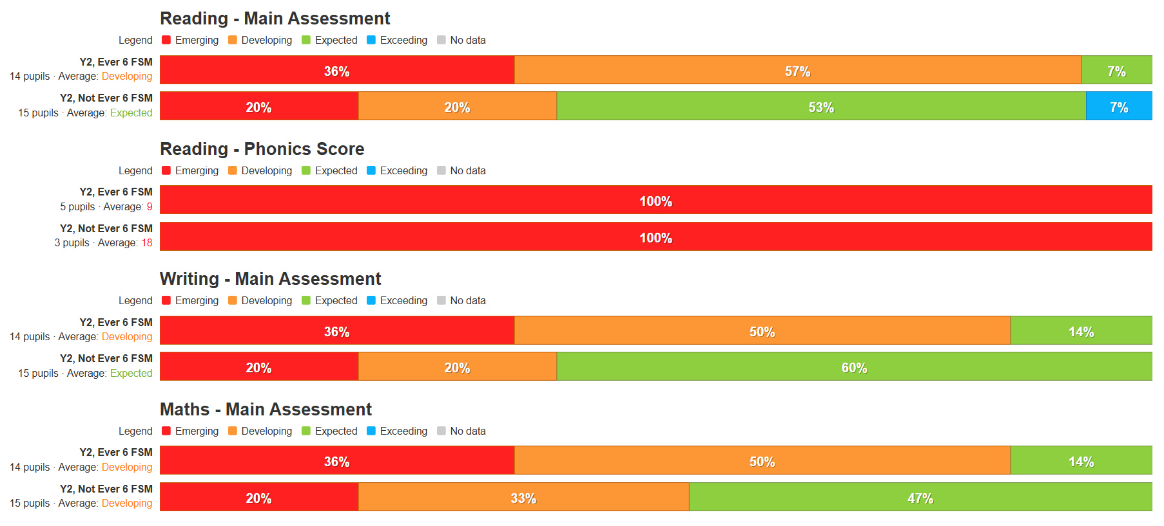

Year 3

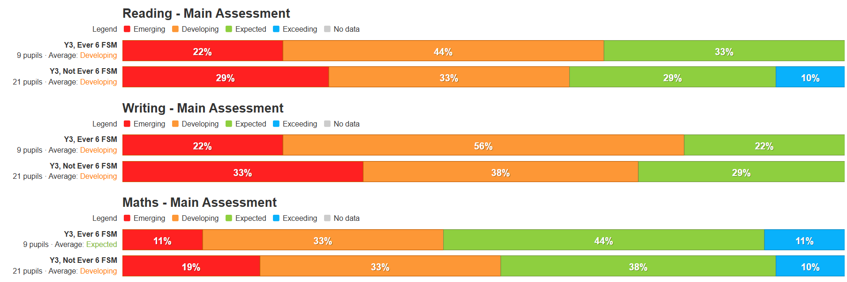

Year 4

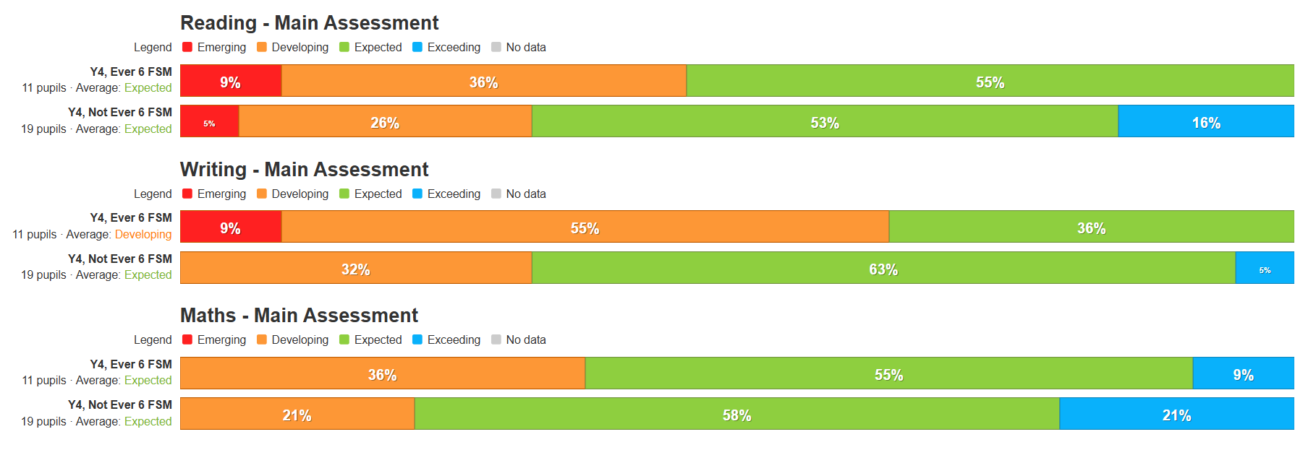

Year 5

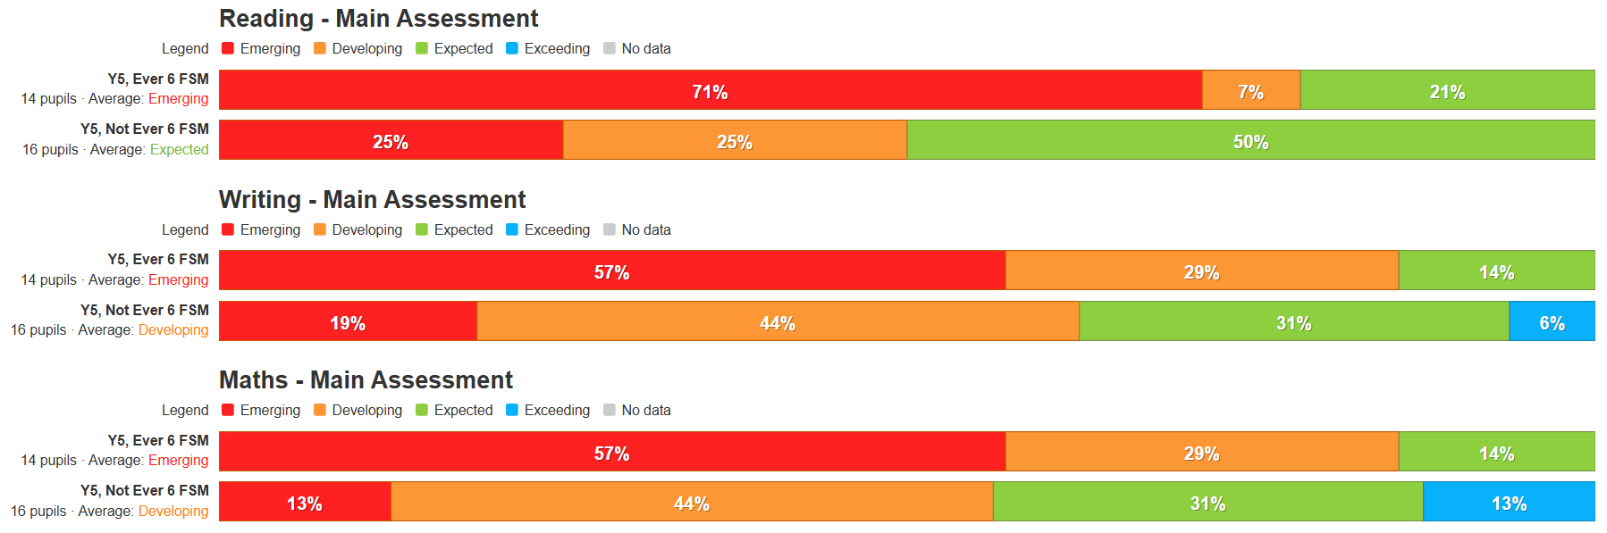

KS2 Support
Targeted Academic Support
- School-led tutoring / intervention support led by Miss Davies (intervention lead) and supported by Mrs Dixon
Write Away intervention to support improving writing skills
Reading comprehension / higher order skills intervention
Arithmetic intervention
Multiplication /times table intervention
- Reading fluency intervention delivered throughout whole year by trained volunteers
- Times Table Rock Stars subscription
- Reading Plus subscription (Year 3 – Year 6)
- Dreambox Maths subscription (Year 4 – Year 5)
- Year 6 booster groups x 3 weekly

Wider Strategies
Family support / Attendance
- Whilst attendance in the LA remains low, school attendance remains around the National Average and has been fairly static since the pandemic. The PSA / SEMH lead works closely with families of PA pupils or pupils at risk of low attendance
- Attendance is regularly reviewed and key information is shared with parents

Pupil support / well-being
Enrichment and enhancement
Aims / outcomes: To promote positive attitude and mental well-being

- THRIVE work continues throughout school
- THRIVE room is available for those children requiring a personal space to regulate
- Additional THRIVE/ nurture rooms have been created as 1:1 / small group activity spaces (including a small sensory room) providing an additional spaces for SEMH lead to work with children (greater need for SEMH support) and further spaces for small group intervention / teaching and learning opportunities – bringing our number of bespoke nurture spaces to four
- Engagement with LA SEMH Team – working alongside team to support specific year groups, individual pupils and staff working in challenging situations
- Regular visits to Forest School for small group of SEN / vulnerable pupils

Counselling Service / SEMH Support: Fund a counsellor, from the Roads Centre, to work in school for one morning each week to support some of the most vulnerable pupils

Aims / outcomes: To promote positive attitude and mental well-being
- Counsellor employed for ½ day a week across the year
- Additional PSA/ SEMH Lead time to assist specific vulnerable children / families

Pre-school care: Free places for those in most need to pre-school club.

Aims / outcomes: Improved attendance and punctuality. Support for working families to access child-care before the working day.
- 50% contribution paid towards Pupil Premium children to attend morning activity club run by Premier Sports (external provider)

Enrichment and Enhancement:
Enhancement of opportunities beyond the normal school curriculum: Opportunities offered to extend learning opportunities outside of the classroom. School to subsidise to ensure access for all pupils

Aims / outcomes: Raise aspirations, improve motivation and engagement and improve self-esteem
- 50% contribution paid towards Pupil Premium children to attend after-school activity club

Subsidised visits: School visits and residential visits subsidised to ensure access for all pupils. Approximately 50% paid towards visits.

Aims / outcomes: Raise aspirations and inclusion for all pupils.
- 50% contribution paid towards Y5 and Y6 residential visits for pupil premium children
- 50% contribution paid towards all visits for pupil premium children
- 50% contribution paid towards swimming for pupil premium children

Music provision: Extend opportunities for pupils to access to the music curriculum, including after school choir

Aims / outcomes: Raise aspirations, motivation and engagement
- High quality music provision provided by peripatetic music specialist (1 day each week)
- Weekly choir session
- Weekly afterschool music club
- Introduction of weekly 1:1 musical instrument lessons (50% contribution paid towards pupil premium children)

Enhance School Environment: Provide outdoor equipment to support structured, safe and engaging outside time which also supports learning

Aims / outcomes: Increase pupil enjoyment, improve behaviour, motivation and engagement
- Purchased additional small equipment for both KS1 and KS2 yard
- Interactive / engaging / activity signs and panels for KS1 and KS2 yard

Externally provided programmes
Please include the names of any non-DfE programmes that you used your pupil premium (or recovery premium) to fund in the previous academic year.
Programme | Provider

Service pupil premium funding (optional)
For schools that receive this funding, you may wish to provide the following information: How our service pupil premium allocation was spent last academic year
The impact of that spending on service pupil premium eligible pupils

Further information (optional)
Use this space to provide any further information about your pupil premium strategy. For example, about your strategy planning, implementation and evaluation, or other activity that you are delivering to support disadvantaged pupils, that is not dependent on pupil premium or recovery premium funding.

