Expressive Arts and Design
We will use the junk modelling area to design and build different forms of transport.
Children will choose colours to use for a purpose e.g. red for a fire engine.
We will act out stories in our play, using available resources e.g. building a space rocket to go to Space.
Children will experiment to create different textures in their work.
We will sing songs and make music linked to journeys to different places.
Children will draw with pencils, pens, crayons, chalks, charcoal on different sized, shaped and textured paper.
Following own ideas and evaluating them.

Personal, Social and Emotional Development
Children will continue to develop their skills in working independently.
We will continue to develop sharing skills in small groups through games and activities.
Children will continue to put coats on and take coats off for outdoor play.
We will be super at tidying up – putting resources away.
Children will speak in a familiar group, sharing their ideas and opinions.
Circle times- we will look at how to be a good friend and what it means to work together as a class

new routines
• Communicate needs to peers and adults.
• Work in pairs and small groups.
• Talk to adults and peers in pairs and small groups.
• Develop independence in choosing activities and putting resources away.
• Learn to take turns.
• In circle time - talk, listen, ask questions, contribute own feelings and ideas.
• Discuss what makes me special, what are my favourite things, people, activities etc.
• Discuss what makes our families special? Important? Who belongs to my family?

Understanding the World
We will be learning about different journeys. The children will be exploring different countries around the world and looking for similarities and differences. We will look at simple maps.
We will be learning about Space and Under the Sea.
The children will be exploring celebrations such as Pancake Day, Valentine’s Day, Chinese New Year and Easter.
Using apps on the I Pads and accessing games on the Clever Touch Boards.
Children will be exploring and investigating signs of Winter and Spring. We will be planting bulbs and flowers in our garden.
Children will cook and look at changes that happen.
Lifecycles

• Explore textures such as wet/dry sand, dough, sand mousse, gravel etc.

• Explore textures such as wet/dry sand, dough, sand mousse, gravel etc.

Additional Information:
We also follow children’s interests throughout topic planning.
Parent’s Evening
Visitors into school
Forest School

Literacy
Children will be reading and understanding simple sentences that they have read.
We will be reading books linked to journeys e.g. Magic Train Ride, My Granny went to Market, Harry’s Home, Man on the Moon, The Train Ride, Commotion in the Ocean, Mr Gumpy’s Motorcar
They will be recognising and writing their name.
Children will be writing for a purpose. They will use their phonic knowledge to write words and begin to form simple sentences, which can be read by themselves and other people. Write cvc and cvvc words.
Holds a pencil effectively to form recognisable letters.
We will have daily Bug Club Phonics sessions to develop reading and writing skills.
Vocabulary Ninja – developing vocabulary.
Developing pencil control through pincer grip activities. Dough Disco! Squiggle while you Wiggle!

Physical Development
We will have climb time on the adventure playground.
We will learn to ride the balance bikes and scooters.
We will use simple tools to effect changes to materials.
Children will form recognisable letters when writing.
We will be showing increasing control over pushing, patting, throwing catching and kicking.
Children will continue to develop their fine motor skills e.g. in the play dough area, dough disco, at the finger gym area using pipettes and tweezers.
Children will use the outdoor equipment to build different types of transport.
Weekly PE Lessons – Gymnastics/Dance (Twinkl) See PE Folder

Journeys MTP
Spring Term
2024


RE Themes
Celebrating, Gathering, Growing, Islam

Mathematics
Maths Mastery
Subitise within 5 focusing on die patterns
Match numerals to quantities within 5
Counting – focus on ordinality and the ‘staircase’ pattern
See that each number is one more than the previous number
Focus on 5
Focus on 6 and 7 as ‘5 and a bit’
Compare sets and use language of comparison: more than, fewer than, an equal number to
Make unequal sets equal
Focus on the ‘staircase’ pattern and ordering numbers
Focus on ordering of numbers to 8
Use language of less than
Focus on 7
Doubles – explore how some numbers can be made with 2 equal parts
Sorting numbers according to attributes - odd and even numbers
Shape, Space and Measure
Compare mass, find a balance, explore capacity, explore length, explore height, talk about time, order and sequence time, recognise, find and use 2D and 3D shapes, identify more complex patterns, copy and continue patterns, patterns in the environment.

Communication and Language
The children will continue to develop speaking and listening skills through discussions linked to our topics and the children’s interests. They will share their own experiences.
Speaking in simple sentences.
Listen to and talk about stories. Talk about what they heard. Using new vocabulary in different contexts

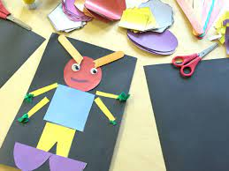
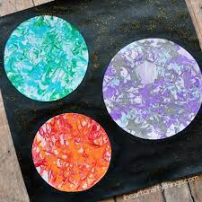

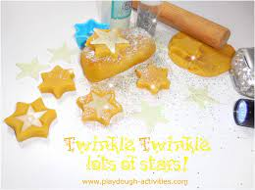
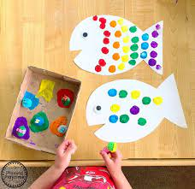
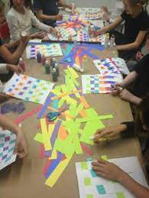
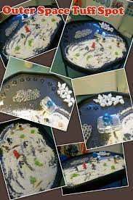
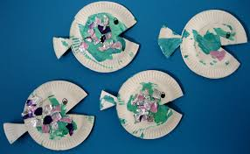

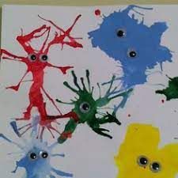
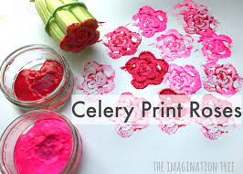

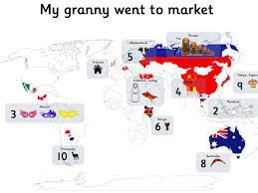
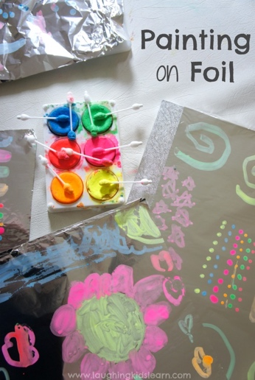
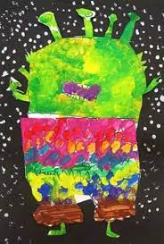

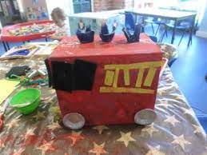

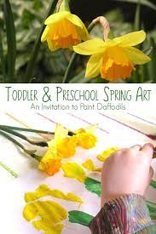
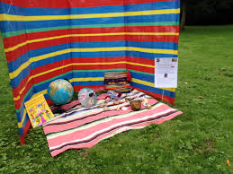
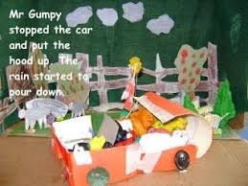

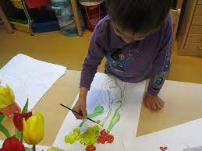
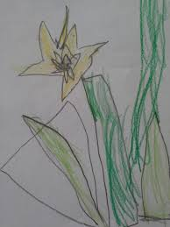
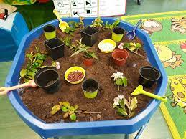
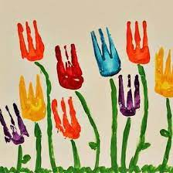
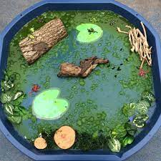

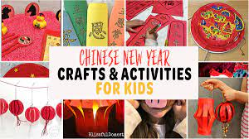
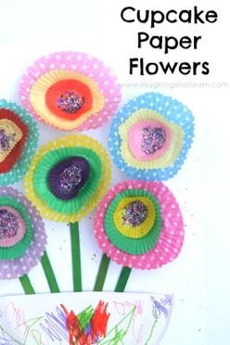
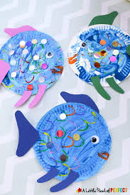
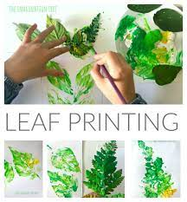
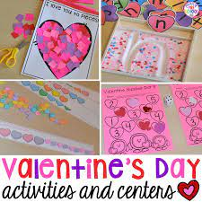

Suggested Books linked to themes: Winter
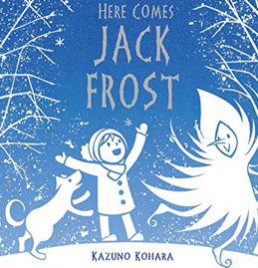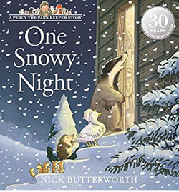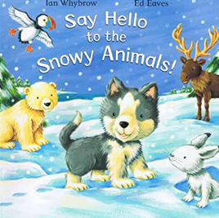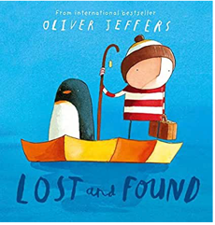
Chinese New Year/Valentine’s Day/Pancake Day
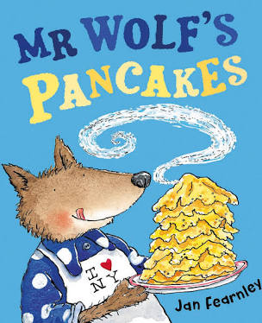
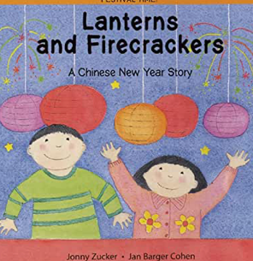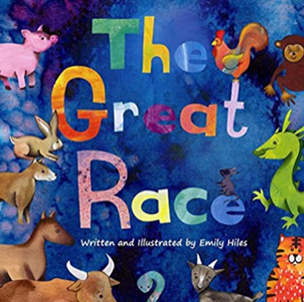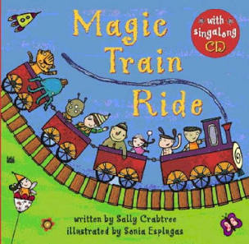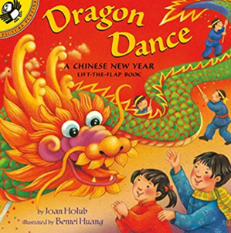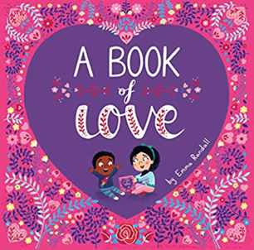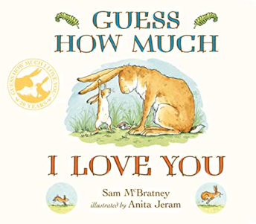
Lifecycles/New Life/Easter:
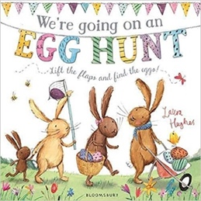
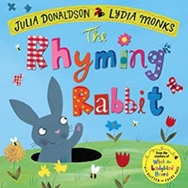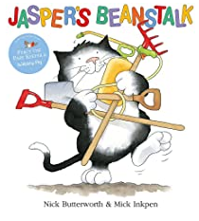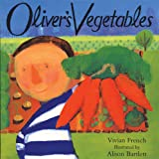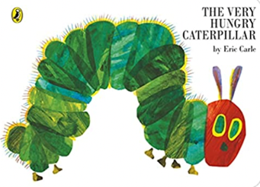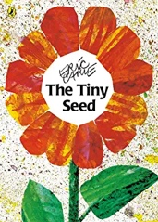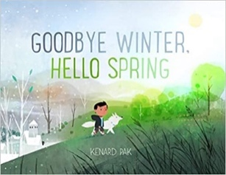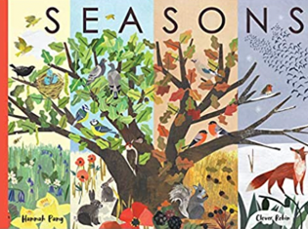

Journeys:
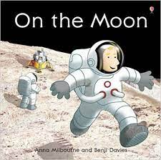
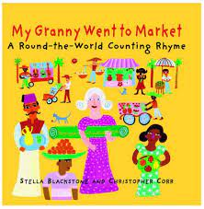
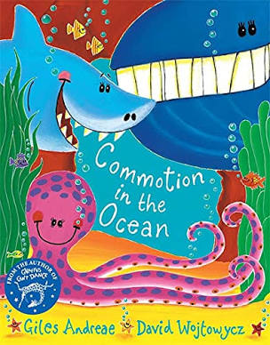
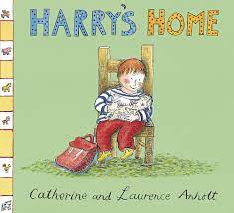
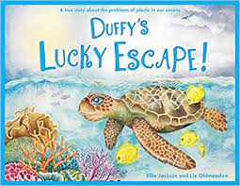
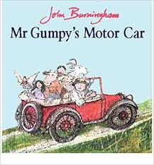

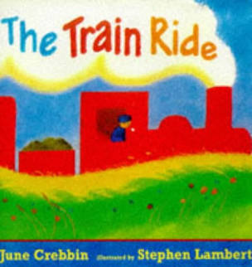

Literacy
Read individual letters by saying the sounds for them.
Blend sounds into words, so that they can read short words made up of known letter-sound correspondences.
Read a few common exception words matched to the school’s phonic programme.
Retell stories in the correct sequence, draw on language patterns of stories.
Suggest how an unfamiliar story read aloud to them might end.
Give a simple opinion on a book they have read, when prompted.
Recognise repetition of words or phrases in a short passage of text.
Play influenced by experience of books.
Innovate a well-known story with support.
Read some letter groups that each represent one sound and say sounds for them.
Read simple phrases and sentences made up of words with known letter–sound correspondences and, where necessary, a few exception words.
Build words using letter sounds in writing.
Use talk to organise describe events and experiences. Begin to write a simple sentence with support.
Spell to write VC, CVC and CVCC words independently using Phase 2 and phase 3 graphemes.
Use appropriate letters for initial sounds.
Orally compose a sentence and hold it in memory before attempting to write it and use simple conjunctions.
Shows a dominant hand. Write from left to right and top to bottom. Begin to form recognisable letters.
See Bug Club Phonics Daily Planning.

Expressive Arts and Design
Develop storylines in their pretend play.
Return to and build on their previous learning, refining ideas and developing their ability to represent them.
Create collaboratively sharing ideas, resources, and skills
Combining different media and skills.
Exploration of natural resources for art - Rubbings of leaves and plants.
Explores and learns how sounds and movements can be changed.
Sings familiar songs (weekly music).
Uses available resources to create props or creates imaginary ones to support play.
Creates representations of both imaginary and real-life ideas, events, people and objects.

Physical Development
Continue to develop their small motor skills so that they can use a range of tools competently, safely, and confidently. Suggested tools: pencils for drawing and writing, paintbrushes, scissors.
Develop the overall body strength, co-ordination, balance, and agility needed to engage successfully with future physical education sessions and other physical disciplines including dance, gymnastics.
Development of threading, weaving, and cutting skills.
Good health – able to say if they are hungry, tired. Dental hygiene.
Own personal hygiene – using the bathroom, dressing and undressing.

Links to Curriculum

Understanding the World
Talk about and understand changes in their own lifetime.
Describe images of familiar situations in the past using books.
Understand the value of being curious and interested in finding out about people within their own community and in other countries - special places and events or objects – through non-fiction texts, stories, visitors, celebrations. Describe special events (Easter).
Comment and ask questions about their immediate environment. Find out more about life cycles. Identify key features of a life cycle of a plant and animal, explain what plants need.
Recognise some environments that are different to the one in which they live e.g., Antarctica.
Use technology and IT equipment to make observations or find information about different locations and places.
Knows how to operate simple equipment e.g. can navigate touch-capable technology with support.
Knows that information can be retrieved from digital devices and the internet.
Completes a simple program on electronic devices.
Personal, Social and Emotional Development
Can show pride in achievements by showing work to others.
Understand behavioural expectations of the setting.
Take pride in themselves, work, and achievements.
Can explain right from wrong and try to behave accordingly.
Can independently manage their own needs.
Can talk about healthy and unhealthy foods.
Consider the listener and takes turns to listen and speak in different contexts.
Identify kindness and considerate behaviour of others. Seek others to share activities and experiences. elaborating play ideas.
Begin to show persistence when faced with challenges.
Knows it is important to work together to look after our classroom resources and our school grounds.
Can keep play going by co-operating, listening, speaking,and explaining.
Can reflect on the work of others and self-evaluate
their own work.
Social skills:
Friendship - Use language to negotiate, play and organise. Knowing what makes a good friend.

Communication and Language
Listen attentively in a range of situations and know how to listen carefully
Maintains attention and concentrates.
Keep play going in response to the ideas of others and engage in conversation relevant to play theme.
happen.
Understanding:
Ask questions to clarify understanding of a text or task. Ask questions to find out more and check understanding.
Retell a story with exact repetition (T4W)

- Understanding:
- Speaking:
- Use talk to pretend objects stand for something else in play.

Mathematics
- See White Rose Hub Planning for SSM and Maths Mastery Planning NCETM.

