St Bede’s
Forest School Handbook
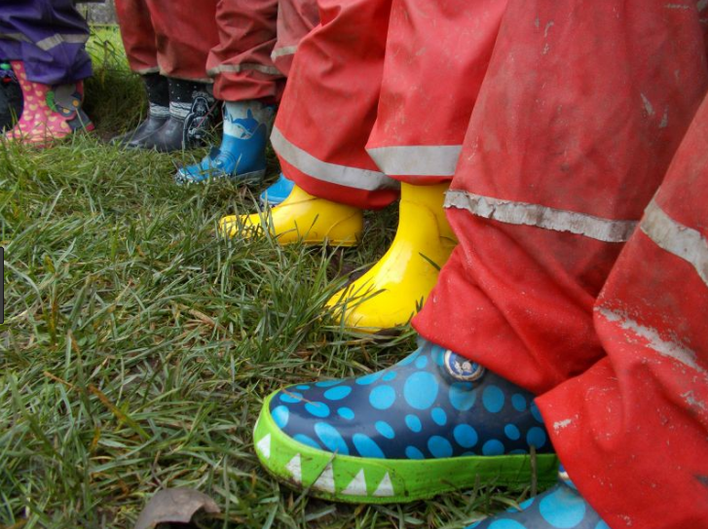

September 2023

Contents
- Introduction to Forest School p3
What is Forest School? p3
Forest School Principles p4
Forest School Approach to Learning p4

- The Pedagogical Approach of Forest School p5
- Roles and Responsibilities p5
Staff / Adult Helpers / Children p5
Ratios p8
Safeguarding p8
First Aid p8

- Clothing and Protective Equipment p9
- Policies and Procedures p11
- Insurance Policy p11
- Risk Management p12
- Normal Operating Procedures p13
- Risk/Benefit Assessments p20
- Site-Specific List of Hazards, Risks and p33
Benefits
- Ecological Impact Assessment p41
Ecological impacts of FS Activities p41
Short History of the Site p43
Scotswood Gardens Site Map p44
Scotswood Gardens Species List p45
- Information to be Shared with Stakeholders p56

Introduction to Forest School

What is Forest School?
Forest School is an inspirational process that offers all learners regular opportunities to achieve and develop confidence and self-esteem through hands-on learning experiences in a woodland or natural environment with trees.
Forest School is a specialised learning approach that sits within and complements the wider context of outdoor and woodland education. The ethos is shared by thousands of trained practitioners across the UK and beyond. Its roots reach back to early years pioneers in outdoor learning in Scandinavia.

At Forest School all participants are viewed as:
- equal, unique and valuable
- competent to explore & discover
- entitled to experience appropriate risk and challenge
- entitled to choose, and to initiate and drive their own learning and development
- entitled to experience regular success
- entitled to develop positive relationships with themselves and other people
- entitled to develop a strong, positive relationship with their natural world

(Forest School Association)

Forest School Principles
The Forest School Association has clarified the pedagogy into six clear principles:

- FS is a long-term process of regular sessions, rather than a one-off or infrequent visits; the cycle of planning, observation, adaptation and review links each session.
- FS takes place in a woodland or natural environment to support the development of a relationship between the learner and the natural world.
- FS uses a range of learner-centred processes to create a community for being, development and learning.
- FS aims to promote the holistic development of all those involved, fostering resilient, confident, independent and creative learners.
- FS offers learners the opportunity to take supported risks appropriate to the environment and to themselves.
- FS is run by qualified Forest School practitioners who continuously maintain and develop their professional practice.

(Institute for Outdoor Learning, 2012)

Forest School Approach to Learning

The aim of our Forest School sessions at St Bede’s is to offer pupils regular and meaningful opportunities to spend time outdoors in our local woodland, Scotswood Gardens. The aim of the session leader is to provide a safe, fun and supportive environment that promotes opportunities to nurture all pupils’ holistic growth through child-led play, exploration and discovery. At St Bede’s, our Forest School ethos is to promote a culture based on collaboration and of embracing challenge in order to strengthen pupils’ character, resilience and empathy and to gain a deeper connection with nature. With close adult guidance, pupils will learn to assess, appreciate and manage risks in order to make sensible and informed decisions about how to approach a wide variety of activities and experiences that they encounter and to cooperate with others.

The Pedagogical Approach of Forest School
“Tell me and I forget; Teach me and I may remember; Involve me and I learn.” Benjamin Franklin

The Forest School approach to learning is closely entwined with the EYFS concepts of child-initiated exploration and learning through play. During Forest School sessions, pupils are given space to explore their natural environment and direct their own learning. They are encouraged to make mistakes, engage in risky play and think outside of the box. Whereas keeping children safe is a primary concern, we strive to provide children with rich opportunities to develop creativity, imagination, resilience and confidence through engaging in some risky play.
Pupils are encouraged to regularly review and reflect upon their Forest School activities and experiences, both during our sessions and within the classroom. Feedback from learners is used to inform future sessions which further build upon prior skills, knowledge and understanding.

Roles and Responsibilities

Staff

Katy Décube Forest School Leader (Class Teacher)
Forest School OCN Level 3 in Forest School Leadership (March 2020)
Outdoors and Paediatric First Aid Certificate (2 Day) (June 2022)

- To have an up-to-date First Aid qualification.
- To ensure the First Aid kit is suitable stocked.
- To ensure an individual’s medication is brought, if needed.
- To comply with Health and Safety risk assessments.
- To maintain an accident book and ensure all parents are fully informed of any incidences that occur during a session.
- To ensure all relevant documentation is up-to-date.
- To ensure all adult helpers understand their role in line with St Bede’s Safeguarding Policy.
- To ensure all adults have a charged mobile phone and list of emergency numbers (including the school office and mobile number).
- To always have an up-to-date class register.
- To share plan and risk benefit assessments with all adults.
- To ensure (where possible) all risk assessments have been completed.
- To ensure all parental consent forms have been signed.
- To ensure all equipment is maintained and safe to use.
- To ensure all Forest School Policies are regularly reviewed and updated accordingly.
- To ensure all children, staff and helpers are appropriately dressed for all weathers.
- To ensure some extra warm clothing and refreshments are brought to all sessions.

Wendy Curry Forest School Assistant (Teaching Assistant)
Forest School OCN Level 1: Introduction to Forest School Principles (March 2019)
- To be aware of all relevant risk/benefit assessments, Health and Safety regulations and the Emergency Action Plan.
- To know the content of the session plan and which routes will be used to both access and walk around Scotswood Gardens.
- To carry a copy of the emergency contact numbers.
- To have a fully charged phone.
- To support learning and development during Forest School sessions.

Adult Helpers
- To be aware of all relevant risk/benefit assessments, Health and Safety regulations and the Emergency Action Plan.
- To be aware of the location of the First Aid kit.
- To know the content of the session plan and which routes will be used to both access and walk around Scotswood Gardens
- To support learning and development during Forest School sessions.
- To carry a copy of the emergency contact numbers.
- To have a fully charged phone.
- To ensure that appropriate clothing is worn at all times.
- To ensure they are never left alone with a child. A member of school staff must always be present.
- To be aware they are duty bound under the Health and Safety at Work Act to work safely, take responsibility for their own safety and the implications of their actions, and report or remove hazards as they occur.
- To report any concerns to a member of staff immediately.

Children
- To take personal responsibility for their own safety as well as the safety of others.
- To listen to and follow all rules, routines and boundaries.
- To walk in double-file to our Forest School site, holding hands with their partner.
- To always stay in sight / ear shot of an adult.
- To always go to the adult who calls, “1, 2, 3, come to me!”
- To bring appropriate clothing and footwear to all Forest School sessions.
- To help to carry equipment when necessary

Ratios
The Department for Children Schools and Families (DCSF) recommend the following staffing ratios as a general guide for off-site visits, however higher ratios of adults to children may be appropriate during some Forest School sessions in order to ensure that the children have access to elements of risk taking in a safe and supported environment.

As a minimum, the following adult to child ratios will apply during Forest School sessions:

EYFS | 1:4
Y1-3 | 1:6
Y4-6 | 1:10

Individual risk assessments will be carried out for Forest School activities. When any associated hazards are identified at risk of causing harm, ratios will be reviewed accordingly.

Safeguarding

All members of staff are DBS checked. All adult helpers involved in Forest Schools are required to sign and date a form to show that they have read the Forest School Handbook, appropriate risk assessments and understand to comply with the health and safety guidelines.

First Aid

At least one member of staff will hold an Outdoors and Paediatric First Aid certificate and be aware of the special educational or medical needs of any member of the group. In case of an incidence requiring further assistance, our school office will get in touch with the child’s named emergency contact.
The First Aid kit contains the following:-
- Instant ice packs
- Antiseptic wipes
- Eye irrigation solution sachets
- Jumbo plasters, medium plasters, small plasters
- Triangular bandages
- Large and small self-adhesive wound dressings
- Crepe bandages
- Pairs of protective gloves
- Eye pads
- CPR face shield
- Foil Blanket

The Forest School Leader will ensure the first aid kit is adequately stocked and replenished. A summary of medical information and emergency phone numbers will also be carried by the Forest School Leader.

Clothing and Protective Equipment

“There is no such thing as bad weather, only inappropriate clothing!”
Alfred Wainwright

To ensure our pupils are comfortable and prepared for Forest School, they will need to be appropriately dressed for all weathers. Some items of clothing (highlighted below) will be provided by school, whereas others will be provided by pupils/parents.

All weathers
- Trousers
- Long sleeved top
- Wellies, trainers or walking boots
- Socks
Wet weather
- Waterproof jacket
- Waterproof trousers (or all-in-one suit)
- Wellies
Colder weather
- An additional warm jumper
- Scarf
- Hat
- Gloves
Sunny weather
- Sun hat
- Sun cream

Children are asked to provide their own sun cream. Staff can assist EYFS and Y1 children with the application of sun cream, as outlined in our Parent Handbook.

Policies and Procedures

Relevant school policies | Amendments required? (y/n) | Overview of amendments
Adult Volunteer Policy | Y | Supporting Forest School sessions
Health, Safety and Well-being | Y | Accidents at Forest School,  Fire Safety, Medication, Risk Assessment
Intimate Care Policy | Y | Toileting at Forest School
Non Smoking Policy | Y | No smoking during sessions
Staff Handbook | Y | Fire procedures, First Aid, Uniform
Security Policy | Y | Uninvited stranger on site
Special Educational Needs Information Report | Y | Adaptions to programme of Forest School activities
SEN and Disability Policy | Y | Adaptions to programme of Forest School activities

Insurance Policy

Insurance provider: Insurance provider is RPA (through DFE)

Policy Number: 148446

Policy expiry date: 31st August 2023

Risk Management

The Forest School Philosophy of Risk-Taking

Cultural perceptions of risk within UK culture have influenced attitudes towards childhood over the last 30 years. According to Connolly & Haughton (2017), young children of today are viewed as ‘vulnerable and in need of adult protection’ and this in turn has led to a decline in outdoor, unsupervised play for children (Play Safety Forum, 2017). Not only have perceptions of risk considerably altered with time, but a culture of blame has also developed within our increasingly litigious society. Coupled with growing pressure about safety from parents, practitioners are often, unsurprisingly, reluctant to expose children to risk within play, especially in the outdoor environment.
It is the Forest School philosophy, however, that involving children in recognising and managing their own risk is empowering and encourages greater opportunities for exploration. It is recognised that in equipping children with skills to manage risk in their play, it promotes safety in new situations and encourages children to make meaningful links in their learning.

Risk Management at St Bede’s
At St Bede’s, all Forest School activities will be measured according to a risk vs. benefit assessment, in which potential harms and gains are considered together (See sections I and J). In carrying out risk/benefit assessments it is hoped that staff and adult helpers can move beyond fears and anxieties associated with risky play. During our Forest School sessions we will strive to nurture children’s have-a-go attitudes and encourage risk-taking within an environment in which the children feel secure, confident and happy.

In addition to completing risk/benefit assessments for all planned activities, the Forest School Leader must ensure that:
- All relevant risk assessments are adapted and uploaded to the EVOLVE system prior to Forest School visits.
- All staff and adult helpers are fully aware of the activities and amenities linked to the visit to the Forest School site.
- In case of an emergency, school is contacted immediately so that parents can be informed as required.
- The school mobile phone is taken on all off-site visits and used in case of an emergency to contact school.
- Any medication e.g. inhalers are taken to Forest School sessions and carried by the Forest School Leader.
- Equipment is checked regularly for wear and tear.
- A pre-session site checklist is carried out before each Forest School session to ensure no new risks are present (e.g. litter, broke glass, dog foul, damaged trees). Any new hazards such be assessed and action taken accordingly.
- Any incidences should be recorded and evaluated accordingly.

Normal Operating Procedures

Toileting
All children will be encouraged to use the toilet before we leave school for each Forest School session. Should a child need to ‘go’ to the toilet during a session, pupils may do so in the compost toilets within Scotswood Gardens. EYFS staff will support Foundation Stage pupils with their toileting needs, where required, in line with their responsibilities within their job description.

Timings
Each Forest School session will run for 2 hours. It takes approximately 20 minutes each way to walk with the children to the Forest school site. This will allow 1 hour 20 mins at Scotswood Gardens itself.

Boundaries
Children will be involved in the risk-management process of establishing and marking out appropriate boundaries within our Forest School site and will be reminded of these at the beginning of each session. Should a child wish to go beyond the boundary, they will need to get permission from a member of staff to do so. In order to reinforce expectations of behaviour, build trust and establish our Forest School boundaries, children will be taught a game in the first session (“1, 2, 3, come to me!”).

The Forest School site map show any areas that are out of bounds or particularly hazardous (e.g. areas of water/ vandalism)

Roles
(See Section C – Roles and Responsibilities)

Travel
Pupils will walk in double file to the Forest School site. The Forest School Leader is responsible for road safety and must stand in the middle of the road to ensure that traffic is stationary until all children have crossed safely. Scotswood Garden is based in the grounds of the John Marley Centre in Scotswood. The children will enter into Scotswood Gardens via a brown gate to the far left hand side of the front entrance (right at the end of the left wing of the building).

Emergency Action Plan
Prior to Forest School sessions, one member of school staff should be identified who can be contacted in the event of an emergency. This person must be adequately prepared to support the Forest School Leader and have access to documentation related to the trip (e.g. a list of all attendees, contact details for the group and parents/carers). A back-up contact should also be identified.

First Aid Incident
In the case of a medical emergency, an adult will blow the emergency whistle three times and the pupils will congregate in the agreed meeting point.
- The qualified Outdoor and Paediatrics First Aider will attend to any casualties.
- If necessary the emergency services will be contacted (see below).
- An additional adult will ensure that the rest of the group is kept safe.
- Where appropriate, the casualty’s next of kin will be informed via the school office.
- Minor accidents are to be reported in the First Aid book. More serious accidents are to be recorded on an Accident Report Form.
In the event of requiring the Emergency Services (999), the following information will be required:
- Address of the Forest School site, including the postcode (Scotswood Garden, Yewcroft Avenue, Newcastle upon Tyne, NE15 6TU)
- School mobile number (07594157864)
- School Office number (0191 2743430)
- What has happened.
- Patient's age, sex and medical history
- Whether the patient is conscious, breathing and if there is any bleeding or chest pain
- Details of the injury and how it happened.
The nearest hospital to Scotswood Garden is the Royal Victoria Infirmary, Queen Victoria Road, Newcastle upon Tyne, NE1 4LP.

Illness of Staff or Children
Any member of staff or child who feels unwell will be asked to stay at school. An additional member of staff will be brought from school to maintain correct adult to pupil ratios.
If a member of staff feels unwell during a Forest School session, then the following procedure should be followed:
- Sit down with extra layers on if cold, or in the shade if warm.
- School office to be contacted and a member of staff to be sent to find the group.
- The person who is unwell should return to school, if they are able to do so, and the new member of staff should take their place.
- Staff to phone Forest School Leader to let them know that they have returned safely.
- If the staff member needs accompanying back to school, then two staff members should be sent.

If a child feels unwell during a Forest School session, then the following procedure should be followed:
- Sit down with extra layers on if cold, or in the shade if warm.
- School office to be contacted and a member of staff to be sent to find the group.
- This member of staff should take the unwell child back to school, or contact school to phone parents to collect if unable to walk.
- Staff to phone Forest School Leader to let them know that they have returned safely.

Unplanned Fire
There will be times when the children take part in fire building activities at Forest School. Any small fire that has occurred as a result of a Forest School activity should be extinguished using water until all smoke and steam has ceased, or stamped out if deemed safe and appropriate to do so, by the Forest School Leader.
In the event that a fire gets out of control or is unplanned, the following procedure should be followed:
- Give instructions clearly and calmly, in a real emergency children will need reassurance
- If the fire is too big to be extinguished, the group should be moved to a safe place and all children and staff accounted for.
- Children using toilets will be escorted by a member of staff to the nearest exit and report to the Forest School Leader at their assembly point
- The fire brigade must be contacted.
All adults need to be aware of the different routes out of the site, as an alternative route may be necessary, should the fire have spread.

On Reaching the Fire Assembly Point:

- Ensure adults and children are silent and orderly so that they can be counted and checked by calling the register
- Missing children’s names should be given to the Forest School Leader who will take the necessary action.
- Order and calm is to be maintained whilst awaiting further instructions from the Forest School Leader or fire officers
- DO NOT ALLOW CHILDREN TO RE-ENTER THE SITE

Registers
It is important that registers are kept accurately and up to date. Anyone leaving early for such things as dental appointments should be signed out by the Forest School Leader. Anyone who arrives late should be marked as present.

Fire Safety Policy
Some staff will be asked by the Forest School Leader to check areas of the site, although maintaining personal safety will be paramount. The above is an attempt to ensure a swift and safe evacuation in an emergency. A degree of flexibility is necessary as it is impossible to anticipate the form that every single incident will take.

Dogs
Children are informed never to approach anyone or any animal in the woodland setting. In the event of a dog entering our Forest School site, the children will respond in the way in which they have been taught to:
- Call out ‘Dog!’ to warn others, especially to those who are afraid of dogs.
- Stand still with their arms crossed over their chest and looking up to the sky, until the dog has gone.
- If a dog is lost in the area of the group then an adult should tether the dog and look for an owner.
- If a dog attacks anyone in the group, do not approach the front of the dog, grasp the tail and pull backwards.
- The police must be informed of any attacks made by a dog.

Uninvited Stranger on Site
Scotswood Gardens is a public area and it is therefore reasonable to expect to come into brief contact with some members of the public. In the event of an uninvited, lingering stranger on site, however, they will politely be asked to leave. If they refuse to do so and the Forest School leader feels that the children are at risk, the school group will immediately leave the site.

Missing Child
In the event of a missing child, the following procedure should be followed:
- Forest School leader will call “1, 2, 3, where are you?” If the child does not appear, the immediate vicinity will be searched.
- While the initial search is made, the Forest School leader will make enquiries of all adults to establish the last sighting and time, clothes that the child was wearing, and the mental state of the child (happy, upset etc.)
- The school office will be informed immediately and this information will be shared with the Head Teacher, who will then decide what action to take.
- Telephone lines should remain as free as possible so that messages are not delayed.
- The activities for the remaining children will continue as normal and staff not involved in the search will attend to the needs of the group.

Death / Serious Injury
In the event of death / serious injury, the following procedure should be followed:
- Appropriate First Aid administered. The qualified Outdoor and Paediatrics First Aider will attend to the casualty whilst another adult removes the rest of the group from the vicinity, ensuring they are kept safe.
- The emergency services will be called immediately.
- The school office will be informed straight away
- This information will be shared with the Head Teacher, who will notify the parents respectively.
- No-one in the group must speak to the media. Any enquiries from journalists must be referred to the Head Teacher.

Risk/Benefit Assessments

Likelihood x Severity = Risk
Likelihood  - Will hardly ever happen or will only happen in extraordinary circumstances  - Will happen rarely  - Will happen occasionally  - Will happen most times the activity is undertaken  - Will happen every time the activity is undertaken |  | Severity  - No adult intervention beyond reassurance  - First Aid on site  - Non-emergency hospitalisation  - Emergency hospitalisation  - Fatality
1-5  Acceptable risk | 5-12  Acceptable Risk, however consider ways to reduce risk |  | 12+  Unacceptable risk unless mitigating circumstances. Consider ways to reduce risk

Hazard/  Activity | Benefits | Risk | Population at risk | Risk assessment (likelihood x severity after control measures) |  |  | Control Measures (Action by: Forest School Leader responsible for implementing control measures and communicating with other adults who should reinforce)
Bill hook | + Opportunity to learn new skills  + Opportunity to engage in risky play  + Used in woodland craft activities  + Sense of achievement and mastery  + Teamwork  + Communication  + Problem-solving skills | Cuts fingers / hands | All | 2 | 2 | 4 | FS Leader to give clear instructions on usage and handling through Tool Talk.  Adult supervision until FS leader is satisfied that user is safe and competent  Ensure adult to children ratios are appropriate to needs of group  Ensure saw is always parallel to body when in use  Use 2 arm and a tool length from others (except work partner)  Designated areas allocated for each group to work in  Clear site of obstacles  Communication with partner modelled and insisted upon  First Aid kit on site at all times  Tools counted in and out  List of emergency contact details
 |  | Large cuts (risk of infection) | All | 2 | 4 | 8 | (As above)
 |  | Losing digits | All | 1 | 4 | 4 | (As above)
 |  | Slips/trips | All (mainly children) | 2 | 3 | 6 | Everyone shown correct procedure during Tool Talk for walking with and handling tool.  Check ground for any trip hazards and remove or make children aware.  Adults and children must always be wearing appropriate footwear
 |  | Straining of back, arm or shoulder muscles | All | 2 | 3 | 6 | Children to work in pairs and take turns  Use a mallet to help drive bill hook through wood
 |  | Misuse of tool as weapon | All | 1 | 5 | 5 | .Children must earn trust through demonstrating an ability to follow rules and boundaries in Forest School sessions before being allowed to use tools
Bowsaws | + Opportunity to learn new skills  + Opportunity to engage in risky play  + Used in woodland craft activities  + Sense of achievement and mastery  + Teamwork  + Communication skills  + Problem-solving skills | Small cuts to hands, arms, body, legs, face | All | 2 | 2 | 4 | FS Leader to give clear instructions on usage and handling through Tool Talk.  Adult supervision until FS leader is satisfied that user is safe and competent  Ensure adult to children ratios are appropriate to needs of group  Use a glove on non-tool hand  Ensure saw is always on outside of the body when in use  Use 2 arm and a tool length from others (except work partner)  Clear site of obstacles  Communication with partner modelled and insisted upon  First Aid kit on site at all times  Tools counted in and out  List of emergency contact details
 |  | Large cuts (risk of infection) | All | 2 | 4 | 8 | (As above)
 |  | Severing of femoral artery | All | 1 | 5 | 5 | (As above)
 |  | Slips/trips | All (mainly children) | 2 | 2 | 4 | Everyone shown correct procedure during Tool Talk for walking with and handling tool.  Check ground for any trip hazards and remove or make participants aware.  Adults and children must always be wearing appropriate footwear
 |  | Misuse of tool as weapon | All | 1 | 5 | 5 | Children must earn trust through demonstrating an ability to follow rules and boundaries in Forest School sessions before being allowed to use tools
 |  | Straining of back, arm or shoulder muscles | All | 2 | 2 | 4 | Children to work in pairs when sawing  Saw horse made from wood to be used
Blindfold games | + Building trust  + Teamwork  + Enhances personal, social and emotional development | Tying the blindfold too tight | All | 3 | 1 | 3 | Blindfolds to be used out of soft materials  Blindfolds to be checked and washed regularly
 |  | Slips/trips | All (mainly children) | 3 | 2 | 6 | Ensure children watch out for trip/slip hazards  Teach children to communicate with their partner about hazards  Adults to monitor the activity  Adults and children must always be wearing appropriate footwear
 |  | Walking into trees/branches | All | 3 | 3 | 9 | (As above)  Make children aware of dangers when blindfolded and the hard that could be caused by leading someone to a hazard  Assess area before commencing activity
 |  | Head and body injuries | All | 3 | 3 | 9 | Encourage the leader to take responsibility for their partner’s well-being throughout the activity
Clay / mud / soil | + Fun to play with  + Great ‘loose part’ for creative activities  + Learning about the properties of soil  + Great medium for creative activities (mud paint) | Toxoplasmosis | All (especially pregnant women) | 2 | 3 | 6 | Caution to be taken when handling earth, particularly where litter is present.  Protective gloves worn if necessary.  Identify an area of soil/mud that is suitable for playing in.  Hands washed after use.
 |  | Infection | All | 1 | 4 | 4 | (As above)  First Aid kit on site at all times  Ensure any cuts are appropriately cleaned
 |  | Cuts/grazes | All | 3 | 2 | 6 | (As above)
Fires | + Opportunity to learn new skills  + Opportunity to engage in risky play  + Sense of achievement and mastery  + Teamwork  + Communication  + Problem-solving skills  + Learning about the dangers of fire  + Understanding the importance of not leaving a lit fire  + Fun and exciting | Smoke in eyes | All | 5 | 1 | 5 | Children advised to turn head to the side, placing their hands across their face, to close their eyes and count to 30  If there is a clear wind direction, avoid seating children in the line of smoke  Fires will not be lit in strong winds
 |  | Burns (smaller than the size of a stamp) | All | 3 | 2 | 6 | Children and staff given safety talk and shown safe fire lighting procedures.  Wear gloves for lighting and feeding fire  Sticks placed on fire, not thrown  High adult/child ratios  Wear non-flammable clothes  Water present to be used to extinguish flames  First aid kit on site at all times  List of emergency contact details
 |  | Burns (larger than the size of a stamp) | All | 2 | 3 | 6 | (As above)  Only FS leader to extinguish fire whilst children remain seated. Pour water on flames in a circular motion starting at the outer edge and working in.
 |  | Falling into the fire | All | 1 | 5 | 5 | (As above)
 |  | Cuts/grazes/splinters | All | 2 | 2 | 4 | Remind children to be careful when handling wood. Use gloves where possible.  Careful not to poke anyone in the eye when toasting marshmallows.
 |  | Slips/trips | All (mainly children) | 3 | 2 | 6 | Everyone shown correct practice by walking around outer side of log circle, and never within it. This is demonstrated before fire is lit.  Adults and children must always be wearing appropriate footwear
Hammer / mallet | + Opportunity to learn new skills  + Opportunity to engage in risky play  + Used in woodland craft activities  + Sense of achievement and mastery | Bruising or breaking fingers | All | 2 | 4 | 8 | FS Leader to give clear instructions on usage and handling through Tool Talk.  Adult supervision until FS leader is satisfied that user is safe and competent  Ensure adult to children ratios are appropriate to needs of group  Use 2 arm and a tool length from others (except work partner)  Clear site of obstacles  Communication with partner modelled and insisted upon  List of emergency contact details
 |  | Misuse of tool as weapon | All | 1 | 5 | 5 | Children must earn trust through demonstrating an ability to follow rules and boundaries in Forest School sessions before being allowed to use tools
Hapa zome | + Offers opportunities to be creative / imaginative  + Fun to explore natural resources  + Great ‘loose part’ for creative activities  + Learning to use a mallet | Toxoplasmosis | All (especially pregnant women) | 1 | 4 | 4 | Caution to be taken when handling earth, particularly where litter is present.  Protective gloves worn if necessary.  An area of soil/mud identified that is suitable for playing in.  Hands washed after use.
 |  | Infection | All | 2 | 3 | 6 | (As above)  First Aid kit on site at all times  Ensure any cuts are appropriately cleaned
 |  | Cuts/grazes | All | 2 | 3 | 6 | (As above)
 |  | Poisoning | All | 1 | 5 | 5 | Children made aware that some plants/leaves are poisonous.  Keep hands away from face.  Hands washed before eating
 |  | Breaks/bruises | All | 2 | 3 | 6 | Children shown safe practice for using a mallet.  Identify stable, flat area for individuals to work on.  Adult support as required.
Kelly Kettles | + Opportunity to learn new skills  + Opportunity to engage in risky play  + Sense of achievement and mastery  + Teamwork  + Communication  + Problem-solving skills  + Learning about the dangers of fire  + Understanding the importance of not leaving a lit fire  + Fun and exciting  + Children are rewarded by enjoying a hot drink | Smoke in eyes | All | 5 | 1 | 5 | Children advised to turn head to the side, placing their hands across their face, to close their eyes and count to 30  If there is a clear wind direction, seating in the line of smoke is to be avoided  Fires will not be lit in strong winds
 |  | Burns (smaller than the size of a stamp) | All | 3 | 2 | 6 | Children and staff given safety talk and shown safe fire lighting procedures.  Wear gloves for lighting and feeding fire.  Feed flames through chimney  Wear non-flammable clothes  Water present to be used to extinguish flames  Designated areas allocated for each group to work in  High adult/child ratios  First aid kit on site at all times  List of emergency contact details
 |  | Large burns (larger than the size of a stamp) | All | 2 | 4 | 8 | (As above)  Only FS leader to extinguish fire whilst children remain seated. Pour water on flames in a circular motion starting at the outer edge and working in.
 |  | Cuts/grazes/ splinters | All | 2 | 2 | 4 | Remind children to be careful when handling wood. Use gloves where possible.
 |  | Scalds | All | 2 | 4 | 8 | Children to keep Kelly kettles on flat, even ground by clearing space first.  Ensure air hole is opposite site to spout  Children to ensure safe fire procedure is followed.  Gloves to be warn when handling kettle.  Other participants to sit a safe distance (1.5+m) away whilst water is being poured.
 |  | Slips/trips | All (mainly children) | 3 | 2 | 6 | Everyone shown correct practice by walking around outer side of log circle, and never within it. This is demonstrated before fire is lit.  Adults and children must always be wearing appropriate footwear
Loppers | + Opportunity to learn new skills  + Opportunity to engage in risky play  + Used in woodland craft activities  + Sense of achievement and mastery  + Teamwork  + Communication skills  + Problem-solving skills | Small cuts to fingers / hands | All | 2 | 2 | 4 | FS Leader to give clear instructions on usage and handling through Tool Talk.  Adult supervision until FS leader is satisfied that user is safe and competent  Ensure adult to children ratios are appropriate to needs of group  Use 2 arm and a tool length from others (except work partner)  Clear site of obstacles  Designated areas allocated for each group to work in  Communication with partner modelled and insisted upon  First Aid kit on site at all times  Tools counted in and out  List of emergency contact details
 |  | Misuse of tool as weapon | All | 1 | 5 | 5 | (As above)
 |  | Losing digits | All | 1 | 4 | 4 | (As above)
 |  | Slips/trips | All (mainly children) | 2 | 2 | 4 | Everyone shown correct procedure during Tool Talk’for walking with and handling tool.  Check ground for any trip hazards and remove or make participants aware.  Children to remain on ground level whilst using loppers.  Adults and children must always be wearing appropriate footwear
 |  | Straining of back, arm or shoulder muscles | All | 2 | 2 | 4 | Children to work in pairs and take turns  Wood to be cut no larger than 10p in diameter
Running games | + Developing gross motor skills  + Developing awareness of space, coordination and balance  + Children enjoy being in natural environment | Small injuries -Cuts/grazes/ splinters/bruises | All | 3 | 2 | 6 | Ground area of main location checked for trip hazards. Removed where possible, or highlighted to everyone if not.  Children and staff given safety talk before an activity begins to make sure everyone is aware of any slippery surfaces, loose gravel and unstable structures.  Adults ensure children follow safe practice.  High adult/child ratios.  First Aid kit on site at all times  List of emergency contact details
 |  | Large injuries (breaks, gashes, multiple injuries/ impact to head) | All | 2 | 4 | 8 | (As above)
 |  | Slips/trips | All | 3 | 2 | 6 | (As above)  Adults and children must always be wearing appropriate footwear
Sheath Knife | + Opportunity to learn new skills  + Opportunity to engage in risky play  + Used in woodland craft activities  + Sense of achievement and mastery  + Teamwork  + Communication skills  + Problem-solving skills | Cuts fingers / hands | All | 2 | 2 | 4 | FS Leader to give clear instructions on usage and handling through Tool Talk.  Adult supervision until FS leader is satisfied that user is safe and competent  Ensure adult to children ratios are appropriate to needs of group  Glove to be used on the non-tool hand  Carve away from the body when whittling  Use 2 arm and a tool length from others (except work partner)  Clear site of obstacles  Designated areas allocated for each group to work in  Communication with partner modelled and insisted upon  First Aid kit on site at all times  Tools counted in and out  List of emergency contact details
 |  | Blisters from whittling | All | 3 | 2 | 6
 |  | Large cuts (risk of infection) | All | 2 | 3 | 6 | (As above)
 |  | Losing digits | All | 1 | 4 | 4 | (As above)
 |  | Slips/trips | All (mainly children) | 2 | 2 | 4 | Everyone shown correct procedure during Tool Talk’ for walking with and handling tool.  Check ground for any trip hazards and remove or make participants aware.  Adults and children must always be wearing appropriate footwear
 |  | Straining of back, arm or shoulder muscles | All | 2 | 3 | 6 | Children to work in pairs and take turns
 |  | Misuse of tool as weapon | All | 1 | 5 | 5 | Children must earn trust through demonstrating an ability to follow rules and boundaries in Forest School sessions before being allowed to use tools
Tarpaulins, string and cords | + Opportunity to learn new skills  + Developing hand-eye coordination (e.g. knots)  + Enhancing fine motor skills  + Teamwork  + Communication skills  + Problem-solving skills  + Sense of achievement and mastery by building own shelter | Small injuries (cuts/grazes/ splinters/bruises) | All | 2 | 2 | 4 | FS Leader to give clear instructions on usage and handling before putting up tarps  Children to climb no higher than the reach of the tallest person  Highest branch identified that chn can climb too  Highlight branches that are too weak for climbing on  Cord tied to beanbag and thrown over branch where possible, rather than climbing  Peers not to stand directly under person climbing  Clear site of obstacles  Designated areas allocated for each group to work in  High adult/child ratio  First Aid kit on site at all times  List of emergency contact details
 |  | Large injuries (breaks, gashes, multiple injuries) | All | 2 | 4 | 8 | (As above)
 |  | Slips/trips | All (mainly children) | 2 | 2 | 4 | Ground area around trees checked for trip hazards. Removed where possible, or highlighted to everyone if not.  Adults and children must always be wearing appropriate footwear
 |  | Running into taut lines | All | 2 | 3 | 6 | (As above)  Staff to be vigilant to identify any misuse of cords  Any children not treating the cord with respect will work with an adult for this activity.
 |  | Strangulation | All | 1 | 5 | 5 | (As above)
 |  | Suffocation | All | 1 | 5 | 5 | (As above)
 |  | Rope burn | Anyone using the cord in high wind | 3 | 2 | 6 | Tarpaulins are not to be erected in high winds.  Activity abandoned if wind gets too strong.
Tree climbing | + Opportunity to learn new skills  + Developing strength, hand-eye coordination, and balance.  + Engaging in risky play.  + Teamwork  + Problem-solving skills  + Challenge / overcoming fears  + Developing sense of achievement and ‘have-a-go attitude’ | Small injuries (cuts/grazes/ splinters/bruises) | All | 2 | 2 | 4 | Children and staff given safety talk before tree climbing commences  Children to climb no higher than the reach of the tallest person  Highest branch identified that children can climb too  Highlight branches that are too weak for climbing on  Children to work in pairs, to help guide each other  Children must not stand directly under person climbing  Tree climbing is not allowed in wet weather  High adult/child ratios  First Aid kit on site at all times  List of emergency contact details
 |  | Falling from trees | All (mainly children) | 2 | 4 | 8 | (As above)
 |  | Slips/trips | All (mainly children) | 2 | 2 | 4 | Ground area around trees checked for trip hazards. Removed where possible, or highlighted to everyone if not.  Adults and children must always be wearing appropriate footwear
 |  | Consuming parts of poisonous tree | All (mainly children) | 1 | 5 | 5 | Tree identification is done of the site before activity commences.  Any poisonous trees, berries, leaves or seed pods are shown to everyone and risk explained.

Site-Specific Risks/Benefits Assessments (Scotswood Gardens)

Pre-session site checklist:
- Check weather forecast
- Ensure paths and walkways are in good working order
- Check site of main activity is clear of any litter and dog waste
- If using area near stream or pond, check water level and flow
- Check for any vandalised damage to trees in area to be used by children
- If high winds have occurred, ensure no damage to trees or structures

Hazard/  Activity | Benefits | Risk | Who is at risk? | Risk assessment (likelihood x severity after control measure) |  |  | Control measures  (FS leader responsible for implementing control measures and communicating to other adults who should reinforce
Bees & wasps | + Learning about the behaviour and importance of different wildlife  +Opportunity to observe minibeasts in nature | Stings | All | 2 | 2 | 4 | Be aware of any known allergies in the group and take extra precautions accordingly (e.g. long-sleeved tops and trousers, apply insect repellent)  Carry antihistamine and insect wipes in First Aid kit
Behaviour | + An opportunity for children to enjoy some independence outdoors  + An opportunity to practise self-control and learn more about themselves | Misuse of tools | All (mainly children) | 3 | 2 | 6 | Children to be given very clear guidelines as to what behaviour is and is not acceptable during each activity  Activity to be stopped if a child’s behaviour makes it unsafe
 |  | Child going missing | Children | 1 | 1 | 1 | Any children with a tendency to run away or wander off should always be in sight of an adult and should work with a friend.
Bushes/Trees | + Part of natural environment  + Opportunities for hiding  + Habitat for wildlife | Scratches, cuts and puncture wounds (especially to eyes) | All | 2 | 3 | 6 | Encourage children to familiarise themselves with the site, especially before engaging in running games
Damaged paths/ walkways | +Children explore different parts of the Scotswood Gardens, offering different opportunities for engagement | Slips/trips/falls | All | 2 | 2 | 4 | Forest School Leader to stay at front of group when walking through Scotswood Gardens to highlight any damaged paths / walkways to group.  Ensure children are given clear boundaries with regards to the areas they can access  Reported back to Education Manager (Harriet Menter at Scotswood Gardens)  Adults and children must always be wearing appropriate footwear
Damaged trees | + Children can engage in activities close by and under the trees, as well as within the trees themselves. | Tree falling | All | 1 | 5 | 5 | Any trees damaged, vandalised or burnt significantly enough to make them unstable are to be avoided at all times.  Encourage group to identify old or dead trees and not use them for fastening or climbing  Reported back to Education Manager (Harriet Menter at Scotswood Gardens)
Dogs | +Children enjoy animals using the space | Bites and scratches | All | 2 | 4 | 8 | Respond as Emergency Action plan  First aid kit to be carried by FS leader
 |  | Dog foul | All | 5 | 1 | 5 | Make children aware of dog foul on the ground and teach children to keep an eye out for it.  Children are taught to report finding dog foul to an adult to be removed
Eating plants/fungi | + Children are rewarded by engaging with nature and exploring their surroundings  + Learning how to forage for food and rewarded by cooking/eating it | Poisoning | Anyone who consumes any plants/fungus from the site | 1 | 5 | 5 | Clear instructions are given to ensure children always show an adult what they have found. An adult will confirm if it is safe to eat and it must be washed before doing so.  Children are taught the dangers of poisonous plants/fungi and the precautions they should take.  All adults must be 100% sure food is safe. If they are unsure, they must consult the Forest School Leader.
Entrance/exits to Scotswood Gardens is through an unlocked gate | + Allows children to access the site | Running onto the road | Children | 2 | 5 | 10 | Member of staff to stay at gateway if activity is taking place close by it.  Regular head count / register to be taken before and after each activity.
General public | +Children see other people enjoying the great outdoors | Inappropriate interactions with members of the public | All (mainly children) | 3 | 1 | 3 | Remind the children of ‘stranger danger’  Politely challenge any lingering members of the general public on site  Always carry school mobile phone with office contact number
 |  | Potential exposure to indecent language or behaviour | All (mainly children) | 3 | 1 | 3 | Politely challenge any ask members of the general public to leave the site where children are playing  Always carry school mobile phone with office contact number
 |  | Attack or kidnapping | All (mainly children) | 1 | 5 | 5 | Remind the children of ‘stranger danger’  Politely challenge any ask members of the general public to leave the site where children are playing  Always carry school mobile phone to phone school office / police as needed
 |  | Missing child | Children | 1 | 5 | 5 | Any children with a tendency to run away should always be in sight of an adult and should work with a friend.
Litter related injuries / incidents | +Children are able to access an inner city woodland within walking distance of their school, that is used by the public. | Glass/sharp debris | All | 2 | 5 | 10 | Main location of site checked for debris before activity begins. Removed where possible, or highlighted to group. Gloves and litter pickers to be used.  Children & staff to sit on waterproof mats rather than directly on the ground.  Children told not to pick any rubbish up and not to play with it.  Children asked to tell an adult if they find any hazardous-looking debris.  Any contact with litter, then hands washed immediately or cleaned with hand sanitiser gel (supplied by FS leader)  Any injuries that result from coming into contact with litter must be dealt with by the FS first aider, parents informed and referred to a GP if necessary.  Information gathered from pupils as to who has a tetanus vaccination
 |  | Wire / cord | All | 1 | 5 | 5 | (As above)
 |  | Contaminated waste | All | 1 | 5 | 5 | (As above)
 |  | Needles / drug use debris | All | 1 | 5 | 5 | (As above)
Rats & mice | +Developing understanding of part they play in the ecosystem | Germs from animal excrement | All | 2 | 4 | 8 | Children taught not to put anything in their mouths  Sticks for toasting marshmallows to be cut from fresh branches, off the ground  Children to thoroughly wash hands on return to school with warm water and soap
Steep inclines/  embankments | +Children explore the different paths through Scotswood Garden  +Opportunities for play | Slips/trips/falls | All | 3 | 2 | 6 | Clearly marked boundaries for activities  An adult to usher children along path where there is an immediate steep drop  Clear instructions given to children about walking carefully past steep drops by walking on the inner side of the path and in single file  Adults and children must always be wearing appropriate footwear
Sticks | +Fun to play with  +Great ‘loose part’ for creative activities  +Good mathematical activity (ordering by size)  +Great medium for creative activities (e.g. wooden frames) | Bodily injuries | All | 3 | 2 | 6 | Clear expectations for behaviour  Children can use a stick no longer than their arm  No hitting or waving stick around  No play-fighting
Stinging nettles / brambles | +Children learn to manage their own risks in the outdoor environment. +Learning about different flora and their properties.  +Exploring texture. | Stings, cuts and scratches | All (especially children) | 3 | 2 | 6 | Support children in identifying nettles and brambles  Where possible, clear pathways and main play areas  Children to wear long trousers all seasons
Walking/ running/ playing on uneven terrain | +Children enjoy being in a natural environment  +Children engage in forest school activities  +Physical activity | Slips/trips | All | 2 | 2 | 4 | Ground area of main location checked for trip hazards. Removed where possible, or highlighted to everyone if not.  Adults and children must always be wearing appropriate footwear
 |  | Small injuries (cuts/grazes/ splinters/bruises) | All | 2 | 2 | 4 | Children and staff given safety talk before an activity begins to make sure everyone is aware of any slippery surfaces, loose gravel, unstable structures.
 |  | Large injuries – breaks, gashes, multiple injuries/ impact to head | All | 2 | 4 | 8 | Staff to ensure children follow safe practice.  High adult to children ratios.  First aid kit carried by trained FS leader  List of emergency contact details
Water – Ponds, rivers & streams | +Children learn about pond life  +Develop an understanding of a water habitat  +Learn about water safety  +Learning about different habitats  +Observing nature  +Pond dipping activities | Drowning | All (mainly children) | 1 | 5 | 5 | Children to explore ponds/streams in small groups under adult supervision.  A ‘safe zone’ marked out using ribbons to ensure the ponds/streams stay outside of the boundaries.  Children taught the dangers of playing close to water and how to enjoy it safely.  Adult to stand on bridge and usher children across safely.
 |  | Falling into water / getting cold or wet | All (mainly children) | 2 | 2 | 4 | (As above)  FS Leader to ensure that spare warm clothes are packed in case children get cold and wet during activities
 |  | Water-borne diseases | All (mainly children) | 1 | 5 | 5 | Children taught not to eat anything from the pond, to avoid putting their hands on faces if exploring the pond, and to wash them thoroughly with warm water and soap on return to school.  Water source to be avoided if there is any discolouring or spillages in it.
Weather | + Experiencing different types of weather throughout the season  + Learning how to care for themselves (health and self-care) | Heat exhaustion | All | 3 | 2 | 6 | Check local weather forecast before each session  On the spot risk assessments will be made if the weather conditions change  All participants should be adequately prepared for any weather  Adults and children need to stay well hydrated during FS activities
 |  | Sunburn | All | 3 | 2 | 6 | Sun hats must be worn in warm weather  Sun cream must be applied to exposed parts of the body prior to the FS session
 |  | Hypothermia | All | 3 | 2 | 6 | Participants must be dressed appropriately for all weathers, especially during colder months  Extra warm clothes must be taken to each FS session for those who get cold  Ensure adults and children are kept warm through a range of activities  Children & staff to sit on waterproof mats rather than directly on the ground, especially in cold weather

Ecological Impact Assessment

Assessing the ecological impacts on our Forest School site
Forest School Activities | Impacts and actions for each layer. Indicate if impact is:- Seasonal (S),  High↑ or Low ↓  Long term (LT), Medium term (MT) or Short term (ST)  Positive + or Negative -
Eg fire, minibeast hunting, running games etc. | Ground layer: (above and below soil) | Field Layer: (Plants to knee height) | Under storey Layer (Shrubs/small trees) | Canopy Layer: (Tree tops, branches, trunks) | Actions (Note any actions you can take to reduce negative impacts)
Building fires | -Logs / twigs burnt  -Ash left on ground  -Soil will become more compact  - Changes in soil chemistry  -Fire can travel underground to roots, even when it spears to have been extinguished  +Burnt wood will replenish soil | -Area may need to be cleared for fire  -Collecting firewood from the woodlands could impact habitats | -Could mark trees or damage above branches |  | Use fire pit or tray instead of building fire directly on ground.  Ensure all fires are fully extinguished before leaving the site  Designate an area to fire building to allow other areas free to grow as normal  Collect only the minimum amount of wood needed
Running games | -Plants being stood on  -Making ground compact  -Insects being stood on  -Regular use will reduce growth | -Long grasses being trampled | -Shrubs being pushed out of the way  -Flower heads getting knocked off | N/A
Tool work | -Area may need to be cleared to create cutting area | - Damage to plants | -Wood may need to be felled for cutting | N/A
Outdoor transient art | -Disturbing leaf litter and soil | -Removal of some plant litter | -Removal of some shrub litter | N/A | Ensure only fallen leaves and flowers are used unless told otherwise by the FS Leader
Building dens | -Trampling of ground | -Accidental damage of plants  -Disturbing habitats | -Accidental breaking of leaves and branches during activity  -Disturbing habitats | N/A | Children to only use deadwood.  Return wood once finished  Restrict den-building to a designated area

Climbing trees | -Making ground compact | -Damage to plants that are more sensitive to losing leaves  -Damage to weaker trees |  | -Damage to weaker trees | -Damage to branches and bark | Restrict tree-climbing to suitable, stronger trees
Woodland crafts | -Clearing ground and making compact | -Plants, sticks, flowers collected from living trees |  | N/A | N/A | Ensure only deadwood is used, or from a sustainable source  Living flowers / leaves only to be collected where there is an abundance.
Minibeast hunts | -Disturbing habitats | -Damaging plants / trees  +Opportunities for building minibeast homes |  | N/A | N/A | Children shown how to look for mini beasts without disturbing their habitat
Litter picking | Temporary litter removal good for flora and fauna. Due to the area, litter will return. |  |  |  |  | N/A
Pond Dipping | -Damage to edge of pond during pond dipping activities |  | -Damaging plants / trees  +Opportunities for improving pond habitat  +Clearing out blanket weed/leaf debris | N/A | N/A | Choose an accessible point that is clear of many plants
To provide enriching Forest School experiences whilst minimising the impact on nature.

Short History of the Site

Scotswood Natural Community Garden was established in 1995 on the site of a school playing field at what is now part of Newcastle College's facilities at the John Marley Centre. The garden covers somewhere between two and three acres. Like all good gardens, Scotswood is a mix of different parts. Three ponds attract a variety of wildlife and are home to frogs, toads, and three species of newt; including the rare Great-crested Newt.

The gardens are some of the oldest in the country and provide a range of fruits, nuts and other food. Fruit is also produced in our orchard area. Some new growing areas were created in 2012 and being managed using Permaculture principles. The garden is recognised as a Land Project by the Permaculture Association, which means that it is part of a network of community gardens that shares expertise and encourages working partnerships.

The garden also has two meadows, one managed for spring flowers, the other for summer flowers. We also have lots of willow growing on site and this is managed to produce materials that can be used for fencing and other structures. The garden also has a number of sculptures that have been installed over the years. The most recent of these were installed as part of a sculpture trail project in 2012.

Most of all, the garden is about people and visitors are welcome to enjoy the garden whenever they can. Admission is free and people can become more involved by becoming a member of the charity (also free). Volunteers are an active group who contribute to a wide range of tasks throughout the year. Lots of activities for young people of all ages are also provided.

Scotswood Gardens Site Map (Google Earth)

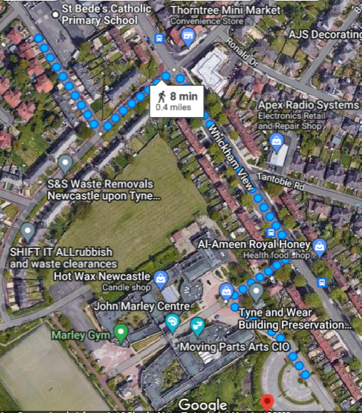

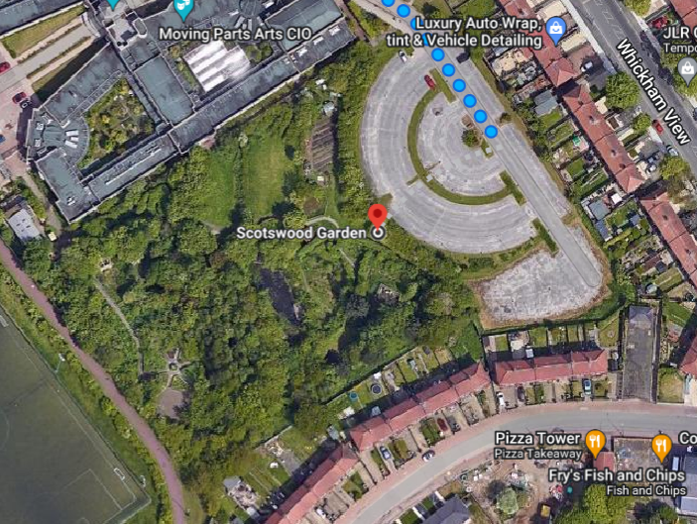
Scotswood Gardens Species List
Species List

Trees:  Ash  Beech  Cherry  Elder  Hawthorn  Hazel  Holly  Norwegian Maple  Oak  Rowan  Silver birch  Sycamore  Wych Elm | Plants:  Bindweed  Bluebells (protected)  Bramble  Cow parsnip  Creeping Buttercup  Dandelion  Dock leaves  Fern  Geranium  Ivy  Nettles  Rose Bay Willow Herb | Fungi:  Common Earthball  Toadstool
Invertebrates:  Ants  Centipedes  Flies  Gatekeeper butterflies  Midges  Millipedes  Painted lady butterflies  Snail  Spiders  Woodlice  Worms | Amphibians and Reptiles:  Frogs  Palmate and smooth newts | Birds:  Blackbirds  Blue tits  Robins  Song Thrush  Sparrows  Wood pigeon
Mammals:  Grey Squirrels  Mice  Rats | Aquatic: (in and around pond)  Pond skaters  Water beetles  Water boatmen  Water snails
Tree and Plant Identification
Scotswood Gardens
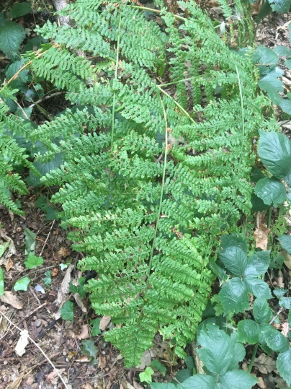
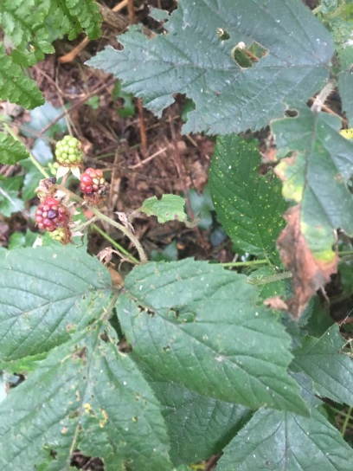
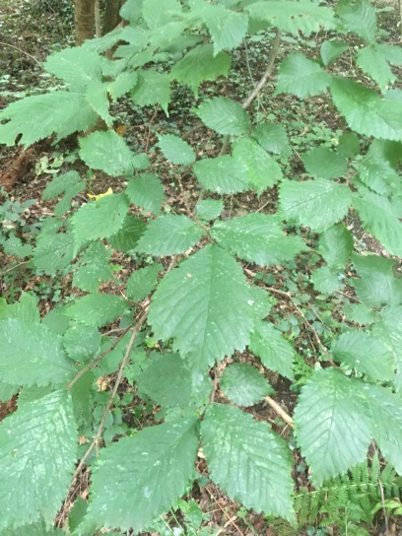
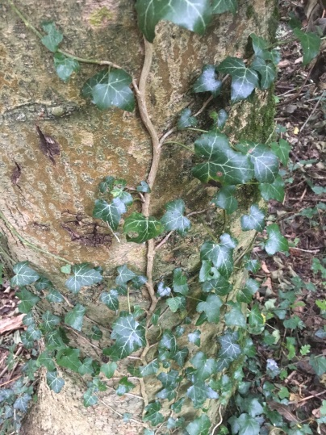
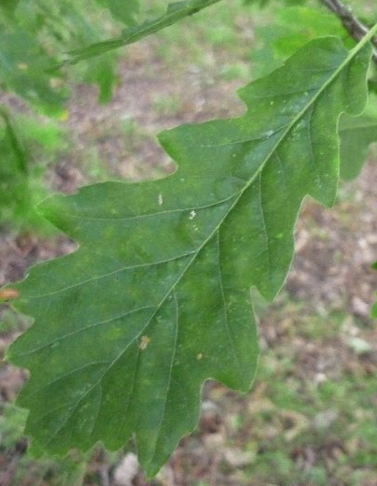
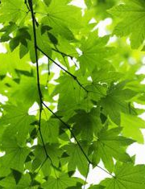
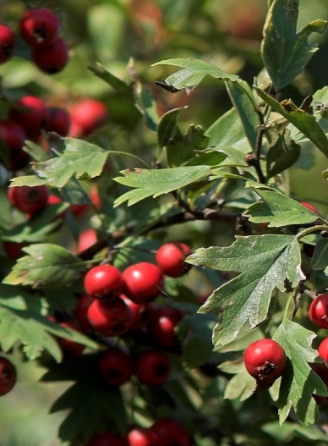
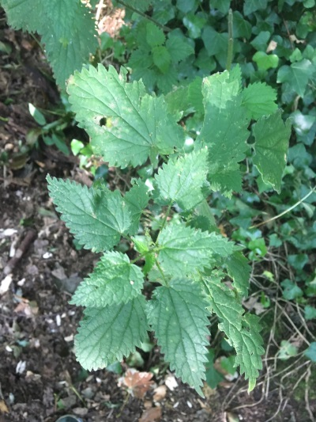

Brambles
Fern
Oak

Sycamore
Wych Elm
Ivy

Ash
Nettles
Hawthorn
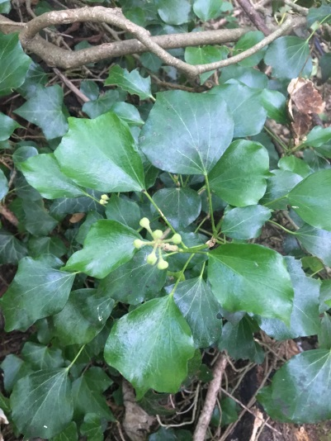
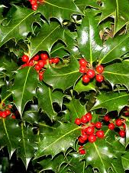
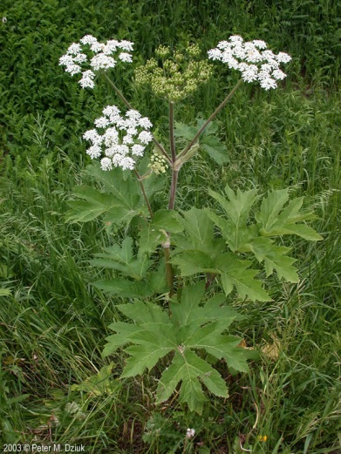
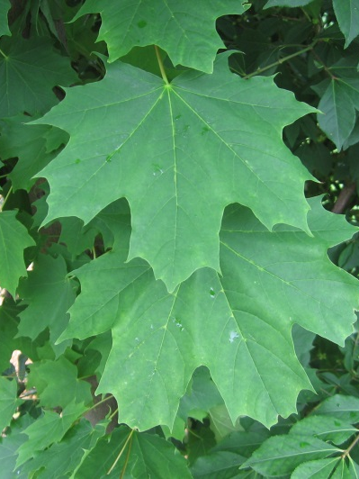
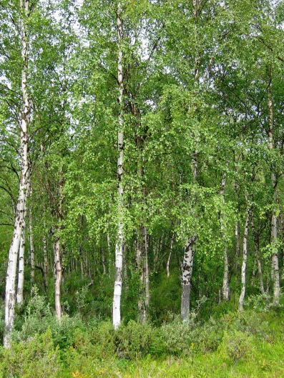
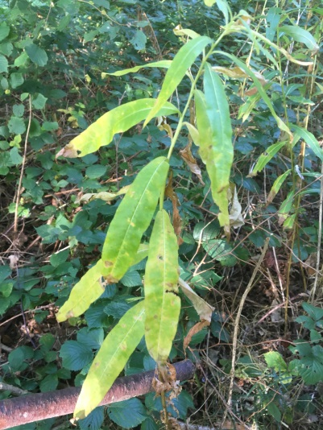
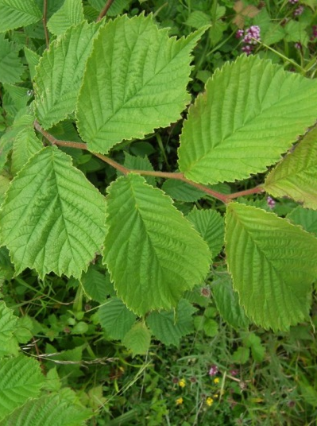
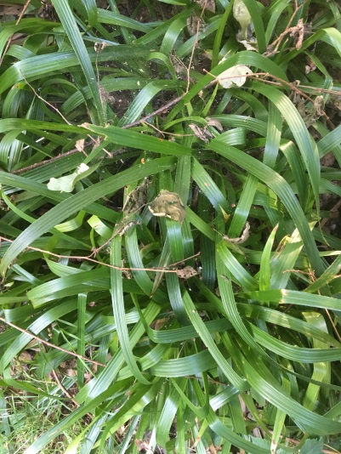
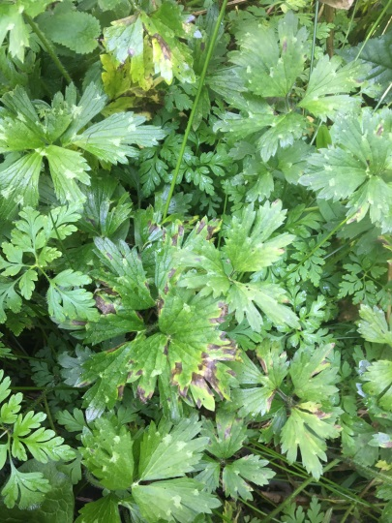
Holly
Holly
(prickly leaf)
Cow Parsnip
Norwegian Maple

Silver Birch
Rose Bay Willow Herb
Hazel
Creeping Buttercup

Bluebells (protected)

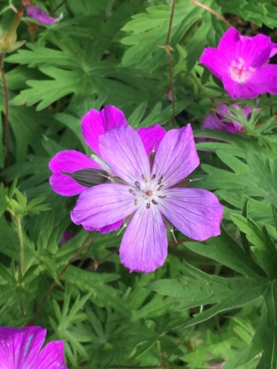
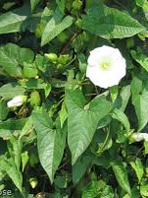
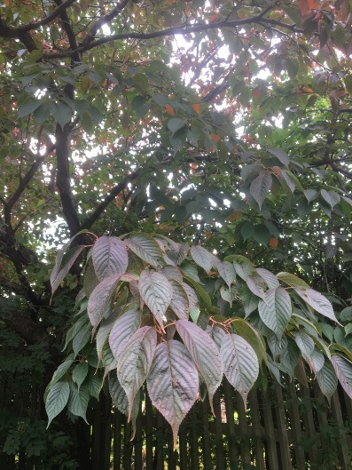
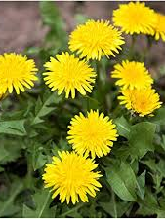
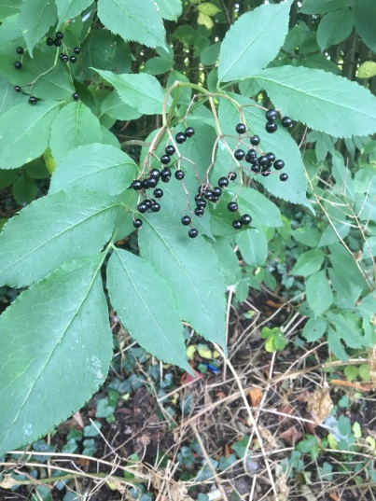
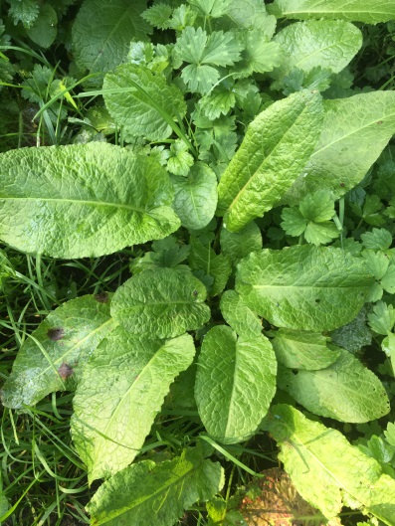
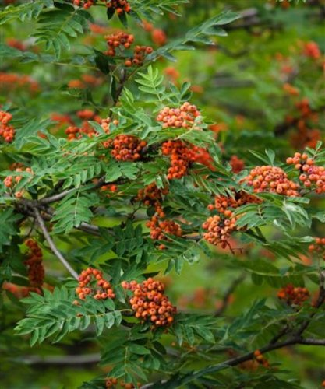
Dock Leaf
Rowan
Geranium
Bindweed
Copper Beech
Dandelion
Elder
Cherry

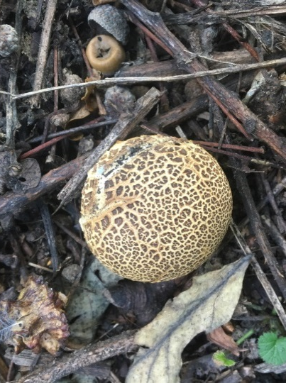
Common Earthball
Fungi Identification
Scotswood Gardens

Bird Identification
Scotswood Garden
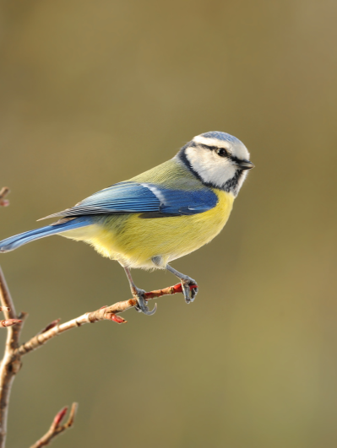
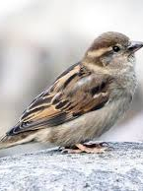
Robin
Song Thrush
Blue Tit
Sparrow
Blackbird
Wood Pigeon

Insect Identification
Scotswood Garden

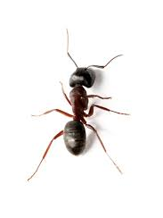
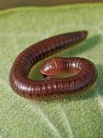
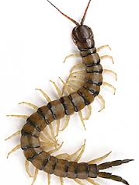
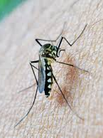
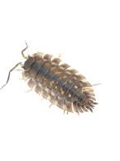
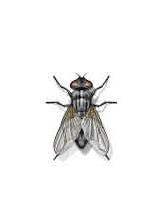
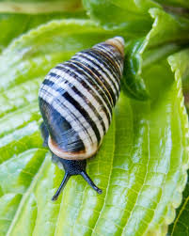

Snail
Worm
Midge

Woodlouse
Spider
Fly

Ant
Millipede
Centipede
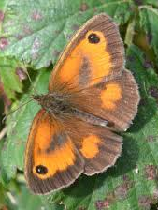
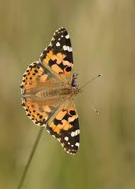
Gatekeeper Butterfly
Painted Lady Butterfly
Insect Identification
Scotswood Garden

Toad
Amphibian and Reptile Identification
Scotswood Garden

Frog
Palmate Newt

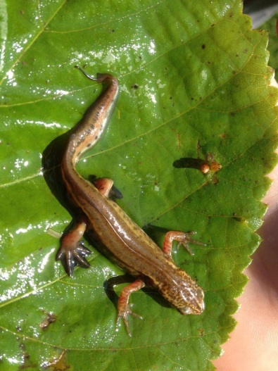

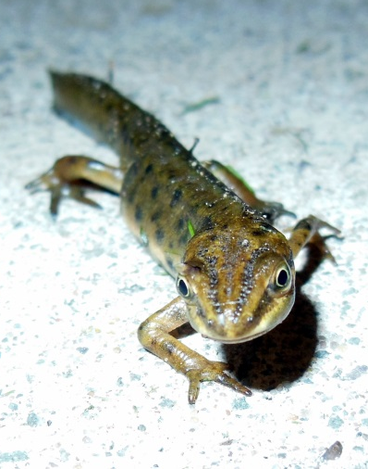

Smooth Newt

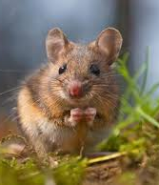
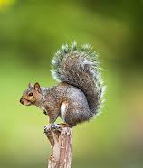
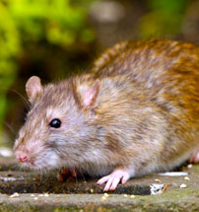
Grey Squirrel
Rat
Mammal Identification
Scotswood Garden

Mouse

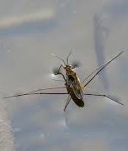
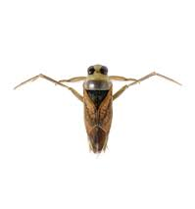
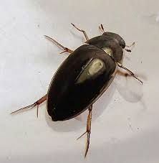
Pond Skater
Water Boatman
Aquatic Identification
Scotswood Garden

Water Snail
Water Beetle

Information to be shared with Stakeholders

