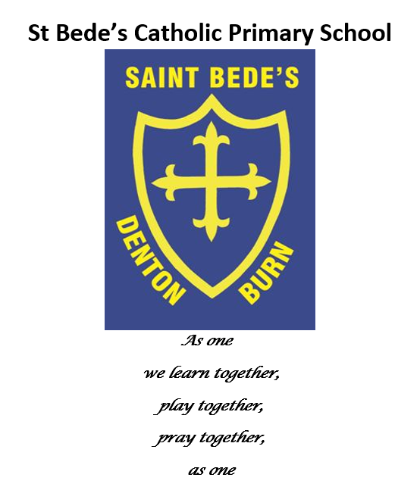

Art Policy and Guidance

Date reviewed: June 2023
Date of next review: June 2024
Art
Intent
At St Bede’s Primary School, we believe that the teaching and learning of art is extremely important in order to stimulate creativity and imagination within the curriculum. We aim to provide the children with a rich and diverse arts experience whether this be in the form of lessons, specialised art weeks, gallery visits and by working with professionals. The children will be comfortable and confident when using a range of media and materials and they will be provided with the knowledge of a range of artists in which they can draw inspiration from for their own work. We believe it is important to provide the children with the tools to motivate the children and enable them to show progression from early years through to upper key stage 2. We want to promote personal creativity within our children and an appreciation for art around them.

Implementation
Various opportunities are provided both inside and outside of the classroom in order for our children to learn the skills required for drawing, painting, collage, sculpture and printing. We expose the children to a range of designers and artists (both contemporary and traditional) from different backgrounds and cultures in order to inspire creativity and we offer a cross curricular approach in order to imbed their learning. The use of sketch books in ks2 helps the children to develop their own sense of creativity and helps the children to practise taught skills. In early years, the children are given many opportunities to create expressive art as part of their continuous provision. We encourage our children to discuss the art work from artists and themselves and share opinions and constructive feedback. Furthermore, the children’s art work is often celebrated through displays which gives the children a sense of pride in their work.

Impact
The children at St Bede’s will have an appreciation and enjoyment of art. They will be confident with the use of equipment and they will have a broad knowledge of technical vocabulary, artists and concepts within art. Sketchbooks will show a creative process and progression of skills will be boosted through our art weeks. Experiences of visiting galleries and looking at various art works will improve enquiry skills about the world around them. Furthermore, we aim to see an improvement of resilience and perseverance by making ‘mistakes’ and constantly evaluating their work.

