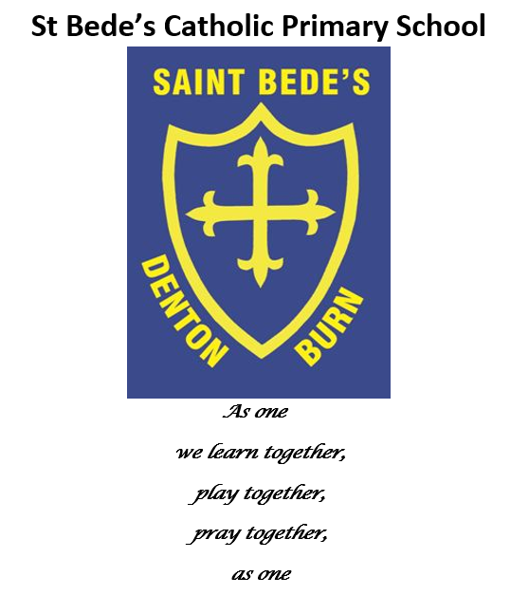
Prayer and Liturgy Policy

Date reviewed: June 2023
Date of next review: June 2024
The Nature of Prayer and Liturgy
Prayer and liturgy in a Catholic school names and celebrates God’s presence in our lives. It is concerned with giving glory, honour, praise and thanks to God. It is our loving response, in word and action, to God’s invitation to enter into relationship, made possible through the work of Jesus Christ and the witness of the Holy Spirit.
‘The celebration of Catholic liturgies and prayers as an integral part of the learning and teaching should enable the school community to become reflective, experience the presence of God and should develop a mature spiritual life.’
(See Appendix 1 Understanding of Prayer and Liturgy – from draft Prayer and Liturgy Directory September 2022)

Legal Requirements
It is a legal requirement that there is a daily ‘act of worship’ offered for all pupils. This can take place at any time during the school day and can be either a single ‘act of worship’ for all pupils, or separate ‘acts of worship’ in school groups. Holding an assembly that includes a prayer, said either by the teacher or everyone present, does not fulfil this requirement. Prayer, liturgical prayer and assembly are distinct activities. They may sometimes form part of the same gathering, but the difference between will always be made clear.

The ‘act of worship’ is not designated curriculum time under regulations and will not be subsumed under any part of the curriculum, including religious education. Responsibility for arranging prayer and liturgy lies with the Local Governing Committee after consultation with the Head Teacher.

Parents have a right to withdraw their child from ‘Collective Worship’. However, given the importance of prayer and liturgy in a Catholic school, parents and prospective parents will be made aware of the fact that it can never be confined to ‘timetabled slots’ but may take place in a variety of contexts other that those which are specifically structured, within Come and See RE curriculum.

The Place of Prayer and Liturgy in the Life of St Bede’s Catholic Primary School
Prayer and liturgy is an integral part of school life and central to the Catholic tradition.

Prayer and liturgy takes into account the religious and educational needs of all who share in it:

- Those who form part of the worshipping community in church;
- Those for whom school may be their first and only experience of church;
- Those from other Christian traditions – or none;
- Those from other faith backgrounds.

The Aims of Prayer and Liturgy
Prayer and liturgy in St Bede’s Catholic Primary School aims to provide opportunities for all pupils and staff:

- To contemplate the mystery of God
- To reflect on spiritual and moral issues
- To explore personal beliefs
- To respond to and to celebrate life
- To experience a sense of belonging and to develop community spirit
- To develop a common ethos and shared values
- To enrich religious experience
- To grow in liturgical understanding and development
- To pray using prayers which are part of the Catholic tradition
- To reinforce positive attitudes
- To participate fully
- To take time out ‘to wonder at’, ‘to come to terms with’ and ‘to give worth to.’

Principles
All acts of prayer in St Bede’s Catholic Primary School will:

- Give glory and honour to God;
- Be a quality activity, fundamental to the life of the school and its Catholic character;
- Enable pupils to develop skills so that they can prepare, organise and lead prayer times;
- Give pupils positive liturgical experiences, appropriate to their age, aptitude and family backgrounds in order to prepare them for the liturgical life of the Church. Celebrations will be appropriate to the age and groupings of the children.

Planning, content and celebration
Prayer and liturgy is planned following a structure with reference to the Church's seasons, Come and See, feast days, the curriculum and significant dates e.g. CAFOD Family Fast Day, Holocaust Memorial Day.
Parish and parents are invited to participate in some celebrations.
A variety of prayer styles will be used appropriate to the age of the children and the occasion. In order to do this, prayer and liturgy will:
- Be kept small wherever possible or appropriate to help to personalise the experience;
- Be short and appropriately paced e.g. 5-6 mins for Key Stage 1, 7-10 mins for Key Stage 2;
- Be simple, including a range of experiences offered in a variety of groupings and in a variety of settings.

The Timetable of Prayer and Liturgy is as below:
- Whole school prayer and liturgy on Monday morning, 9.20am – 9.50am, led by Mrs Young or one of the senior leaders.
- In class prayer and liturgy on Tuesday – class or chapel based
- Key Stage hymn singing on Wednesday morning, 9.20am – 9.50am, led by Mrs Young or class teachers on a rota basis
- Wednesday Word focus prayer and liturgy on Wednesday
- In class prayer and liturgy on Thursday (pupil-led as appropriate) – class or chapel based
- Staff prayers each Friday morning, led by all staff on a rota basis
- Whole school prayer and liturgy and school celebration on Friday morning 11.00am – 11.30am

- Daily class prayers – to begin the day, grace before lunch, prayer after lunch, to close the school day

- Class ‘Stay, Play and Pray’ twice yearly opportunities to invite parents to attend

Leading Prayer and Liturgy
As faith leader of the school, the Head Teacher will plan and lead prayer and liturgy for children and staff. A rota has also been developed to include the Head Teacher, Deputy Head Teacher, Religious Education Subject Lead and Phase Leaders to plan and lead whole school prayer and liturgy, with the Head Teacher leading on a fortnightly basis and the rest of staff on a rota. The class teacher will lead class prayer and liturgy. Children are taught to plan and lead prayer times according to their age.

Recording
Whole school prayer and liturgy is recorded in our class ‘Mission Journals’ where the weekly ‘missions’ from each prayerful gathering are stored.
Class prayer and liturgy is recorded within each year group’s ‘prayer and liturgy’ journal.

Monitoring and Evaluation
Prayer and liturgy is monitored using a prayer and liturgy monitoring form.
(see Appendix 2)
Following monitoring, training needs will be identified and outcomes used to inform the school’s CSED (Catholic Schools Evaluation Document).

Resources
Shared resources are stored in the Nurture Room cupboards (former prayer room). Mrs Weatherburn and Mrs Savage are responsible for auditing and managing the shared resources.
The new Chapel space is available every afternoon for class prayer and liturgy opportunities.

The learning environment
'Symbols and icons of the Catholic faith when displayed in school and throughout its premises will help the school community and visitors to experience the uniqueness and sacredness of this learning environment'
Focal points in each classroom and throughout the school will reflect the liturgical season and will reference Come and See topics. In this way they will be an outward sign of the school's ethos.

Retreats
Year 6 annually attend a residential retreat at the Youth Village in Consett.

Other opportunities
A monthly school-led Parish Mass is built into our annual pattern of prayer and liturgy. Classes also attend Parish Mass throughout the year to join with the parishioners in their celebration of the Eucharist.
Due to our close proximity to the Church, we often visit the Church for prayer and liturgy experiences.
We gather each year as a group of Newcastle Catholic Primary Schools for some joint prayer and liturgy services at St Mary’s Cathedral (Year 5 – Carol Service in December, Year 4 – Stations of the Cross during Lent and Year 6 for a Leavers Mass in July)

The Coordinator for Prayer and Liturgy
Mrs Weatherburn, the Subject Lead has responsibility for leading, managing and supporting the delivery of and training in Prayer in Liturgy and is supported by Mrs Savage as Link TA. (The Diocesan role off the Subject Leader is attached in Appendix 3)

Policy Monitoring and Review
This policy is monitored by the Prayer and Liturgy Coordinator and is evaluated and reviewed by the whole school staff and governors every two years. The Foundation Governors in particular will play a most important role.

This Policy was ratified on ………………………………………………………………….…

Signed: …………………………………………………………………. (Chair of Governors)

Review date: ……………………………………………………………………………………..

Signed: …………………………………………………………………………(Head Teacher)

APPENDIX 1

Introduction: Understanding Prayer and Liturgy
(From the draft Prayer and Liturgy Directory, September 2022)
In any school there will be a range of prayer and liturgy: classroom prayer, meditation, assemblies, devotions, special services for times in the school year, celebrations of Mass and the Sacrament of Reconciliation. Each form of prayer and liturgy will have its own character dependent on the circumstances, size and age of the group, the place of celebration and its content.

Definition of Terms
Prayer, Liturgical Prayer, and Liturgy form a continuum with silent meditation at one end and a celebration of Mass on a Solemnity of the Church (e.g., Ascension of the Lord) at the other. Of course, there are areas of overlap between the categories.
Prayer Liturgical Prayer Liturgy
Christian meditation Service of the Word Sacraments:
Prayer before meals Assembly Liturgy of Hours Mass
Penance
Devotions Benediction

Prayer | Liturgical Prayer | Liturgy
Simple structure | Structured (often 4 part) | Taken from official books
One or two elements | Elements drawn from liturgy | Complex structure
Balance of familiarity & creativity | Places of Scripture | Many elements
 | Contrasts and creativity | Range of ministry
In Catholic terminology ‘worship’ is not generally used to name and describe a distinct type of prayer or event. Worship is about living our lives in a way that recognises that everything we have is a gift from God and that everything we do gives glory to God. That, of course, does include prayer but the scope is broader. With that understanding of worship it will be seen that that the purpose of education in a Catholic school is to know and love Christ and to
open the vision and imagination of all pupils to the wonder of living in God’s world, and the
responsibilities that follow from this.

Under Section 48 of the Education Act 2005 there is a statutory duty to inspect and report on denominal education (that is religious education) and collective worship in schools designated as having a religious character. For this reason, the term ‘Collective Worship’ has been kept as the headline judgement by the Catholic Schools Inspectorate but throughout the framework it is referred to as prayer and liturgy. This model policy addresses the shift in vocabulary and is an interim response to the draft Prayer and Liturgy Directory. When the Directory is published it will contain a model policy which the Diocese of Hexham and Newcastle will adapt for schools.

APPENDIX 2

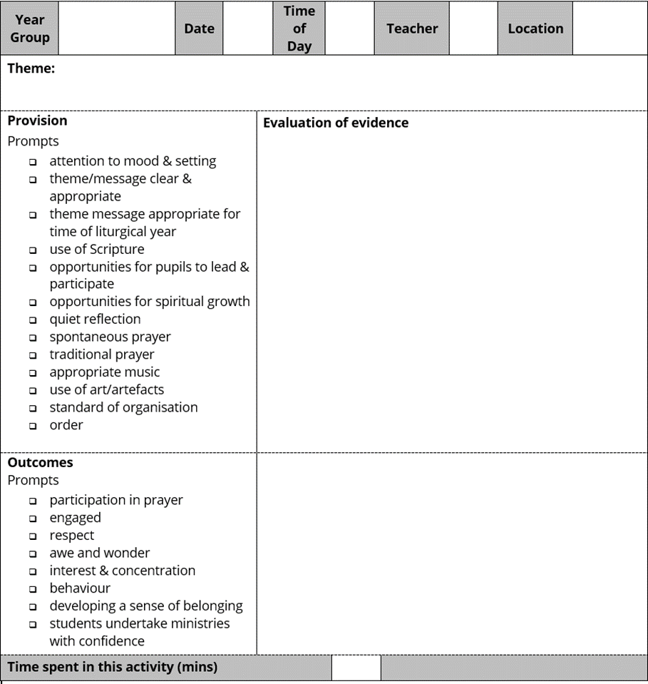

APPENDIX 3

The Role of the Subject Leader for Prayer and Liturgy

Formulating a written policy for prayer and liturgy
- Ensuring that there is a development plan for prayer and liturgy included in the school development plan
- Ensuring that prayer and liturgy is appropriate to the age, aptitudes and faith backgrounds of pupils
- Ensuring that prayer and liturgy takes account of the religious and educational needs of all who share in it and is rooted in the principles of the ‘Directory for Masses with Children’
- Organising themes for prayer times
- Assisting the governors and headteacher to carry out their legal responsibilities with regard to prayer and liturgy including withdrawal from Collective Worship
- Developing staff confidence and expertise e.g. through modelling different prayer styles

Planning, recording, monitoring and evaluating
- Maintaining and developing effective procedures and documentation
- Observing Acts of Prayer and Liturgy and providing feedback
- Informing the headteacher of standards and developments in prayer and liturgy

Communication
- Communicating to members of the school community the significance and content of prayer and liturgy
- Reporting to and consulting with the governors and headteacher regarding matters of concern and development
- Acting as consultant to colleagues
- Encouraging positive attitudes towards prayer and liturgy
- Informing newly appointed colleagues of school policy regarding prayer and liturgy
- Communicating with parents, governors and the parish community
- Liaison with the school chaplain
- Liaison with the Diocesan Department for Education

Professional development/Ongoing formation
- Leading and organising in-service training and ongoing formation for prayer and liturgy
- Attending appropriate in-service courses, reporting back and leading staff training
- Keeping up to date by personal reading

Resources
- Evaluating existing resources
- Developing the resources available for prayer and liturgy including visual aids, artefacts, drapes, music, visitors, leaders, new and relevant books, posters etc.
- Budgeting efficiently

[Consideration should be given to the establishment of a planning group, which might include, the coordinator, the headteacher, deputy, staff, pupils, governors and school chaplain. It would be part of the role of the coordinator to lead this group.]

Christ at the Centre Rev Marcus Stock, 2005
Directory for Masses with Children, paragraph 9.
Christ at the Centre Rev Marcus Stock, 2005

