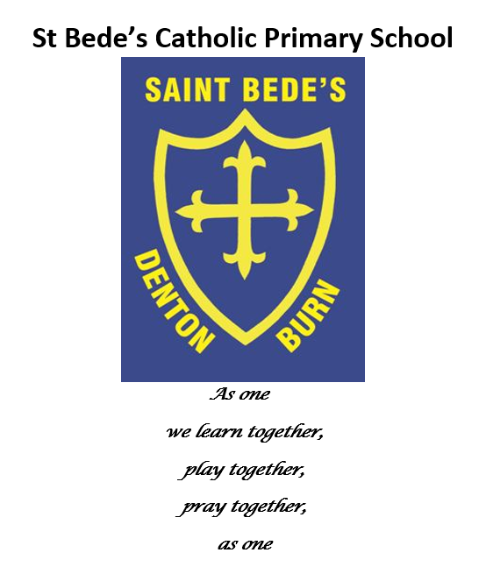Reading Policy and Guidance Policy

Date reviewed: June 2023
Date of next review: June 2024

Our Reading Vision Statement:

Reading is a vital skill that supports children’s learning across the whole curriculum. As a school, we ensure that our children are taught to read with fluency, accuracy and understanding through a variety of discreet and cross-curricular learning opportunities. Above all, we want children in our school to enjoy reading. We want all children to become enthusiastic, independent and reflective readers.

At St. Bede’s, we strive to give pupils a stimulating environment, where reading materials are presented in an attractive, inviting way that promotes a love of reading. Displays will be vocabulary-rich with working walls allowing new vocabulary to be added.

Reading at home
Reception / EYFS children are initially required to read one lilac (picture) book at home. Pink books are sent home to match phonics sounds as they are covered. Phase 2 tricky words will be sent home as flash cards when phase 2 is introduced.

KS1 send home two books every week. Phonics sounds and common exception words that children do not know will be sent home to be practised every half-term based on assessment.

KS2 are expected to read regularly and are encouraged to take home one book per week. Parents are expected to sign that they have done this in their homework diaries or on the elearning platform electronically.

All classes must keep record sheets to track the books children have read. Individual book band record sheets are available on the network drive for all books up to Lime and teachers should make sure that children are reading at the correct level in line with their assessments. Children working beyond Lime are given more freedom and encouraged to choose books from their allocated year group, the library or home. More freedom is given to avid readers. When children are working beyond Lime, they should record the book they have read on a blank grid.

Library
The library is timetabled so that each class has access at least one session each week during the school day. Parents can access the library after school with their children if they wish to.

Assessment
All children in Reception and Year 1, and those in Year 2 who did not meet the expected standard in the Year 1 Phonics Screening Check, will be assessed every half term using Phonics Tracker. Any sounds and common exception words that children do not know will be sent home to be practised.

Termly reading assessments are carried out in all year groups and recorded electronically on the data tracker. Collins Fluency in Reading Assessments are used on a termly basis in KS1, and with those children in KS2 who are below the expected standard for reading, to ensure that we are able to track progress in fluency. Comprehension skills are taught in guided reading sessions and Collins Comprehension Assessments are used for all children on a half-termly basis. All children across school who are not word reading at the expected level are given additional reading time in small groups or 1:1 which is recorded.

Phonics:
Reception / EYFS and KS1 follow Pearson’s Bug Club Phonics Scheme. Daily phonics sessions in Reception and Year 1 follow a structured format: review previous sounds, introduce new sound, practise reading the sound and apply knowledge by writing words that contain the sound. Children are also taught to read and spell words from the National Curriculum and are tested on these from Year 1 term 2. Common exception words are referred to as ‘tricky’ words and are taught alongside phonetically decodable words.

Reception EYFS class covers phase 2 and 3 of Letters and Sounds, introducing elements of phase 4 (consonant blends.) The children are split into three smaller teaching groups, enabling children to make accelerated progress.

Year 1 review phase 3, learn phases 4 and 5 then are introduced to alternative spellings and pronunciation.

Year 2 review phase 5 and then focus on spelling patterns.
(See Appendix 1 Bug Club Phonics Programme Structure)

Reading in Reception / EYFS and Key Stage 1
Reception / EYFS
In Early Years, the children enjoy an increasing number of books through sharing stories together and verbal questions based on retrieval and basic understanding. Children take part in small-group reading sessions with an adult focussing on word reading, grammar, punctuation and vocabulary, basic retrieval and discussion about understanding of the text. Children are taught to decode through daily whole class phonics and may be grouped according to their targeted intervention.

Year 1
Word reading objectives will be covered in phonics, small group guided reading and other English lessons. Children should have access to small group guided reading a minimum of twice a week and whole class guided reading once a week

Whole Class guided reading in year 1: Children answer questions about texts which require them to retrieve, interpret and predict. In the autumn term, this session is completed verbally with a main focus on retrieval. As the term progresses, the focus changes to interpreting, inference and making predictions based on what they have read. By the end of the summer term, the children move to producing some written responses to these questions.

Year 2
At the end of year two, the expectation from the Government is that children should be fluent and write responses to questions about texts. Children should have access to small group guided reading once a week to focus on word reading objectives and whole class guided reading a minimum of twice a week.
All children in EYFS and KS1 have individual formatted sheets to record what and how often they have read in reading sessions and objectives that have been evidenced. Coverage of comprehension skills is recorded on formatted guided reading planning.

Reading in Key Stage 2
As the children progress, we aim to build on the reading experiences already acquired. The aim is to develop independence, fluency and self-reliance. A greater variety of texts are made available to allow for more depth, choice and enjoyment. More varied texts are available to support the widening interest shown as children progress.

Whole Class Guided Reading
Guided reading is a taught session which takes place in addition to English lessons. This happens at least three times a week. It promotes reading for pleasure and purpose. It also gives children the opportunity to answer focused questions about a wide range of texts and genres which cover the reading objectives. key skills for reading that are covered in these sessions are:
• Literal skills (answers can be directly lifted from the text)
• Deductive skills (the text does not directly give the answer but we can work things out from the information given)
• Inferential skills (the text does not directly tell us the answer but we can work things out by considering the hints and clues in the text in light of our own knowledge and experiences)
• Evaluative skills (giving personal opinions, often about whole texts, or successes of author in creating mood, character etc...)

Teachers use a formatted planning sheet to record the texts used and objectives covered. This is to ensure that all of the objectives are covered throughout the year. Every term, teachers must ensure that the children have explored the different text types (fiction, nonfiction and poetry). Teachers may explore a range of texts including class novels, short extracts, pictures, etc.
In KS2, teachers and teaching assistants work with smaller groups to focus on readers who are working below expectations or groups with particular focuses. Individual formatted recording sheets are kept for any children who are working below the expected level for that year group as they receive targeted intervention.

Reading intervention throughout school
Volunteers come in weekly to listen to children read and help to develop fluency. Reading volunteers are trained by St Bede’s staff to help them to be able to ask the children different questions from the text and are given a bank of questions relating to the reading objectives for each year group.

Teachers and teaching assistants must give extra support to those who are working below the expected standards. This may be in the form of support in guided reading sessions, extra guided reading sessions or 1:1 reading support. Teachers closely track SEND, PP and EAL pupils to ensure that they are achieving support to reach the expected standard.

Reading for Pleasure / Class Readers
Teachers read class books to the pupils on a regular basis to promote reading for pleasure. Class books relate to the author of the term, class topics or are recommended reads for that specific year group.

Appendix 1: Bug Club Phonics Programme Structure
Early Years – Reception / EYFS
Phase 2 sounds are taught in the following order.

Phase 2  units (Bug Club sequence) | Sounds taught | Tricky Words
Units 1 and 2 | s, a, t, p, i, n, m, d | n/a
Unit 3 | g, o, c, k | to
Unit 4 | ck, e, u, r | the, no, go
Unit 5 | h, b, f, ff, l, ll, ss | I, into, her

The children are then taught phase 3 sounds.

Phase 3  units (Bug Club sequence) | Sounds taught | Tricky Words
Unit 6 | j, v, w, x | me, be
Unit 7 | y, z, zz, qu | he, my, by, she
Unit 8 | ch, sh, th, ng | they
Unit 9 | ai, ee, igh, oa, oo (long), oo (short) | we, are
Unit 10 | ar, or, ur, ow, oi | you
Unit 11 | ear, air, ure, er | all, was, give, live

When the children are confident in phase 2 and 3 sounds they progress to phase 4.

Phase 4 units (Bug Club  sequence) | Sounds taught | Tricky Words
Unit 12 | Adjacent consonants consolidation (cvcc, ccvc, ccvcc, cccvc, cccvcc) | said, have, like, so, do, some, come, were, there, little, one, when, out, what

Year 1
At the beginning of Year 1, the children consolidate their learning from the end of Early Years by revisiting the phase 4 sequence where they also have the opportunity to apply their previously learnt phase 2 and 3 knowledge. Children then progress to phase 5 where they learn a set of new graphemes, alternative pronunciations for graphemes already known and alternative spellings for phonemes. At the end of year one, the children sit their Phonics Screening Test in the summer term.

Phase 5 units (Bug Club  sequence) | Sounds taught | Tricky Words
Unit 13 | wh, ph | oh, their, people
Unit 14 | Long a: ay, a-e, eigh, ey, ei | Mr, Mrs, Ms
Unit 15 | Long e: ea, e-e, ie, ey, ei | looked, called, asked
Unit 16 | Long i: ie, i-e, y, i | water, where
Unit 17 | Long o: ow, oe, o/oe | who, again
Unit 18 | Long u: ew, ue, u-e short oo: u, oul | thought, through
Unit 19 | aw, au, al | work, laughed, because
Unit 20 | ir, er ear | Thursday, Saturday, thirteen, thirty
Unit 21 | ou, oy | different, any, many
Unit 22 | ere, eer, are, ear | eyes, friends
Unit 23 | c, k, ck, ch | two, once
Unit 24 | ce/ci/cy, sc/stl/se | great, clothes
Unit 25 | ge/gi/gy, dge | It’s, I’m I’ll, I’ve
Unit 26 | Le, mb, kn/gn, wr | don’t, cant, didn’t
Unit 27 | tch, sh, ea, zh, (w)a, o | first, second third

Year 2
In Year 2, daily phonics lessons follow the phase 6 sequence of Bug Club Phonics looking at suffix morphemes, plural morphemes and prefix morphemes. Spelling, grammar and punctuation lessons continue throughout the year in addition to daily literacy lessons. Children who need to take their Phonics Screening Test again at the end of Year 2 will do so in the summer term. Extra interventions will be put in place to help these children to ‘catch up’.

Phase 6 units (Bug Club  sequence) | Focus: | Tricky Words
Unit 28 | Suffix morphemes: ing, ed | clearing, gleaming, rained, mailed
Unit 29 | Plural morphemes: s, es | men, mice, feet, teeth, sheep
Unit 30 | Prefix morphemes: re, un prefix +  root + suffix | Vowel consonant prefix  suffix syllable

