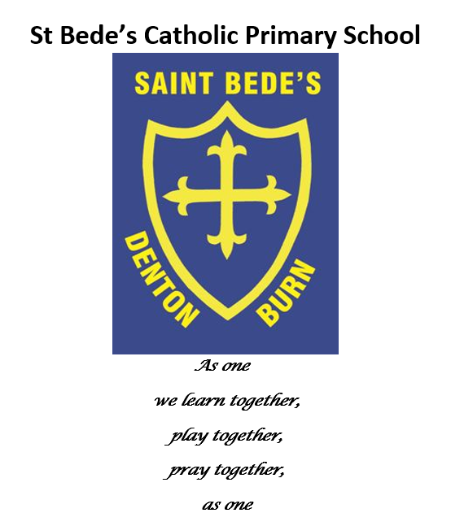
Writing Policy and Guidance

Date reviewed: June 2023
Date of next review: June 2024

Aims

Intent
By the end of year six we intend our children to have developed a love of writing, a wide vocabulary and an ability to express their thoughts and ideas clearly and creatively through both spoken skills and the written word. We want them to write easily and fluently for a range of purposes and to develop the habit of writing widely and often, for pleasure and information. We also intend to create writers who can re-read, edit and improve their own writing and confidently use the essential skills of grammar, punctuation and spelling. At St Bede’s, we set high expectations for all our children to take pride in their work and have a fluent, cursive handwriting style that allows their imagination to flourish on the page.

Implementation:
In order to help us to develop confident, enthusiastic writers who can express themselves in a variety of different styles and across a variety of contexts, our teaching of writing is often cross circular and linked to our class topics. This provides our children with regular opportunities to write for a range of purposes and audiences. Writing tasks are specific and meaningful. They engage children and aim to illustrate how their writing skills can be applied to real life contexts. Writing genres are clearly mapped out across each year group in long term writing plans. Teachers produce medium-term plans which give a clear overview of the genre being taught each week and the texts used. Medium-term plans also include the organisation of spelling, grammar and punctuation. Children learn spellings at home each week and these are tested in school. Additionally, spelling is taught daily in in key Stage 2 and through phonics sessions in Key Stage 1. Children who need additional support with spelling receive interventions.

Impact
The impact on our children is that they have the knowledge and skills to be able to write successfully and make good progress in writing. By the end of year six they will be able to write clearly and accurately and adapt their language and style in and for a range of contexts, purposes and audiences. Most importantly, they will develop a love of writing and be well equipped for the rest of their education.
Progress across classes is monitored by the subject leaders and senior leadership team. Monitoring includes: planning and book scrutinies, learning walks and lesson observations as well as analysing teacher assessment and data on Insight Tracker. The findings of any monitoring is used to inform next steps for the children and the implementation of writing across the school as a whole.

Non-negotiables.
- Weekly planning is to be drawn from the long-term overview provided for each year group, along with the unit plans for each half term (which are a guide to be adapted to the class). Every opportunity for a range of genres through cross curricular writing should be planned for and developed. Planning should demonstrate a multisensory approach, and as so, lessons need to make the most of VAK learning approaches and differentiation according to the class needs.
- All KS1 and KS2 classes need to focus time on spelling, punctuation and grammar by ensuring terminology, knowledge and skills are given suitable curriculum time within lessons.
- Phonics and spellings should take place in all classes on a daily basis in Reception / EYFS and KS1.
- Good examples of work should be shared regularly with the class and rewarded with house points. One piece of writing half term is to be displayed on a board in the foyer to celebrate the writing taking place.
- All staff at St Bede’s are aware of the importance of presentation, and as so will adhere to and promote the handwriting policy during all lessons.
- Examples of writing need to be displayed within classrooms. This can be in the form of specific English writing lessons, through cross-curricular lessons or on working walls.
- Moderation of judgements and standardisation are to take place throughout the year, both internally, with local schools and clusters.
- Self- and peer-assessment are important parts of children’s learning and as so opportunities for these are to be planned for.
- Re-drafting work is a vital component of developing and improving writing, and as so the children should be given time to regularly re-draft short sections of their own work.
- In line with the National Curriculum, all year groups are to study a range of age-appropriate authors throughout the year. These are to be used across reading and writing and should be used as examples and stimuli for the children’s own reading and writing.
- Every child has an Independent Writing book (as well as their English Book). This contains finished pieces of independent writing that can be used to form a clear picture of our children as writers. It is expected that children would complete in KS2 will complete one piece of independent writing each week. Children in KS1 should complete at least 3 or 4 pieces of independent writing each half term. This writing will be completed after detailed text marking, word/sentence level work and shared and guided writing.
- The following tools are made readily available as part of first quality teaching throughout the school:
-themed prompt sheets
-dual coded vocabulary aids / word banks (with pictures and words)
-peer support
-dictionaries
-excellent examples of writing structures
-Vocabulary Ninja working walls
-peer editing for any spelling, grammar or punctuation mistakes
–success criteria grids.
- Children are used to editing and up-levelling their work as part of the writing process.

Spelling.

‘As vocabulary increases, teachers should show pupils how to understand the relationships between words, how to understand nuances in meaning, and how to develop their understanding of, and ability to use, figurative language. They should also teach pupils how to work out and clarify the meanings of unknown words and words with more than 1 meaning.’ (National Curriculum)

- To support the children in their journey to reach a high standard of spelling, they need to be explicitly taught the skills needed. Daily phonics takes place in Reception / EYFS and Year 1 giving the children the opportunity to learn a new pattern, practise it and apply it in a range of activities.
- From Year 2 – Year 6, at least 3 weekly spelling sessions take place lasting for a minimum of 15 minutes (this will be incorporated into morning task work as well as discrete teaching within lessons). This will ensure that the appropriate spelling patterns have been taught.
- VOCABULARY NINJA by Andrew Jennings. The children in Year 1- Year 6 will be introduced to a vocabulary rich program. Children will be given challenging vocabulary to investigate and in turn developing a wider understanding of vocabulary. Using ‘Vocabulary Ninja’ (Andrew Jennings) https://vocabularyninja.wordpress.com, the children will be given daily words to discuss, investigate and the challenge themselves to use either in writing, discussions or identify in their reading. Children will be given a class reward for every successful use of a new word. Children will learn to celebrate language and challenge themselves to use new words in a variety of ways. New vocabulary will be displayed in the classroom with the meaning and must be accessible by all. To encourage the children to develop the vocabulary, they will be given house points every time they appropriately use spelling words or Vocabulary Ninja words.

Home / school links
St Bede’s Primary School values the relationship with parents in supporting their children’s English skills. Parents are involved in their children’s learning by:
- Providing weekly spellings to revise at home ready for a spelling check at the end of the week.
- Spelling patterns to be shared with parents.

Regularity of Lessons
Reception / EYFS– Children will have a dedicated English lesson each day, where possible.
Children will be directly taught writing skills in order to raise the standards on entry into
Key Stage 1.

KS1 and KS2 - Children will have a dedicated English lesson each day, where possible.
Children will have worked modelled to them regularly and will have many opportunities for extended writing, including redrafting their own work.

Additionally, children should be expected to use the skills and techniques learnt during English lessons across a range of cross-curriculum areas in order to further develop their skills.

SEND and Inclusion
At St Bede’s, we are committed to all children being able to access the English
curriculum, regardless of race, gender, ability or disability, religion, social background and
culture. Wherever possible, work is adapted to meet individual needs and requirements. This
includes the provision of interventions where relevant and writing materials such as pens and the size of lined paper.

Assessment
Self- and peer-assessment are integral parts of the writing process, and provision is made
accordingly. Teachers assess when marking through the school’s marking and feedback
policy, and provide verbal feedback during lessons. These assessments inform future
planning and support. Teachers are asked to formally assess writing at the end of each term.
This assessment is based on pupil’s independent writing from both English lessons and
lessons across the wider curriculum. Teacher assessments are record on Insight Tracking.

Roles and Responsibilities of the Subject Lead including monitoring
The Subject Lead and Headteacher should be responsible for improving the standards of teaching and learning in writing by monitoring and evaluating through:
- Monitoring the quality of the learning environment e.g. Vocabulary Ninja display with weekly words and ‘Word of the Day’
- Analysing data and identifying progress within the cohort and vulnerable groups, and those groups in need of support or intervention. (Insight, spelling results, etc.)
- Supporting colleagues in their CPD
- Purchasing and organising resources
- Book Scrutiny- focus on use of vocabulary; spelling patterns being used
- Monitoring of independent writing books
- Learning walks and observations
- Pupil voice will also be used to monitor learning and attitudes to writing.

This policy will be reviewed every year or in the light of changes to legal requirements

This Policy was ratified on ………………
Signed:…………………………………………………..(Chair of Governors)
Review Date:……………
Signed: …………………………………………………. (Head Teacher)

