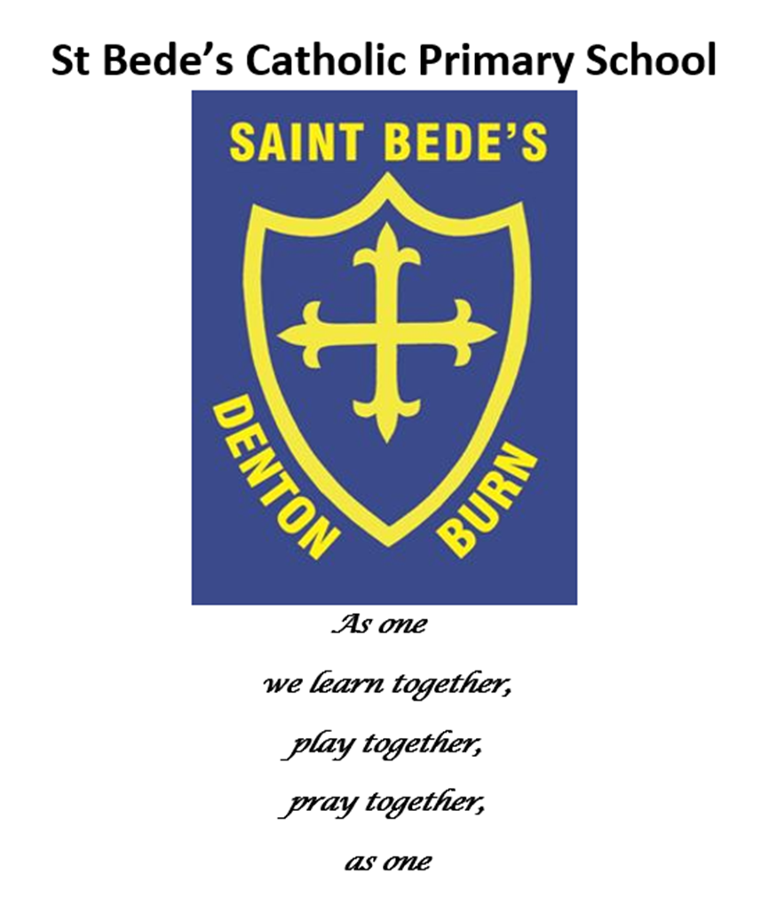

**Relationships and Sex Education and Personal, Social and Health Education Policy and Guidance**

|  |
| --- |
| Date reviewed: October 2024 |
| Date of next review: September 2025 |

St Bede’s Catholic Primary School Relationships and Sex Education (RSE) and Personal, Social and Health Education (PSHE) Policy outlines our commitment to delivering education on personal, health, relationships and sex that aligns with Catholic teachings, values, and the developmental needs of our pupils. The policy ensures that education in this area is provided within a framework that emphasises respect, responsibility, and the dignity of every human being as created in the image of God.

Rationale:

Through our Relationships and Sex Education (RSE) and Personal, Social and Health Education (PSHE) curriculum we want the pupils:

* To acquire knowledge and understanding of ourselves (emotional and physical).
* To acquire strategies and skills to aid in the making of informed choices.
* To build positive attitudes towards self and others.
* To increased self-esteem and self-respect.
* To build mutual appreciation and respect in all relationships.
* To build personal growth, self-respect, and an understanding of the sanctity of human relationships.
* To learn about the physical, emotional, and social aspects of growing up, focusing on healthy, respectful relationships.
* To be provided with accurate information appropriate to their age, supporting their moral and spiritual development.
* To develop a sense of responsibility, empathy, and a deep understanding of family and community roles.

The curriculum aims to help all pupils to develop:

* An understanding of their physical development.
* An understanding of their emotions and feelings.
* An understanding of the relationships they have and will encounter.
* Strategies and skills that will enable them to make informed decisions as they mature within our society.

RSE / PSHE are an essential part of supporting our pupils to develop their academic, personal and social education. Our main curriculum drivers are to strive to ensure that our pupils are successful learners, confident leavers and responsible citizens.

RSE Curriculum

Our RSE element of the curriculum is rooted in Catholic values and teachings. It emphasises the sacramentality of marriage, the importance of family life, and the belief that human sexuality is a gift from God meant to be expressed within the sacred context of marital love. While imparting essential knowledge, the RSE curriculum seeks to cultivate virtues such as love, chastity, and integrity.

We are partners with parents in ensuring that our children are safe and healthy and we present this information in the context of Catholic education.

We recognise parents as the primary educators of their children in matters of relationships and sexuality. Our school works in partnership with parents to provide transparent communication regarding the content and delivery of RSE lessons. Parents are invited to review the materials used and participate in discussions to align the teachings with their faith and values.

We follow the National Curriculum as a base for our RSE element of the curriculum, following Diocesan guidance for teaching Relationships and Sex Education (RSE) and using Diocesan approved resources - TEN:TEN Life to the Full and Journey in Love.

The RSE curriculum is age-appropriate and developmentally sensitive, structured as follows:

* EYFS / Key Stage 1: Basic concepts of friendship, kindness, and the importance of family; an introduction to personal safety and self-care.
* Key Stage 2: Deeper discussions on the changes during puberty, understanding emotions, healthy relationships, and the foundations of respect and responsibility in interactions.

The content is presented in a manner that respects the innocence and gradual understanding of children, with a focus on nurturing their physical, emotional, and spiritual development.

PSHE Curriculum

Our PSHE element of the curriculum aims to provide pupils with the knowledge, skills and understanding that they need to lead confident, healthy, independent lives, enabling them to become informed, active and responsible citizens.

The PSHE curriculum is age-appropriate and developmentally sensitive. The three over-arching themes covered throughout EYFS, KS1 and KS2 are:

* Health and Well-being
* Relationships
* Living in the Wider World

The learning opportunities address the following concepts, skills and attitudes:

* **Identity** (their personal qualities, attitudes, skills, attributes and achievements and what influences these; understanding and maintaining boundaries around their personal privacy, including online)
* **Relationships** (including different types and in different settings, including online)
* **A healthy** (including physically, emotionally and socially), **balanced lifestyle** (including within relationships, work-life, exercise and rest, spending and saving and lifestyle choices)
* **Risk** (identification, assessment and how to manage risk, rather than simply the avoidance of risk for self and others) and **safety** (including behaviour and strategies to employ in different settings, including online in an increasingly connected world
* **Diversity** and **equality** (in all its forms, with due regard to the protected characteristics set out in the Equality Act 2010)
* **Rights** (including the notion of universal human rights)**, responsibilities** (including fairness and justice) and **consent** (in different contexts)
* **Change** (as something to be managed) and **resilience** (the skills, strategies and ‘inner resources’ we can draw on when faced with challenging change or circumstance)
* **Power** (how it is used and encountered in a variety of contexts including online; how it manifests through behaviours including bullying, persuasion, coercion and how it can be challenged or managed through negotiation and ‘win-win’ outcomes)
* **Career** (including enterprise, employability and economic understanding

**Curriculum Development:**

We have developed our own curriculum plan for RSE / PSHE which combines the National Curriculum, the Diocesan guidance for RSE and builds in our existing PSHE coverage. Each year group has an overview document which is mapped out into individual weeks and incorporates various stands offering a broad and balanced curriculum:

* Diocesan RSE learning intention
* Statements to Live By
* Come and See RE Curriculum
* Journey in Love
* TEN:TEN Life to the Full
* PSHE Toolkit
* Operation Encompass Next Steps materials
* Science Curriculum

The intention is that staff always cover the Journey in Love or TEN:TEN Life to the Full elements but they can also include other resources over the week and make links with other aspects of the curriculum.

Governors and parents were consulted initially when we introduced the Diocesan approved resources and links were sent out to parents to allow them to view the resources. Each year, particularly in Year 5 and Year 6, parents are consulted prior to any RSE teaching linked to puberty or intimacy. Parents have the right to withdraw their children from any element of teaching linked to sex and relationships but not elements linked to personal development and puberty – we do make parents aware when we are covering any aspect linked to puberty however to enable them to either prepare their children prior to the lessons or be ready to answer any questions which may follow as a result of the teaching.

The Ten:Ten RSE curriculum is structured around the following strands:

Created and Loved by God (Health and Wellbeing)

Created to Love Others (Relationships)

Created to Live in the Community (Living in the Wider World)

**Safeguarding and Inclusivity:**

The RSE/ PSHE Policy incorporates a strong safeguarding component, ensuring that pupils understand boundaries, personal safety, and how to seek help if needed. The curriculum is inclusive, promoting respect for all individuals regardless of background, while remaining faithful to Catholic doctrine.

**Training and Support for Staff:**

Teachers delivering the RSE/PSHE curriculum receive relevant training to ensure confidence and competence in presenting sensitive material. Resources are provided to align educational practices with Catholic teachings and to respond appropriately to questions raised by pupils.

Teachers are aware of the importance of ensuring that their own personal beliefs and attitudes do not influence the teaching of the RSE / PSHE curriculum. Information is shared based on a common value framework in line with British values, the Nolan Principle. Teachers are aware of what will be taught in a whole-class setting and what will be dealt with on an individual basis. For example, if a question is raised which is specific to a certain pupil or their own personal family circumstances, a personal response would be given rather than a whole school response – this would involve working alongside parents in order to ensure that the correct information was provided at a age-appropriate level.

**Guidance:**

Unconditional confidentiality should not be offered to pupils or their parents. It will be made clear to pupils that staff cannot promise confidentiality and that, on some occasions, information may need to be passed on in the young person’s best interest.

Information about behaviour likely to cause harm to the pupil of others must be passed on to the appropriate agency.

**Monitoring and Review:**

The RSE/ PSHE policy is reviewed annually by school leadership, with input from parents, staff, and diocesan advisors. This ensures that the curriculum continues to meet educational standards and reflects the teachings of the Church.