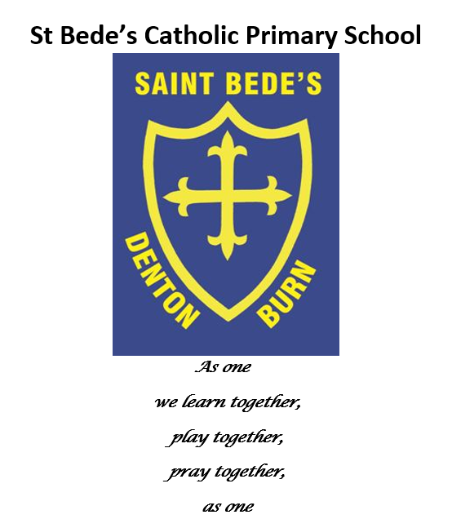Positive Mental Health Policy

Date reviewed: July 2023
Date of next review: July 2024

Introduction

St Bede’s Catholic Primary School recognises the importance of good mental health for our learners and our staff. As an organisation we aim to promote positive mental health for every learner, and every member of staff working in our school.

We aim to do this through a whole organisation approach, ensuring everybody is aware of mental health, and factors that accompany this. In addition to this, we aim to signpost and refer to specialised, targeted approaches for those who are most vulnerable.

St Bede’s follows the principles outlined by the THRIVE approach. The Parent Support Advisor (PSA) is a trained THRIVE practitioner and all staff have completed THRIVE training. In addition to this, Mrs Howell is also a trained Senior Mental Health Lead.

In addition to promoting positive mental health, we aim to recognise and respond to mental ill health. We aim to develop and implement practical and relevant mental health policies, implementing provisions in regards to positive mental health/well-being and mental ill health, ensuring that we are able to promote a safe and stable environment for any individual facing difficulties in this particular area.

Related Documents/Resources

Health & Safety Policy
Child Protection Policy
Safeguarding Policy
Special Needs Policy
DFE Guidance

St Bede’s Catholic Primary School recognises the definition of mental health put forward by the World Health Organisation:

‘Mental Health is a state of well-being in which every individual realises his or her own potential, can cope with the normal stresses of everyday life, can work productively and fruitfully, and is able to make a contribution to his or her community.’

Roles and Responsibilities

The Designated Safeguarding Lead (DSL) will work alongside the PSA/ SEMH Lead and SENDCo to support staff in promoting positive mental health, identifying relevant CPD and signposting staff to build a whole school approach to dealing with mental health issues and generally promoting a learning environment where children feel safe and secure and able to share their feelings.

The Link Safeguarding / SEMH Governor will be kept informed by the PSA and DSL to ensure that they are fully aware of school policy and practise.

Policy Implementation

This policy applies to all teaching, non-teaching, associate and volunteer staff.
St Bede’s Catholic Primary School fully recognises the contribution it can make to promote positive mental health, and also the recognition of those who are most vulnerable, and providing the correct support for those individuals. We are committed to providing an environment where all learners and staff can feel safe, happy and comfortable. There are several key features included within this policy:
- Promote positive mental health (in staff and learners)
- Increase understanding and awareness of common mental health issues
- Alert staff to early warning signs of mental ill health
- Provide support to staff working with young people with mental health issues
- Provide support to learners suffering mental ill health and their peers/parents or careers.

Teaching about Mental Health

The skills, knowledge and understanding of mental health and how to keep ourselves, as well as others, physically and mentally healthy/safe is included within our RSE/ PSHE curriculum.

We will support learners to recognise and understand aspects which cause mental ill health, and will use our curriculum delivery and other appropriate tools to promote positive metal health and develop resilience in our learners.

Signposting

St Bede’s Catholic Primary School will ensure that staff, learners and parents are aware of the different support that we, as an organisation, have available to them, and also from the local community.

We will display relevant sources of information and support around the site, through the use of posters and leaflets that will be on display for learners to see and through our newsletters and website. We will also implement sources of support into the curriculum when relevant, so that we are reinforcing the idea of support.

We will ensure we have relationships with services and support networks and can seek advice and guidance regarding learner and organisation needs when required.

As a school, we also buy into the Road’s Centre Counselling Service to support some of our more vulnerable learners.
.
Warning Signs
St Bede’s Catholic Primary School recognises that any indication of mental ill-health should be taken seriously and staff observing any of these warning signs should communicate these concerns to our DSL or Deputy DSL.
Possible warning signs may include:
- Physical signs of harm that are repeated or appear non-accidental
- Changes in eating/sleeping habits
- Increased isolation from friends or family (socially withdrawn)
- Changes in activity and mood
- Lowering of academic achievement
- Talking or joking about self-harm or suicide
- Abusing drugs or alcohol
- Expressing feelings of failure, uselessness or loss of hope
- Changes in clothing
- Secretive behaviour
- Increase in lateness or absence

Managing Disclosures

A learner / pupil may choose to disclose concerns about themselves or somebody else, and this could be to any member of staff, so all staff need to know how to respond appropriately to a disclosure. Staff should not promise a child that they will keep any disclosure a secret or confidential if this would compromise the student’s safety or well-being, or that of another student.

All disclosures should be recorded in writing and held on the CPOMS system. The information should be shared with the DSL and PSA who will offer support about what the next steps should be.
Records and Confidentiality

Accurate written notes will be kept of all incidents or child protection concerns relating to individual students (stored on CPOMS). We recognise that all matters relating to child protection are confidential. The DSL and PSA will disclose personal information about a learner to other members of staff on a ‘need to know basis’ only. It is important that staff are aware of difficulties in order to consider how best to work educationally with the learner.

All staff have a professional responsibility to share information with other agencies in order to safeguard children.

Working with Parents

St Bede’s Catholic Primary School will consider and determine when it is appropriate to inform parents of any mental ill-health or difficulties that their child may be facing.

We recognise issues around confidentiality and consent and these will be fully taken into account. We understand that we need to be sensitive when informing parents, as they may struggle to accept the information that they have received.

We also recognise that we need to provide further sources of information and give any support that we can provide to families. We will also provide means of contacting us with further questions and consider follow up meetings to discuss any further problems should they arise. Each meeting will end with an agreed upon next step and a record will be kept of the meeting in the learner’s confidential file (stored on CPOMS).

Training

All staff will receive regular training about recognising and responding to mental health issues as part of their regular safeguarding / child protection training, so that they are able to keep learners safe.

