Attendance Policy

Date reviewed: October 2023
Date of next review: October 2024

At St Bede’s we want all of our pupils to be the best they can be and reach their potential. Good attendance and good punctuality are crucial in achieving this.

Why does attendance matter?
There is a direct link between attendance and how well children do in school (their attainment)
The more your child comes to school the more likely they are to achieve in life
If your child is not in school we can’t teach them!

Did you know…?
School is open for 190 days of the year. This leaves 175 non-school days a year for holidays, cultural experiences and family time.
100% attendance offers greater opportunities for a child to be happy and successful in school.
90% attendance means that your child misses on average:
- One half day every week
- Nearly four weeks every school year
- Over one school year in a school career

2 weeks holiday in term time every year with no other absences means that your child:
- Can only ever achieve 95% attendance
- Will miss about two terms in a school career

Also, being 5 minutes late every day means missing about 3 days of school every year.

Aims:
We are committed to meeting our obligation with regards to school attendance through our whole school approach that values good school attendance, including:
- Promoting good attendance
- Ensuring every child has access to full time education
- Building and maintaining a strong relationship with families to enable targeted support to better school attendance
- Reducing absence, including persistent and severe absence
- Acting early to address patterns of absence
- Promoting the importance of arriving to school and lessons on time to support punctuality

Roles and Responsibilities:
The Local Governing Committee (LGC)
The LGC is responsible for:
- Promoting the importance of school attendance across the school’s policies and ethos
- Making sure school leaders fulfil expectations and statutory duties
- Regularly reviewing and challenging attendance data
- Monitoring attendance figures for the whole school
- Making sure staff receive adequate training on attendance
- Holding the headteacher to account for the implementation of this policy

The Headteacher
The headteacher is responsible for:
- Implementation of this policy at the school
- Monitoring school-level absence data and reporting it to governors
- Supporting staff with monitoring the attendance of individual pupils
- Monitoring the impact of any implemented attendance strategies
- Working alongside the Local Authority to issue fixed-penalty notices, where necessary

The designated senior leader responsible for attendance (Mrs Howell)
The designated senior leader is responsible for:
- Leading attendance across the school
- Offering a clear vision for attendance improvement
- Evaluating and monitoring expectations and processes
- Having an oversight of data analysis
- Devising specific strategies to address areas of poor attendance identified through data
- Arranging calls and meetings with parents to discuss attendance issues
- Delivering targeted intervention and support to pupils and families

The designated senior leader responsible for attendance is Mrs Howell and can be contacted via the school telephone number (0191) 2743430

The LA attendance officer
The LA school attendance officer is responsible for:
- Monitoring and analysing attendance data
- Benchmarking attendance data to identify areas of focus for improvement
- Working with relevant school staff to tackle persistent absence.
- Advising the headteacher when to issue fixed-penalty notices

Class teachers
- Class teachers are responsible for recording attendance on a daily basis, using the correct codes, and submitting this information to the school office e by 9.00am each morning and 1.20pm in the afternoon.

School admin staff
School admin staff will:
- Take calls from parents about absence on a day-to-day basis and record it on the school system, informing relevant members of staff.

Parents/carers
Parents/carers are expected to:
- Make sure their child attends every day on time
- Call the school to report their child’s absence before 8.50am on the day of the absence and each subsequent day of absence, and advise when they are expected to return
- Provide the school with more than 1 emergency contact number for their child
- Ensure that, where possible, appointments for their child are made outside of the school day

Pupils
Pupils are expected to:
- Attend school every day on time

100%
99%, 98%, 97%
96% 95%, 94%, 93%, 92%, 91%, 90%
Below 90%
Attendance Zones
- All of our pupils’ attendance is colour-coded based on the number of days that they attend school. This is converted into a percentage.
- WE expect all of our children to achieve ‘gold’ or ‘green’ attendance levels
- We will contact you if we are concerned about your child’s attendance. This will be done either by telephone or a letter home. You may be required to attend an attendance meeting.
- If your child’s attendance falls below 97%, we would like to support you to improve it.

Punctuality:
The school operates a ‘soft opening’ from 8.40am to support working parents and reduce congestion in the neigbouring streets. Pupils can arrive from 8.40am, however the actually school day starts at 8.50am.
All pupil gates are locked at 8.50am. If your child arrives after this time you must bring them to the school office and sign them in on the electronic sign-in system.

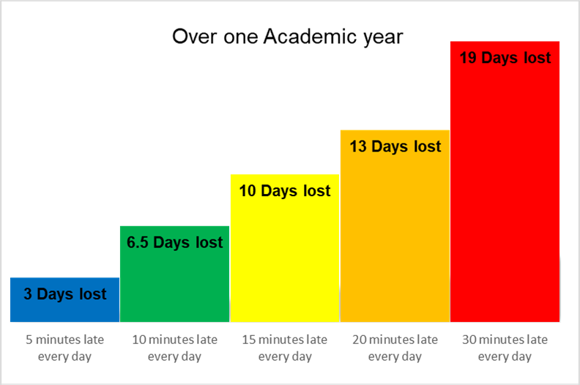
Every minute counts and teaching begins straight away – being on time ensures your child does not miss any learning!

Rewarding Attendance:
At the end of every term, children who have achieved 97% and above will be rewarded with a book prize.
Any children who achieve 100% attendance for the full academic year will receive a special reward
If you need any support regarding your child’s attendance please contact our Parent Support Advisor, Mrs Howell, on the office number.

