Tots to Teams
The Embroidery Specialist
Unit 10b, Airport Industrial Estate, Kingston Park, Newcastle upon Tyne NE3 2EF
Tel: 0191 2715454 Fax : 0191 2716466
E-mail : sales.tots@btconnect.com VAT No: 733811836
ST. BEDE’S R.C. PRIMARY SCHOOL
U N I F O R M P R I C E L I S T : 2022
Item | Colour | 3-4 |  | 5-6 |  | 7-8 | 9-10 |  | 11-12 | 13 | Price
Sweatshirt [Sportex] | Royal |  |  |  |  |  |  |  |  |  | £9.00 *£10.50
Sweat Cardigan  [Sportex] | Royal |  |  |  |  |  |  |  |  |  | £9.50 *£11.00
Polo Shirt [Banner] | Sky |  |  |  |  |  |  |  |  |  | £8.20
Polo Shirt [Banner] | Yellow |  |  |  |  |  |  |  |  |  | £8.20
P.E T-Shirt [Russell] | Yellow |  |  |  |  |  |  |  |  |  | £5.00
Fleece Jacket [Banner] | Royal |  |  |  |  |  |  |  |  |  | £12.25
Mistral Jacket [Banner] | Royal |  |  |  |  |  |  |  |  |  | £17.75
R160 Reversible Waterproof Jacket | Royal |  |  |  |  |  |  |  |  |  | £21.00
*Gingham Dress | Gold |  |  |  |  |  |  |  |  |  | £13.00
Book Bag [QD51] | Royal | [£5.85 + VAT] £7.02
P.E. Bag [QD17] | Royal | [£3.60 + VAT] £4.32
Cap | Royal |  |  |  |  |  |  |  |  |  | £4.75
Wool Hat | Royal |  |  |  |  |  |  |  |  |  | £4.50
Shorts [Shadow Stripe] | Navy | 18”/20” |  |  | 22”/24” |  |  | 26”/28 |  |  | £4.20
Printed Iron-on Name Labels x20 |  |  | [£2.25] + VAT £2.70
*Small Adult Size
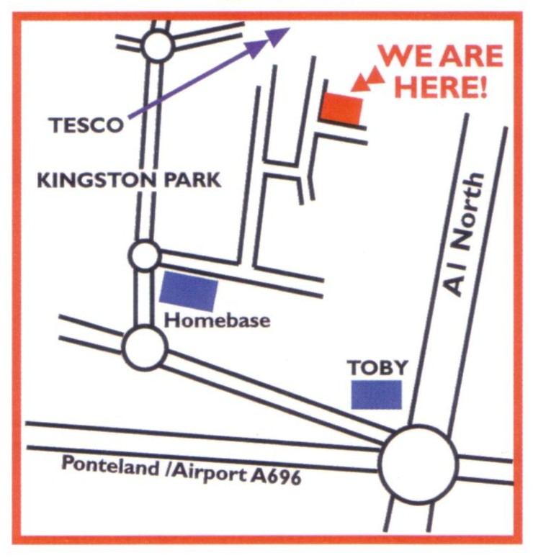
Call in at our shop, situated at the above address, or alternatively use our website easy ordering facility on www.totstoteams.co.uk
Our shop opening hours are :
Monday – Thursday 8am – 4.30pm
Friday 8am – 4.00pm
Saturday 9am – 12 noon
Cash and Card Payments accepted –
Cards £5 and over only

Please note we are closed on Bank Holidays

