

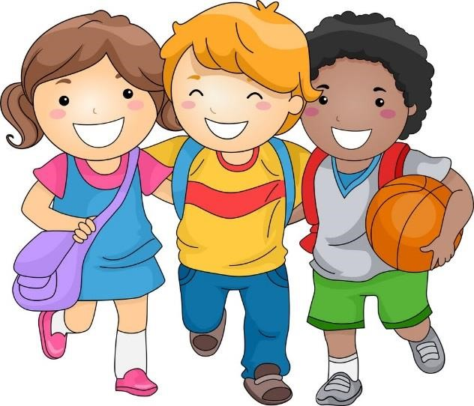

**Years 1 and 2**

**Being Happy at School**

A Child Friendly Child on Child Abuse Policy

Last updated: September 2022

**Being happy at school**

At school we want you to feel safe and happy.

At school we learn to be kind to each other.



When someone is **not** kind we want to know.



**Ways of being unkind**

Sometimes we hurt people but we don’tmean it. When this happens, we say **sorry**. This is what happens **most** of the time in school.

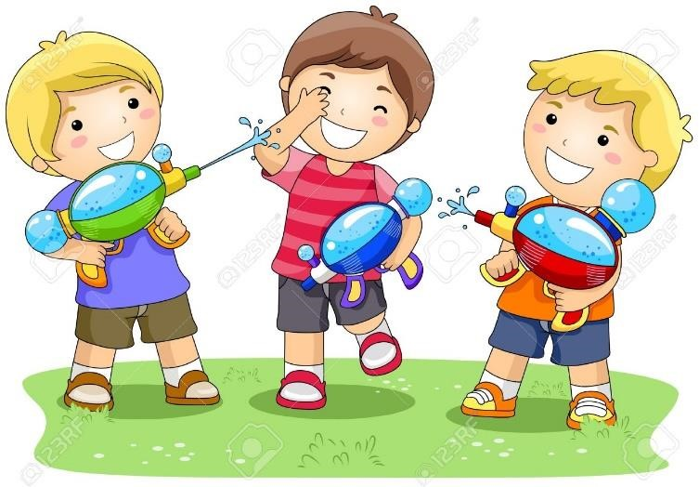

Sometimes you may get **hurt** on **purpose**.

Someone may hurt you by kicking or hitting you.



They may hurt you by making you **feel** silly, calling you names or making you feel **left out.**

**Bullying**

***Bullying is when you keep picking on someone because you think you are better than them or in charge of them.***

* Calling someone **names.**
* Hurting your **feelings.**
* Not letting you **play games.**
* Making fun of someone’s **size.**
* Making fun of the **colour** of **skin.**
* Making fun of the way someone **talks.**
* **Pushing, Punching** or **kicking.**



**Being Friends**

When we are friends it should make us feel **good** and **happy**.

Words for **good** friendships:

fun honest share listen safe trust equal support

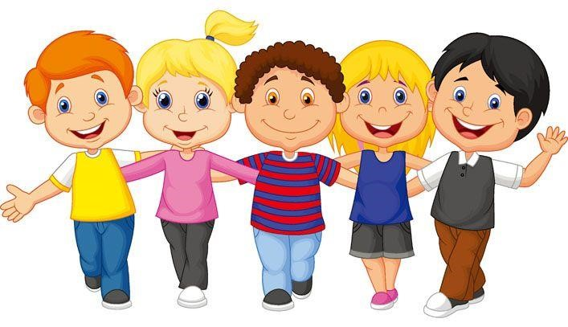

Words for **bad** friendships:

push hit bossy scared angry nervous sad alone

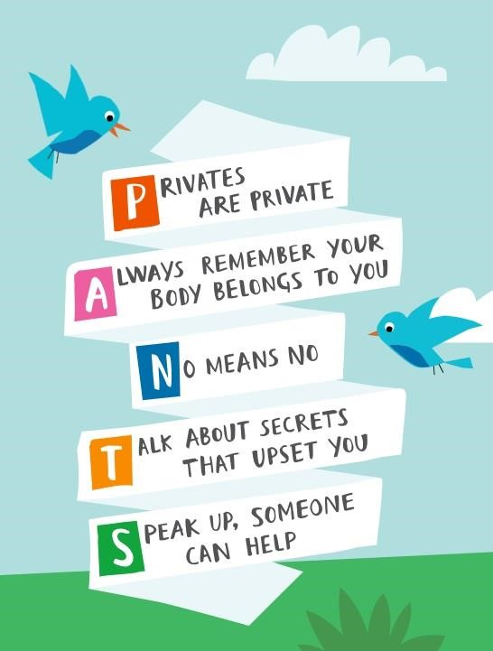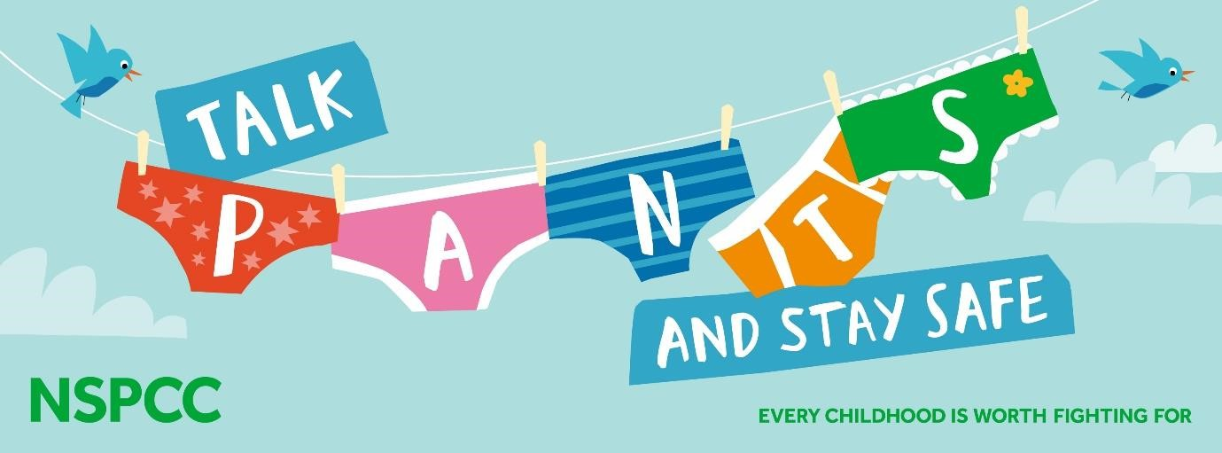

**What do I do if I am being hurt?**

The first thing you should do is **tell someone.**

You could tell the **person,** tell a **friend** or tella **teacher.**

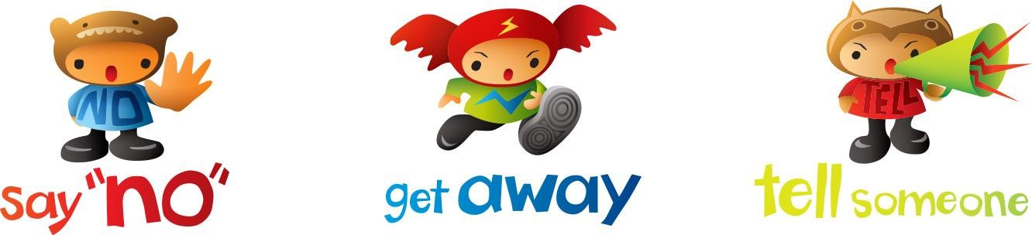

You should **try not** to:

* **Do** what the person says.
* Let what the person says or does **upset** you.
* Get **angry** or hit them.

**Who can I tell?**

If you feel sad or upset **tell someone.**

If your **friend** feels sad or upset **tell someone.**

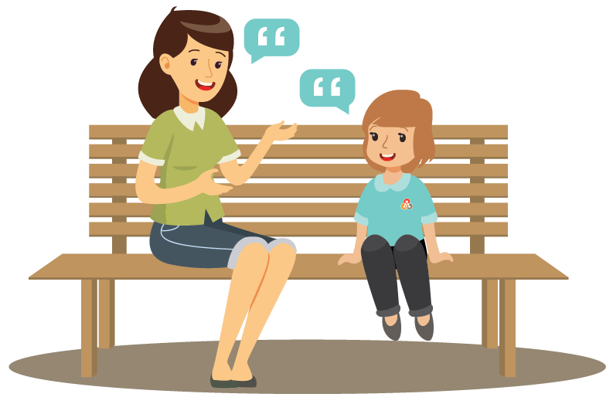

You can tell a **teacher** or an **adult** at **school** or at **home** and they will **help** you.

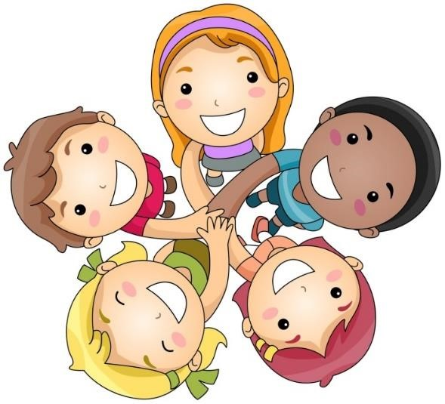

**Let’s keep our school a happy place!**

**Our Statements To Live By …**

1. **We are all special.**
2. **I can say one good thing about myself.**
3. **I can say how I feel.**
4. **I can laugh and have fun.**
5. **I know what to do if I see anyone being hurt.**
6. **I understand that rights match responsibility.**
7. **I try to stand up for myself and others without hurting others.**
8. **I try to be just and fair.**
9. **I can tell you how I look after myself.**
10. **I think before I make choices that affect my health.**
11. **I can work, play, rest and pray each day.**
12. **Simple things can make us happy.**
13. **I try to love others as I love myself.**
14. **I try to follow our school and classroom rules.**
15. **I know I belong in a community that includes my school.**
16. **I know we are happiest when we are united.**
17. **I listen to what you say. I show that I am listening to you.**
18. **I co-operate with others in work and play.**
19. **I try to use words that make the world a better place. (Please, sorry, thank you).**

**20.I try to appreciate the beauty and the wonder in the world around me**

1. **I know that it is ok for me to make mistakes.**
2. **I can learn from my mistakes and failures.**
3. **I try to keep going when things are difficult and not give up hope.**
4. **I know what humility means.**
5. **I know when to ask for help and who to ask for help from.**
6. **I can recognise comfortable and uncomfortable feelings.**
7. **I know how to help others when they are in trouble.**
8. **I understand what trust means.**
9. **I try to forgive people when they hurt me.**
10. **I try to accept forgiveness from others.**
11. **I know how to show I am sorry.**
12. **I understand the importance of peace.**
13. **I know what human dignity means and I show that I respect others.**
14. **I stand up for people who are being treated unfairly.**
15. **I notice that we are the same and we are different.**
16. **I try to be accepting of others.**