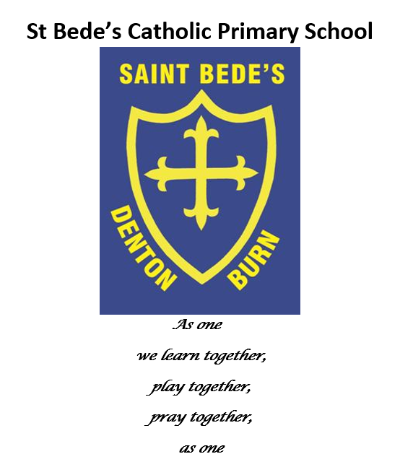

MFL Policy - French

Date reviewed: September 2023
Date of next review: September 2024

“To have another language is to possess a second soul.”
Charlemagne

Intent

It is our intent at St Bede’s to provide all of our children with a high-quality education in Modern Foreign Languages (MFL), which develops their love of learning about other languages and cultures and helps to provide them with an understanding of our rich and diverse world. We aim to build the children’s ‘cultural capital’ through developing positive attitudes towards language learning and building competence in understanding and communicating in French.

Our aim is that pupils will feel confident engaging in spoken French, and develop skills in reading, listening and writing. We hope that all pupils will develop a genuine interest and curiosity about languages, finding them enjoyable and exciting and show a desire to continue their language learning beyond KS2.

We believe that learning another language gives children a balanced and broad perspective on the world, encouraging them to understand their own values, religion and culture and those of others.

Implementation
We follow The Primary French Project scheme of work as part of our broad and balanced curriculum in Key Stage 2. This scheme provides clear progression for the development of the four key skills: speaking, listening, reading and writing. It includes a comprehensive bank of resources to support teaching and learning opportunities for all pupils.

Children in KS2 should:
- Receive a weekly 30-minute French lesson, adapted from The Primary French Project scheme of work.
- Be taught by our PGCE Primary French Specialist.
- Engage in 2x 10-minute consolidation tasks each week, led by Language Learners from each year group.
- Take part in games, role-play, dialogues, action songs and rhymes in order to develop their language acquisition.
- Feel safe and confident to “have-a-go” and be praised for the contributions they make in French, however great or small.

Impact
Our MFL curriculum ensures that all pupils develop key language learning skills set out by the National Curriculum, as well as a love of languages and learning about other cultures.

- Children will become aware that a language has a structure, and that the structure differs from one language to another.
- Children will explore relationships between language and identity, and develop a deeper understanding of other cultures and the world around them
- Children will develop their language and communication through the development of the four key skills of speaking, listening, reading and writing.
- Children will become increasingly familiar with the sounds, structures and written forms of French.
- Children will develop knowledge and understanding of the French culture.
- Children will transfer to KS3 effectively and successfully and will be well prepared to continue and develop their language learning journey.

Guidelines
The 2014 National Curriculum states that the teaching of a foreign language is compulsory in Key Stage 2. It aims to ensure that all pupils can understand and respond to the spoken and written foreign language; speak with increasing confidence, fluency and spontaneity; write at varying length for different purposes and audiences; and discover and develop an appreciation of a range of writing in the language studied.

Links to Core Subjects
English: Links to grammar and punctuation in line with the English curriculum for each year group. Children will further develop their speaking and listening skills through conversation and role-play activities.
Maths: Counting, addition, subtraction games in French.
ICT: Use of the Interactive Whiteboard during activities can be used to encourage word recognition, reading and listening skills. The internet also allows access to the language in “real life”, and can be used as a research tool.
Art and Design: Studying the work of French artists and architects.

Equal Opportunities
All children will be given an equal opportunity to maximise their individual potential; this is regardless of ability, gender, race, religion/beliefs or disability. Activities both within and outside the classroom are planned in a way that encourages full and active participation by all children, matched to their knowledge, understanding and previous experience.

Review Framework
This policy will be reviewed every year (or sooner in the event of revised legislation or guidance).

