St Bede’s Catholic Primary School
Computing Policy

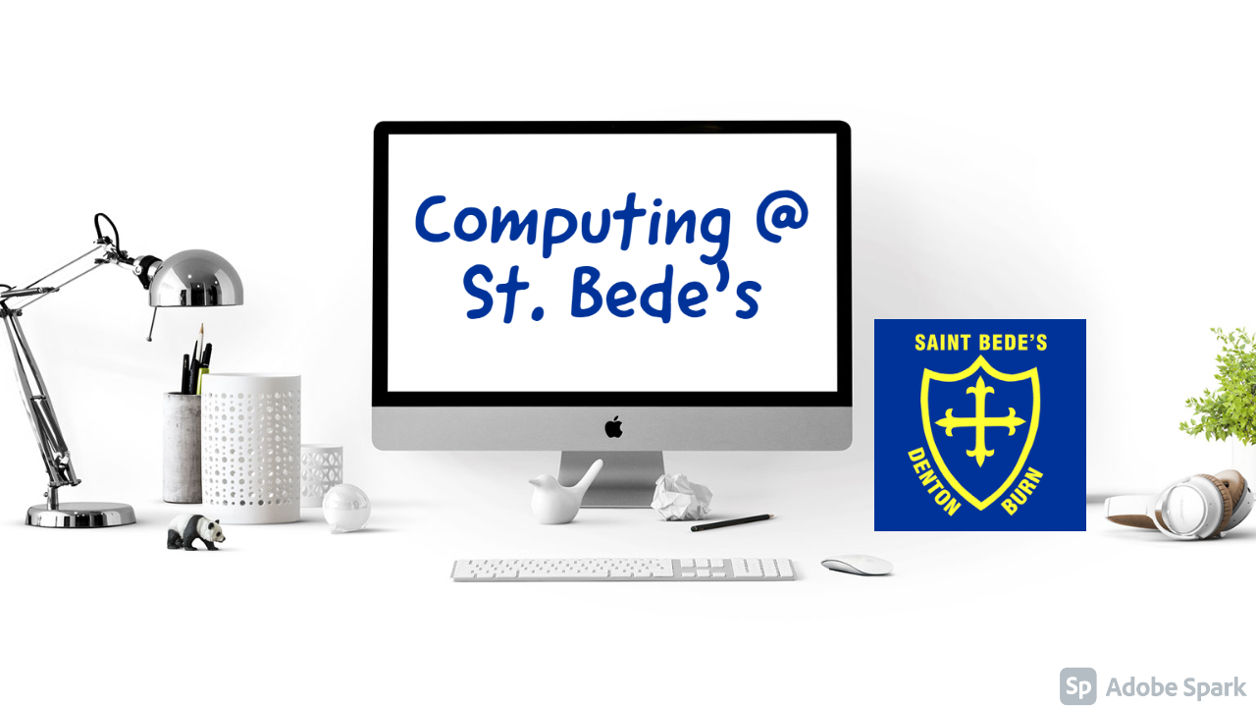

Autumn 2022
Review Date: Autumn 2024

Introduction

Computing and the skills related to computing are an integral part of modern life. As well as being a great tool to enhance the school curriculum across many subjects – the teaching of computing is vital. This policy will detail what Computing looks like at St. Bede’s Catholic Primary School and should be read alongside our Intent, Implementation and Impact statement.

Aims

The overarching aim that drives our computing curriculum is to equip our children with the skills to safely and confidently use technology.

In addition, we strive to:
- Provide a relevant, challenging and exciting computing curriculum for all pupils.
- Meet the requirements of the national curriculum programmes of study for computing.
- Use computing as a tool to enhance learning throughout the curriculum.
- Respond to new developments in technology.
- Equip pupils with the confidence and capability to use computing throughout their later life.
- Develop the understanding of how to use computing safely and responsibly.

The national curriculum for computing aims to ensure that all pupils:

- Can understand and apply the fundamental principles of computer science, including logic, algorithms, data representation, and communication
- Can analyse problems in computational terms, and have repeated practical experience of writing computer programs in order to solve such problems
- Can evaluate and apply information technology, including new or unfamiliar technologies, analytically to solve problems.
- Are responsible, competent, confident and creative users of information and communication technology.

Rationale

At St. Bede’s, we believe that computing:
- Gives pupils immediate access to a rich source of materials.
- Can enable information to presented in different ways.
- Can motivate and enthuse pupils.
- Can help pupils focus and concentrate.
- Has the flexibility to meet the individual needs and abilities of each pupil.
- Can inspire the next generation of inventors, engineers and computer scientists.

Objectives

Early Years

It is important in the foundation stage to give children a broad, play-based experience of ICT in a range of contexts, including outdoor play. Computing is not just about computers. Early years learning environments should feature scenarios based on experience in the real world, such as in role play. Children gain confidence, control and language skills through opportunities to explore using noncomputer based resources such as metal detectors, controllable traffic lights and walkie-talkie sets. Recording devices can support children to develop their communication skills. This is particular useful with children who have English as an additional language.

A bespoke computing curriculum has been developed for children in our Reception class to ensure they are prepared for the national curriculum computing offer in Key Stage One and Two. This curriculum encourages the use of language and exploratory opportunities that form the foundations that are built upon when pupils progress through school. We have invested in high quality equipment to support this solid start to computing.

Key Stage One

By the end of key stage 1 pupils should be taught to:

- Understand what algorithms are, how they are implemented as programs on digital devices, and that programs execute by following a sequence of instructions
- Write and test simple programs

- Use logical reasoning to predict and computing the behaviour of simple programs
- Organise, store, manipulate and retrieve data in a range of digital formats
- Communicate safely and respectfully online, keeping personal information private, and recognise common uses of information technology beyond school.

Key Stage Two

By the end of key stage 2 pupils should be taught to:

- Design and write programs that accomplish specific goals, including controlling or simulating physical systems; solve problems by decomposing them into smaller parts
- Use sequence, selection, and repetition in programs; work with variables and various forms of input and output; generate appropriate inputs and predicted outputs to test programs
- Use logical reasoning to explain how a simple algorithm works and to detect and correct errors in algorithms and programs
- Understand computer networks including the internet; how they can provide multiple services, such as the world-wide web; and the opportunities they offer for communication and collaboration
- Describe how internet search engines find and store data; use search engines effectively; be discerning in evaluating digital content; respect individuals and intellectual property; use technology responsibly, securely and safely
- Select, use and combine a variety of software (including internet services) on a range of digital devices to accomplish given goals, including collecting, analysing, evaluating and presenting data and information.

Resources and access

The school acknowledges the need to continually maintain, update and develop its resources and to make progress towards a consistent, compatible system by investing in resources that will effectively deliver the strands of the national curriculum and support the use of computing across the school. Teachers are required to inform the computing coordinator and/or our IT support team of any faults as soon as they are noticed in a log book or via email. Resources, if not classroom based, are located in the computer areas or stored away by the computing coordinator. Service level agreements with IT Assist and Gem Education are currently in place to help support the staff in school with equipment, resources, workshops and training.

Planning

The school is using a Computing Scheme of Work produced by the computing coordinator in collaboration with Animate2Educate. This curriculum overview is supported by further opportunities from NAACE (the education technology association). Our taught sessions are supplemented by workshops planned, prepared and delivered by GEM education. The combination of these schemes of work and externally provided workshops allow us to deliver a high-quality computing curriculum.

Teachers adapt planning and resources to meet the needs of children in their classes – offering both support to those who require it and additional opportunities for challenge where possible.

Our curriculum overview works on the basis that 50% of our curriculum time is focused on digital literacy and creativity, 30% focused on computer science and 20% focused on online safety.

Digital Leaders

During the course of the 2020-2021 academic year, a group of ‘Digital Leaders’ will be established to raise the profile of computing at St. Bede’s. This group, made up of several Year 6 pupils will be tasked with planning and delivering workshops for classes, attending and running computing clubs and assisting with the implementation of technology in school.

Assessment and record keeping

Assessment in computing is currently fulfilled formatively. This is where teachers monitor the pupils completing short focused tasks and activities. They provide pupils and teaching staff with the opportunity to reflect on their learning in the context of the agreed success criteria. This feeds into planning for the next lesson or activity and allows pupils to build upon their learning.

Throughout 2020-2021, the computing coordinator will explore further ways to assess pupils in computing to ensure any gaps in curriculum knowledge and understanding can be addressed and further supported.

Monitoring and evaluation

The computing coordinator is responsible for monitoring the standard of the children’s work and the quality of teaching. As well as having work saved in folders on the school server, staff and pupils can now save work on our online learning journal – Seesaw – this is something that will be embedded throughout 2020-2021.

The computing coordinator is also responsible for supporting colleagues in the teaching of computing, for being informed about current developments in the subject, and for providing a strategic lead and direction for the subject in the school. This will be achieved through attending computing networks, offering staff training and informal support too.

The governors will ensure this policy is reviewed.

Equal opportunities

We will ensure that all children are provided with the same learning opportunities whatever their social class, gender, culture, race, disability or learning difficulties. As a result we hope to enable all children to develop positive attitudes towards others. All pupils have equal access to computing and all staff members follow the equal opportunities policy. Resources for children unable to access the computing curriculum in its original form will be produced and adapted accordingly.

We also appreciate that computing and technology can provide some pupils (e.g. those with particular SEND) opportunities to access the curriculum – this will be encouraged, supported and celebrated where possible.

Health and safety (see also health and safety policy)

The school is aware of the health and safety issues involved in children’s use of ICT and computing.

- All fixed electrical appliances in school are tested by a LA contractor every five years and all portable electrical equipment in school is tested by an external contractor every twelve months. It is advised that staff should not bring their own electrical equipment in to school but if this is necessary, then the equipment must be PAT tested before being used in school.

- Damaged equipment should be reported to the computing coordinator, IT support or school admin who will arrange for repair or disposal.

- Children should not put plugs into sockets or switch the sockets on.

- Trailing leads should be made safe behind the equipment

- Liquids must not be taken near the computing equipment.

- E-safety forms an integral part of the curriculum and the school will deliver further education through assemblies and parent presentations.

Security

- The IT support team (Mercu) will be responsible for regularly updating anti-virus software.
- All pupils will be aware of the school rules for responsible use on login to the network and will understand the consequence of any misuse.
- The agreed rules for safe and responsible use of computing technology and the internet will be frequently visited in classes.

Date: Autumn 2022
To be reviewed: Autumn 2024

