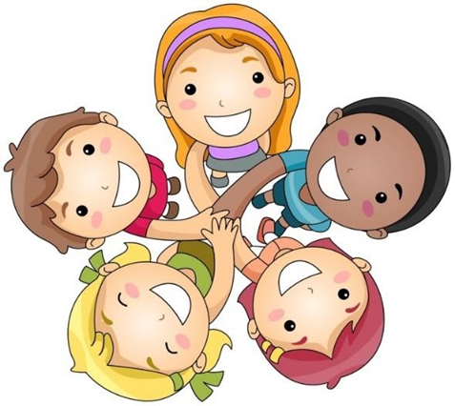

Years 3 and 4
Feeling safe and happy at school

A Child Friendly Child-on-Child Abuse Policy
Last updated: September 2022

Feeling safe and happy at school

At St Bede’s, we want you to feel looked after, safe and happy. Sometimes we don’t know if something bad is happening, so you need to tell us.
It is good to tell someone in school so we can do something about it straight away.
This booklet talks about some of the things that might make people feel sad or unsafe.
We come to school to learn how to live, work and play together. Sometimes we can make mistakes and our actions can make another child feel unhappy or unsafe. When this happens over and over again it is called child-on child abuse.
We can help you by:
- Teaching you what child-on-child abuse is.
- Teaching you what to do if you feel like you are being abused, or if someone else is being abused.
- Making sure you know the grown-ups you can speak to if you are worried.

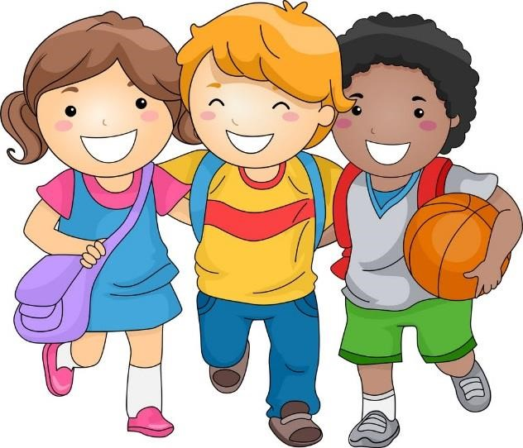

What is child-on child abuse?
A child is a young person who might be your friend, a someone who is at school with you, or another young person you may know.
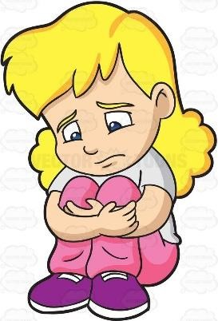
Abuse is when someone hurts someone else on purpose. A child might hurt someone physically by kicking or hitting them. Sometimes they might hurt them emotionally by calling them names, leaving them out, threatening or making someone feel very embarrassed.
Sometimes, it can be hard to know when abuse is happening, because not all abuse will hurt, scare or upset you, and you might not know it is happening.
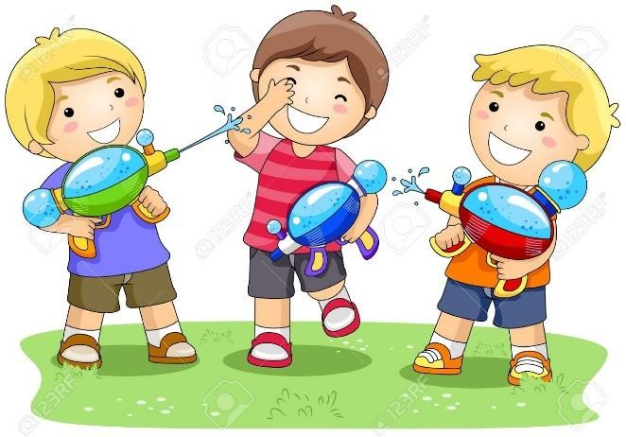
Also, it might not be happening on purpose such as bumping into each other in a line, or when someone says something as a joke but it still upsets us. You know they didn’t mean it if they say sorry and stop doing it.
It’s really important you know when you are being abused so we can make sure it stops.
Here is some more information about different kinds of abuse.

Bullying
Bullying is when you keep picking on someone because you think you’re cooler, smarter, stronger or better than them.
Bullying can be different things, and isn’t just hitting or kicking another person.
Emotional bullying is hurting someone’s feelings, leaving them out or bossing them about.
Physical bullying is punching, kicking, spitting, hitting or pushing someone.
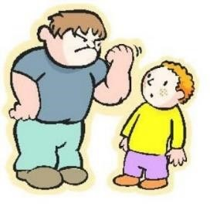
Verbal bullying is teasing someone, calling them names or using rude hand signs. People can also use verbal bullying to be racist or homophobic.
Racist means bullying someone because of their skin colour, race or what they believe in.
Homophobic means bullying someone because of their gender or sexuality; calling someone gay or lesbian to hurt their feelings would be homophobic.
Sexist means bullying someone because of their sex (whether they are a boy or a girl).
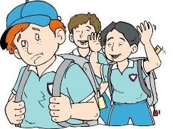
Cyber bullying involves sending horrid messages over the internet or by text message.
Bullying can be done through another person, by one person sending another person to say nasty things.
Relationships
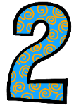
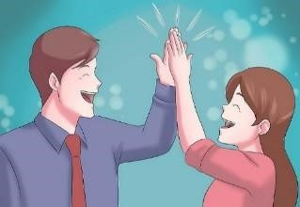
Any relationship you have should be good and happy. A bad relationship might make someone feel scared, confused, worried and even unsafe.
It’s really important that you know the difference between a good relationship and a bad relationship.

Good Relationships
- You are happy and comfortable around that person. They make you smile and feel good about yourself.
- You can be honest with that person and tell them the truth. They won’t make fun of you for being yourself.
- You can say how you feel, what you are thinking and you listen to each other.
- You support each other and treat each other nicely.
- You feel safe.
- You trust that person.
- You are equal – you don’t boss each other around or tell each other what to do.
- You feel looked after.
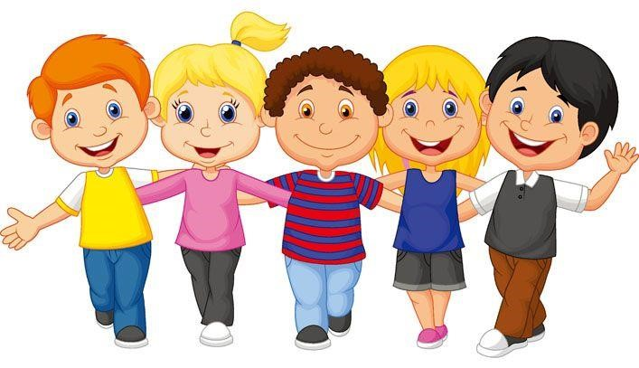

Bad Relationships

- The person might push you, hit you or destroy your things.

- The person might tell you what to do, what to wear or who you can see.

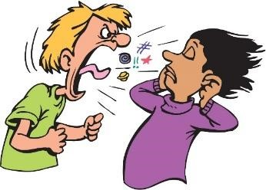
- You might feel scared – they might say they will hurt you if you don’t do something. They might also say they will hurt you if you do something too.

- The person calls you names, makes you feel bad in front of other people and makes you feel bad about yourself.

- The person gets angry easily and you don’t know what will make them angry – it might make you feel nervous.

- The person might not take no for answer when you say you don’t want to do something.

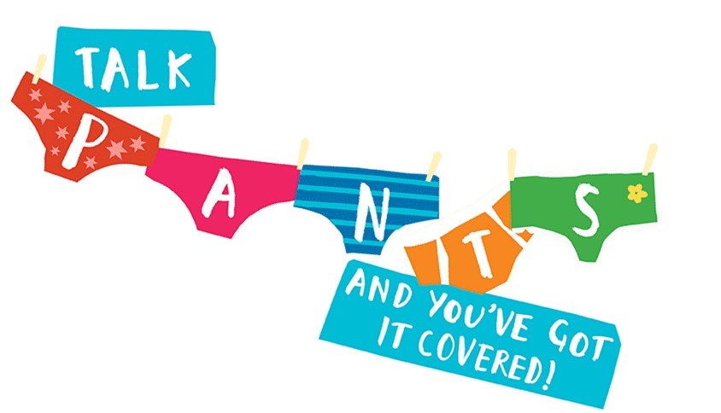
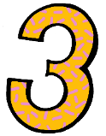
Privates are Private
Sometimes, people can make us feel uncomfortable or embarrassed by saying rude things or playing rude games.
It could be:
- Someone making rude comments, like telling stories or saying rude things.

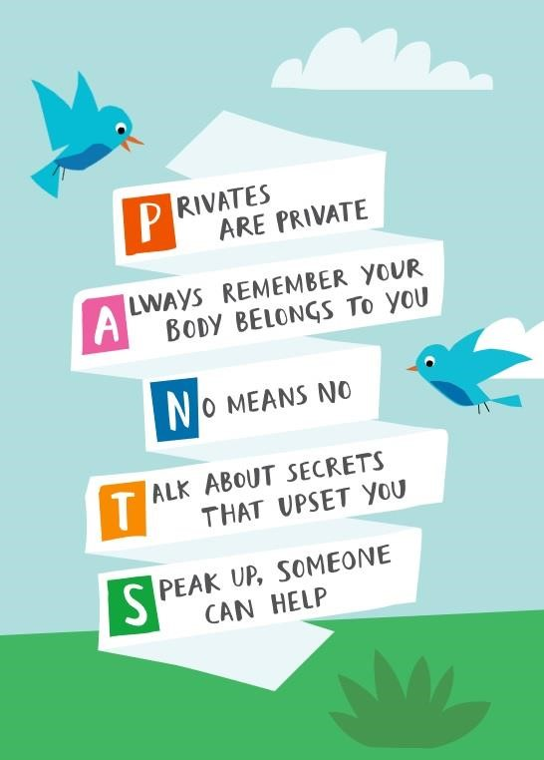
- Calling someone rude names or making rude jokes.

- Being physical, like touching which makes you feel uncomfortable, messing with your clothes, or showing pictures or drawings which are rude.

- If you feel like this then
SPEAK UP, SOMEONE CAN HELP!

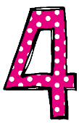
How do I know if someone is being abused?
It might be hard for you to know if you are being abused and you might not really understand it is happening. It is important you can recognise when behaviour isn’t appropriate.
It’s also important that you can notice when someone else might be being abused.

Some signs might be:
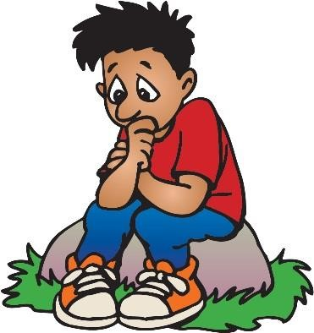
- Not going to school.
- Having injuries, like bruises.
- Feeling sad and down.
- Feeling withdrawn or shy.
- Getting headaches or stomach ache.
- Feeling nervous.
- Not being able to sleep, sleeping too much or getting nightmares.
- Feeling panicked.
- Changing looks to look much older.
- Being abusive to someone else.

Remember: you can feel all of these things too without being abused.
Listen to how you feel, and know that these signs can mean you are being abused.

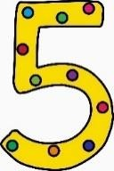
What do I do if I am being abused?
The first thing you should do is tell someone you trust. This could be a family member, a friend or a teacher.

You can also tell the person abusing you to leave you alone. If telling them to leave you alone would make you feel too scared or worried that they might hurt you, make sure you tell someone so they can help.
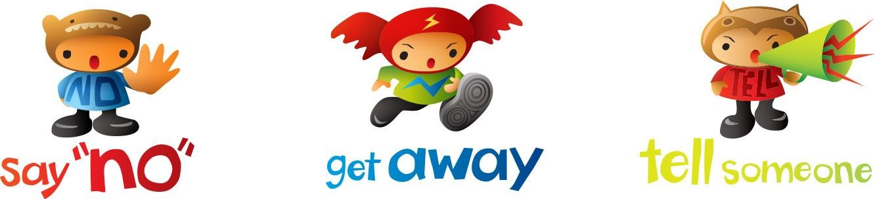

You should try not to:
- Do what the person says.
- Let what the person says or does upset you.
- Get angry or hit them.

Always remember that if you are being abused, it is not your fault and you are never alone.
You shouldn’t be scared to talk to someone if you are being abused. If you talk to a grown-up, we can make the abuse stop.
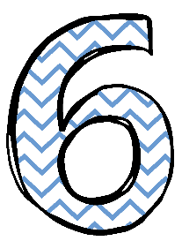
What do I do if someone else is being abused?
If you see someone else being abused, it is important that you help that person.

You should never walk way and ignore the problem if you see someone else being abused, because the person might keep upsetting them.
If you can, and it is safe to do so, tell the person abusing you to stop, but never get angry or hit them.
Tell a grown-up, such as a teacher, as soon as you’ve seen someone being abused.
Grown-ups can stop the abuse and make that person feel happy again.
You should never feel scared to tell someone about abuse.
Sometimes, you might not see someone being abused, but you might be worried about them.
It’s really important you tell someone even if you are worried, but haven’t seen any abuse.

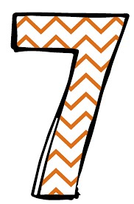
Who can I talk to?
It is important you tell someone as soon as you are being abused, or you notice someone else being abused.

Speaking to someone like your mum, dad, carer or teacher will mean that we can make sure the abuse stops and doesn’t happen again.
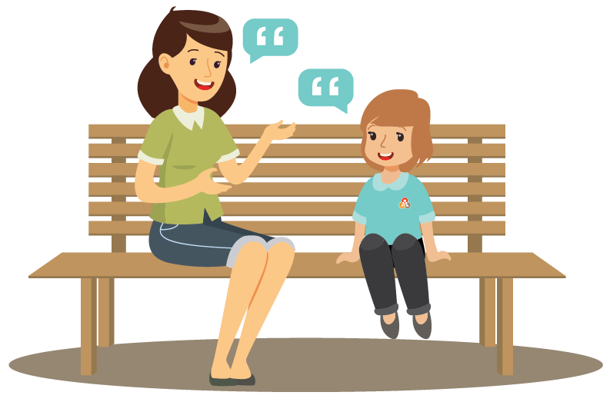

The list below shows the grown-ups at our school that you can speak to:
- Your teacher
- Your support staff
- Mrs Howell
- Mrs Young
- Mr Keys
- Miss Cumming or Mrs Walton in the office
- Or any of the grown ups that you know in school
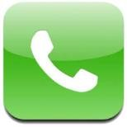 NSPCC Childline: 0800 1111

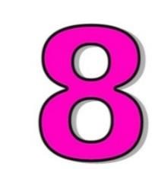
How can I help stop abuse from happening?

We can all help stop abuse at our school by:

- Making sure we understand how we should act towards others.
- Helping others when they are in need.
- Being kind, friendly and respectful to others.
- Thinking about people’s feelings before we say or do something.
- Taking part in school activities, like assemblies, PSHE lessons and circle time, which talk about peer-on-peer abuse.
- Follow our Statements To Live By.
- Talking to someone when we are worried.

You should know that abuse is never OK and it is serious. It is not funny, or part of growing up. If you abuse someone, you will get into trouble.

Let’s keep our school a happy place!

Our Statements To Live By …
- We are all special.
- I can say one good thing about myself.
- I can say how I feel.
- I can laugh and have fun.
- I know what to do if I see anyone being hurt.
- I understand that rights match responsibility.
- I try to stand up for myself and others without hurting others.
- I try to be just and fair.
- I can tell you how I look after myself.
- I think before I make choices that affect my health.
- I can work, play, rest and pray each day.
- Simple things can make us happy.
- I try to love others as I love myself.
- I try to follow our school and classroom rules.
- I know I belong in a community that includes my school.
- I know we are happiest when we are united.
- I listen to what you say. I show that I am listening to you.
- I co-operate with others in work and play.
- I try to use words that make the world a better place. (Please, sorry, thank you).
20.I try to appreciate the beauty and the wonder in the world around me
- I know that it is ok for me to make mistakes.
- I can learn from my mistakes and failures.
- I try to keep going when things are difficult and not give up hope.
- I know what humility means.
- I know when to ask for help and who to ask for help from.
- I can recognise comfortable and uncomfortable feelings.
- I know how to help others when they are in trouble.
- I understand what trust means.
- I try to forgive people when they hurt me.
- I try to accept forgiveness from others.
- I know how to show I am sorry.
- I understand the importance of peace.
- I know what human dignity means and I show that I respect others.
- I stand up for people who are being treated unfairly.
- I notice that we are the same and we are different.
- I try to be accepting of others.

