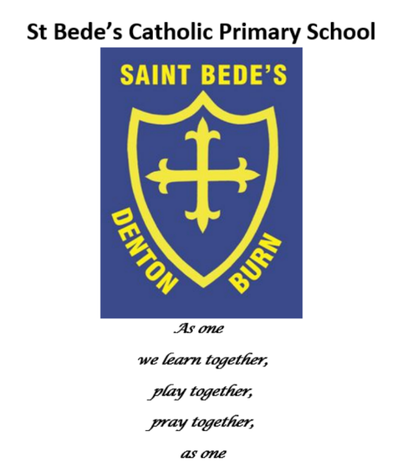

We pray together…
School Prayer Booklet

School Prayers
At St Bede's Catholic Primary School, the children are taught traditional Catholic prayers in certain year groups. These prayers can also be shared to be used at home to support parents in developing their children's knowledge of prayer and to continue to develop their children's understanding of what the words mean to us as Christians today.

Praying hands
The Sign of the Cross (Reception)
In the name of the father,
and of the Son
and of the Holy Spirit.
Amen

Hail Mary (Reception)
Hail Mary, full of grace, the Lord is with thee.
Blessed art thou among women, and blessed is
the fruit of thy womb, Jesus.
Holy Mary, Mother of God, pray for us sinners,
now, and at the hour of our death.
Amen.

Our Father (Reception)
Our Father, Who art in Heaven, hallowed be
Thy Name. Thy Kingdom come. Thy Will be done,
on earth, as it is in Heaven. Give us this day our
daily bread and forgive us our trespasses as we
forgive those who trespass against us; and lead us
not into temptation, but deliver us from evil.
Amen.

Morning Prayer (Reception)
Oh my God, you love me.
You’re with me night and day.
I want to please you always in all I do and say.
I’ll try to please you Father, bless me through the day.
Amen

Evening Prayer (Reception)
God our Father, I come to say
thank you for your love today.
Thank you for my family
and all the friends you give to me.
Guard me in the dark of night
and in the morning send your light.
Amen.

Grace before Meals Prayer (Reception)
Bless us, O God, as we sit together.
Bless the food we eat today.
Bless the hands that made the food.
Bless us, O God.
Amen.

Grace after Meals Prayer (Reception)
Thank you, God, for the food we have eaten.
Thank you, God, for all our friends.
Thank you, God, for everything,
Thank you God.
Amen

Glory Be (Y1)
Glory be to the Father, and to the Son, and to the Holy Spirit,
as it was in the beginning, is now, and ever shall be, world without end.
Amen.

Prayer to the Guardian Angel (Y1)
Angel sent by God to guide me,
be my light and walk beside me;
be my guardian and protect me;
on the paths of life direct me.

Eternal Rest (Y2)
Eternal rest give unto them, O Lord.
And let perpetual light shine upon them.
May they rest in peace.
Amen.

The Angelus (Y3)
The Angel of the Lord declared to Mary: and she conceived of the Holy Spirit.
Hail Mary... Holy Mary...
Behold the handmaid of the Lord: be it done to me according to your word.
Hail Mary... Holy Mary...
And the Word was made flesh: and dwelt among us
Pray for us, O holy Mother of God. That we may be made worthy of the promises of Christ.

Let us pray:
Pour forth, we beseech you, O Lord,
your grace into our hearts,
that we to whom the incarnation of Christ, your Son,
was made known by the message of an angel,
may be brought by his passion and cross
to the glory of his resurrection,
through Christ our Lord. Amen.

Eucharist Act of Sorrow (Y3)
O my God, I thank you for loving me.
I am sorry for all my sins:
for not loving others
and not loving you.
Help me to live like Jesus
and not sin again.
Amen.

The Memorare (Y4)
Remember, O most loving Virgin Mary,
that it is a thing unheard of,
that anyone ever had recourse to your protection,
implored your help,
or sought your intercession,
and was left forsaken
Filled therefore with confidence in your goodness
I fly to you, O Mother, Virgin of virgins.
To you I come, before you I stand, a sorrowful sinner.
Despise not my poor words,
O Mother of the Word of God,
but graciously hear and grant my prayer.
Amen.

The Magnificat (Y5/6)
My soul glorifies the Lord,
My spirit rejoices in God, my Saviour.
He looks on his servant in her loneliness;
henceforth all ages will call me blessed.
The Almighty works marvels for me.
Holy his name!
His mercy is from age to age, on those who fear him.
He puts forth his arm in strength and scatters the proud-hearted.
He casts the mighty from their thrones and raises the lowly.
He fills the starving with good things, sends the rich away empty.
He protects Israel, his servant,
remembering his mercy, the mercy promised to our fathers,
to Abraham and his sons for ever.

Nunc Dimittis (Y5/6)
At last, all powerful Master,
you give leave to your servant to go in peace,
according to your promise.
For my eyes have seen your salvation
which you have prepared for all nations,
the light to enlighten the Gentiles
and give glory to Israel, your people.
Give praise to the Father almighty,
to his Son, Jesus Christ, the Lord,
to the Spirit, who dwells in our hearts,
both now and forever.
Amen.

Holy Spirit Benedictus (Y5/6)
Blessed be the Lord, the God of Israel;
he has come to his people and set them free.
He has raised up for us a mighty saviour,
born of the house of his servant David.
Through his holy prophets he promised of old
that he would save us from our enemies,
from the hands of all who hate us.
He promised to show mercy to our fathers
and to remember his holy covenant.
This was the oath he swore to our father Abraham:
to set us free from the hands of our enemies,
free to worship him without fear,
holy and righteous in his sight all the days of our life.
You, my child, shall be called the prophet of the Most High;
for you will go before the Lord to prepare his way,
to give his people knowledge of salvation
by the forgiveness of their sins.
In the tender compassion of our God
the dawn from on high shall break upon us,
to shine on those who dwell in darkness and the shadow of death,
and to guide our feet into the way of peace.
Glory to the Father and to the Son and to the Holy Spirit,
as it was in the beginning, is now, and will be forever.
Amen.

Prayer to the Holy Spirit (Y6)
O Come, Holy Spirit,
fill the hearts of your faithful,
and enkindle in them the fire of your love.
Send forth your Spirit and they shall be created.
And you shall renew
the face of the earth.
O God, who has taught the hearts of the faithful
by the light of the Holy Spirit,
grant that by the gift of that same Spirit
we may be always truly wise
and ever rejoice in his consolation.

Apostles Creed (Y6)
I believe in God the Father Almighty, Creator of Heaven and earth,
and in Jesus Christ, His only Son, our Lord, Who was conceived by
the Holy Spirit, born of the Virgin Mary, suffered under Pontius Pilate,
was crucified, died, and was buried.
He descended into Hell; the third day He arose again from the dead;
He ascended into Heaven and is seated at the right hand of God
the Father Almighty, from thence He shall come
to judge the living and the dead.
I believe in the Holy Spirit, the Holy Catholic Church,
the Communion of Saints, the forgiveness of sins,
the resurrection of the body, and life everlasting.
Amen.

