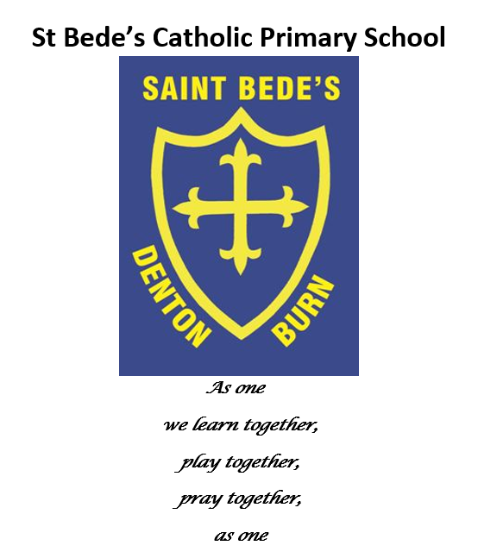

Humanities Policy

Date reviewed: July 2023
Date of next review: July 2024

Our Vision

St Bede’s Catholic Primary School aims develop the whole child. Our priority is to create conditions to enable every child to stimulate their natural curiosity and apply their creative thinking. Our curriculum has been designed to empower all our pupils to have curious minds and become active, confident, independent learners, giving each child ‘the opportunity to think’ rather than telling them ‘what to think.’ We embrace and celebrate every child’s uniqueness, continually providing opportunities to develop their resilience, knowledge and skills, thus providing them with the cultural capital necessary to live a happy, healthy, truly fulfilling life.

At St Bede’s Catholic Primary School we aim for all pupils to receive a broad experience in the Humanities subjects. Geography and History will feature either as part of the termly projects taught in school or as a stand-alone unit of work. Reference to type of humanities the children are exploring will be stated prior to each unit of work eg History, Geography.

Intent
A high-quality history education aims to provide pupils with opportunities to investigate the past and make sense of why and when important events happened, as well as introducing them to key historical figures.

A high-quality geography education should provide pupils with an opportunity to study the world and the human and physical processes which help to shape it. Pupils have a chance to study their local area and contrast it with other places around the world. Geography enables children to gain a greater understanding of the lives and cultures of people from around the world.

Our aims:
- Children are engaged and motivated to deepen their knowledge in specific areas linked to the National Curriculum.
- Develop cross curricular links and strengthen further links with the local and wider community and global world.
- Deepen children’s knowledge and understanding by planning extracurricular visits.
- Increase children’s knowledge of local history and geography.
- Learn how to interpret the past using high quality resources.
- Carry out local geographical studies and compare to alternative locations.
- Encourage children to build up a deeper appreciation of where we come from and what aspects of history have influenced modern day.

Implementation
- Design and construct a varied and engaging long term plan that is ambitious and ensures the projects are linked to the National Curriculum but are also linked to the interests of the children in school.
- Enable pupils to recognise that Geography is the study of people and places and the interaction between them and develop an awareness that the past has lessons for the present and future.
- Build and use a wide range of geographical vocabulary and relate this to English Language as a whole.
- Integrate fieldwork / trips as an important part of the enquiry process.
- Help pupils deal, openly and sensitively, with issues of environmental change and sustainable development.
- Use a variety of resources, including ICT to develop teaching and learning The National Curriculum Themes and Breadth of Study.
- Teachers have good knowledge of the subject they are teaching.
- Visitors are invited from the local and wider community to share their knowledge of the surrounding area, including visitors linked to the local church, historians and professionals.

History Content

Key Stage 1

Pupils should be taught about:
- Changes in living memory. Where appropriate, these should be used to reveal aspects of change in national life.
- Events beyond living memory that are significant nationally or globally.
- The lives of significant individuals in the past who have contributed to national and international achievements. Some should be used to compare aspects of life in different periods.
- Significant historical events, people and places in their own locality.

Key Stage 2

Pupils should be taught about:
- Changes in Britain from the Stone Age to the Iron Age.
- The Roman Empire and its impact on Britain.
- Britain’s settlement by Anglo-Saxons and Scots.
- The Viking and Anglo-Saxon struggle for the Kingdom of England to the time of Edward the Confessor.
- A local history study.
- A study of an aspect or theme in British History that extends pupils’ chronological knowledge beyond 1066.
- The achievements of the earliest civilisations – an overview of where and when the first civilisations appeared and a depth study of one of the following: Ancient Sumer, the Indus Valley, Ancient Egypt, the Shang Dynasty of Ancient China.
- Ancient Greece – a study of Greek life and achievements and their influence on the western world.
- A non-European society that provides contrasts with British history – one study chosen from: early Islamic civilisation, including a study of Baghdad c AD900; Mayan civilisation c AD900; Benin (West Africa) c AD900-1300.

Geography Content

Key Stage 1

Locational Knowledge Pupils should be taught to:
- name and locate the world’s seven continents and five oceans.
- name, locate and identify characteristics of the four countries and capital cities of the United Kingdom and its surrounding seas.

Place Knowledge
- understand geographical similarities and differences through studying the human and physical geography of a small area of the United Kingdom, and of a small area in a contrasting non-European country.

Human and Physical Geography
- identify seasonal and daily weather patterns in the UK and the location of hot and cold areas of the world in relation to the Equator and the North and South Poles.

Use basic geographical knowledge to refer to:
- key physical features, including: beach, cliff, coast, forest, hill, mountain, sea, ocean, river, soil, valley, vegetation, season and weather,
- key human features, including: city, town, village, factory, farm, house, office, port, harbour and shop

Geographical skills and fieldwork
- use world maps, atlases and globes to identify the UK and its countries, as well as the countries, continents and oceans studied at this key stage.
- use simple compass directions and locational and directional language to describe the location of features and routes on a map.
- use aerial photographs and plan perspectives to recognise landmarks and basic human and physical features; devise a simple map; and use and construct basic symbols in a key.
- use simple fieldwork and observational skills to study the geography of their school and its grounds and the key human and physical features of its surrounding environment.

Key Stage 2

Locational knowledge
- Locate the world’s countries, using maps to focus on Europe (including the location of Russia) and North and South America, concentrating on their environmental regions, key physical and human characteristics, countries, and major cities
- name and locate counties and cities of the United Kingdom, geographical regions and their identifying human and physical characteristics, key topographical features (including hills, mountains, coasts and rivers), and land-use patterns; and understand how some of these aspects have changed over time
- identify the position and significance of latitude, longitude, Equator, Northern Hemisphere, Southern Hemisphere, the Tropics of Cancer and Capricorn, Arctic and Antarctic Circle, the Prime/Greenwich Meridian and time zones (including day and night)

Place knowledge
- understand geographical similarities and differences through the study of human and physical geography of a region of the United Kingdom, a region in a European country, and a region in North or South America

Human and physical geography

Describe and understand key aspects of:
- physical geography, including: climate zones, biomes and vegetation belts, rivers, mountains, volcanoes and earthquakes, and the water cycle
- human geography, including: types of settlement and land use, economic activity including trade links, and the distribution of natural resources including energy, food, minerals and water

Geographical skills and fieldwork
- use maps, atlases, globes and digital/computer mapping to locate countries and describe features studied
- use the 8 points of a compass, 4- and 6-figure grid references, symbols and key (including the use of Ordnance Survey maps) to build their knowledge of the United Kingdom and the wider world
- use fieldwork to observe, measure record and present the human and physical features in the local area using a range of methods, including sketch maps, plans and graphs, and digital technologies

EYFS
Humanities has been referenced in ‘Understanding the World’ in the new Early Learning Goals as set out in the Early Years Foundation Stage Statutory Framework 2021. These goals are addressed through topic content throughout the whole year of Reception and are as follows;

Past and Present
- Talk about the lives of the people around them and their roles in society
- Know some similarities and differences between things in the past and now, drawing on their experiences and what has been read in class;
- Understand the past through settings, characters and events encountered in books read in class and storytelling;

People, Culture and Communities
- Describe their immediate environment using knowledge from observation, discussion, stories, non-fiction texts and maps;
- Know some similarities and differences between different religious and cultural communities in this country, drawing on their experiences and what has been read in class;
- Explain some similarities and differences between life in this country and life in other countries, drawing on knowledge from stories, non-fiction texts and when appropriate – maps.

Planning
We ensure that there are opportunities for children of all abilities to develop their skills and knowledge in each project. Planning ensures progression throughout the scheme of work so that the children are increasingly challenged as they move up through the school. Long term planning is done on a whole school basis, which is determined by the requirements of the 2014 National Curriculum and the EYFS Curriculum. Planning is monitored by the Head Teacher and the Humanities Lead.

Impact
- Children are engaged and motivated to learn developing their understanding further.
- Cross curricular links are made and this, therefore, deepens the children’s knowledge.
- Children understand that the presentation and quality of work is essential in all areas.
- Children develop an understanding of the local, national and global history.
- Children develop a sense of time and understanding of History in its chronological setting and develop geographical knowledge and understanding.
- Children acquire practical skills of first-hand and second-hand investigations and research and introduce pupils to the process of geographical enquiry.
- Children develop an interest and enthusiasm for the study of the past.

Assessment
We assess children’s work in Humanities by making informal judgements during each Humanities lesson. Learning is promptly evaluated after each lesson and this is then used to inform future planning.

Equal Opportunities
We are committed to providing a teaching environment conducive to learning. Each child is valued, respected and challenged regardless of ability, race, gender, religion, social background, culture or disability, in line with the School Policy for Equal Opportunities.

