Thursday 21st December 2023

Dear Parents and Carers,

As we come to the end of a busy term, I wanted to review the term so far and update you in some important information for the new term.

Can I start by thanking all of the staff for a successful term. We have ended the term with a number of special events – Christmas lunch, EYFS, Year 1 and Year 2 Nativity performances, KS2 Carol Service and Christmas Mass. Thank you to all who supported us in these events, it was lovely to see so many parents / family members attending and, as always, the children were fabulous!
Father Paul blessed our Bambinelli during the Whole School Mass
Some of our events this half term:
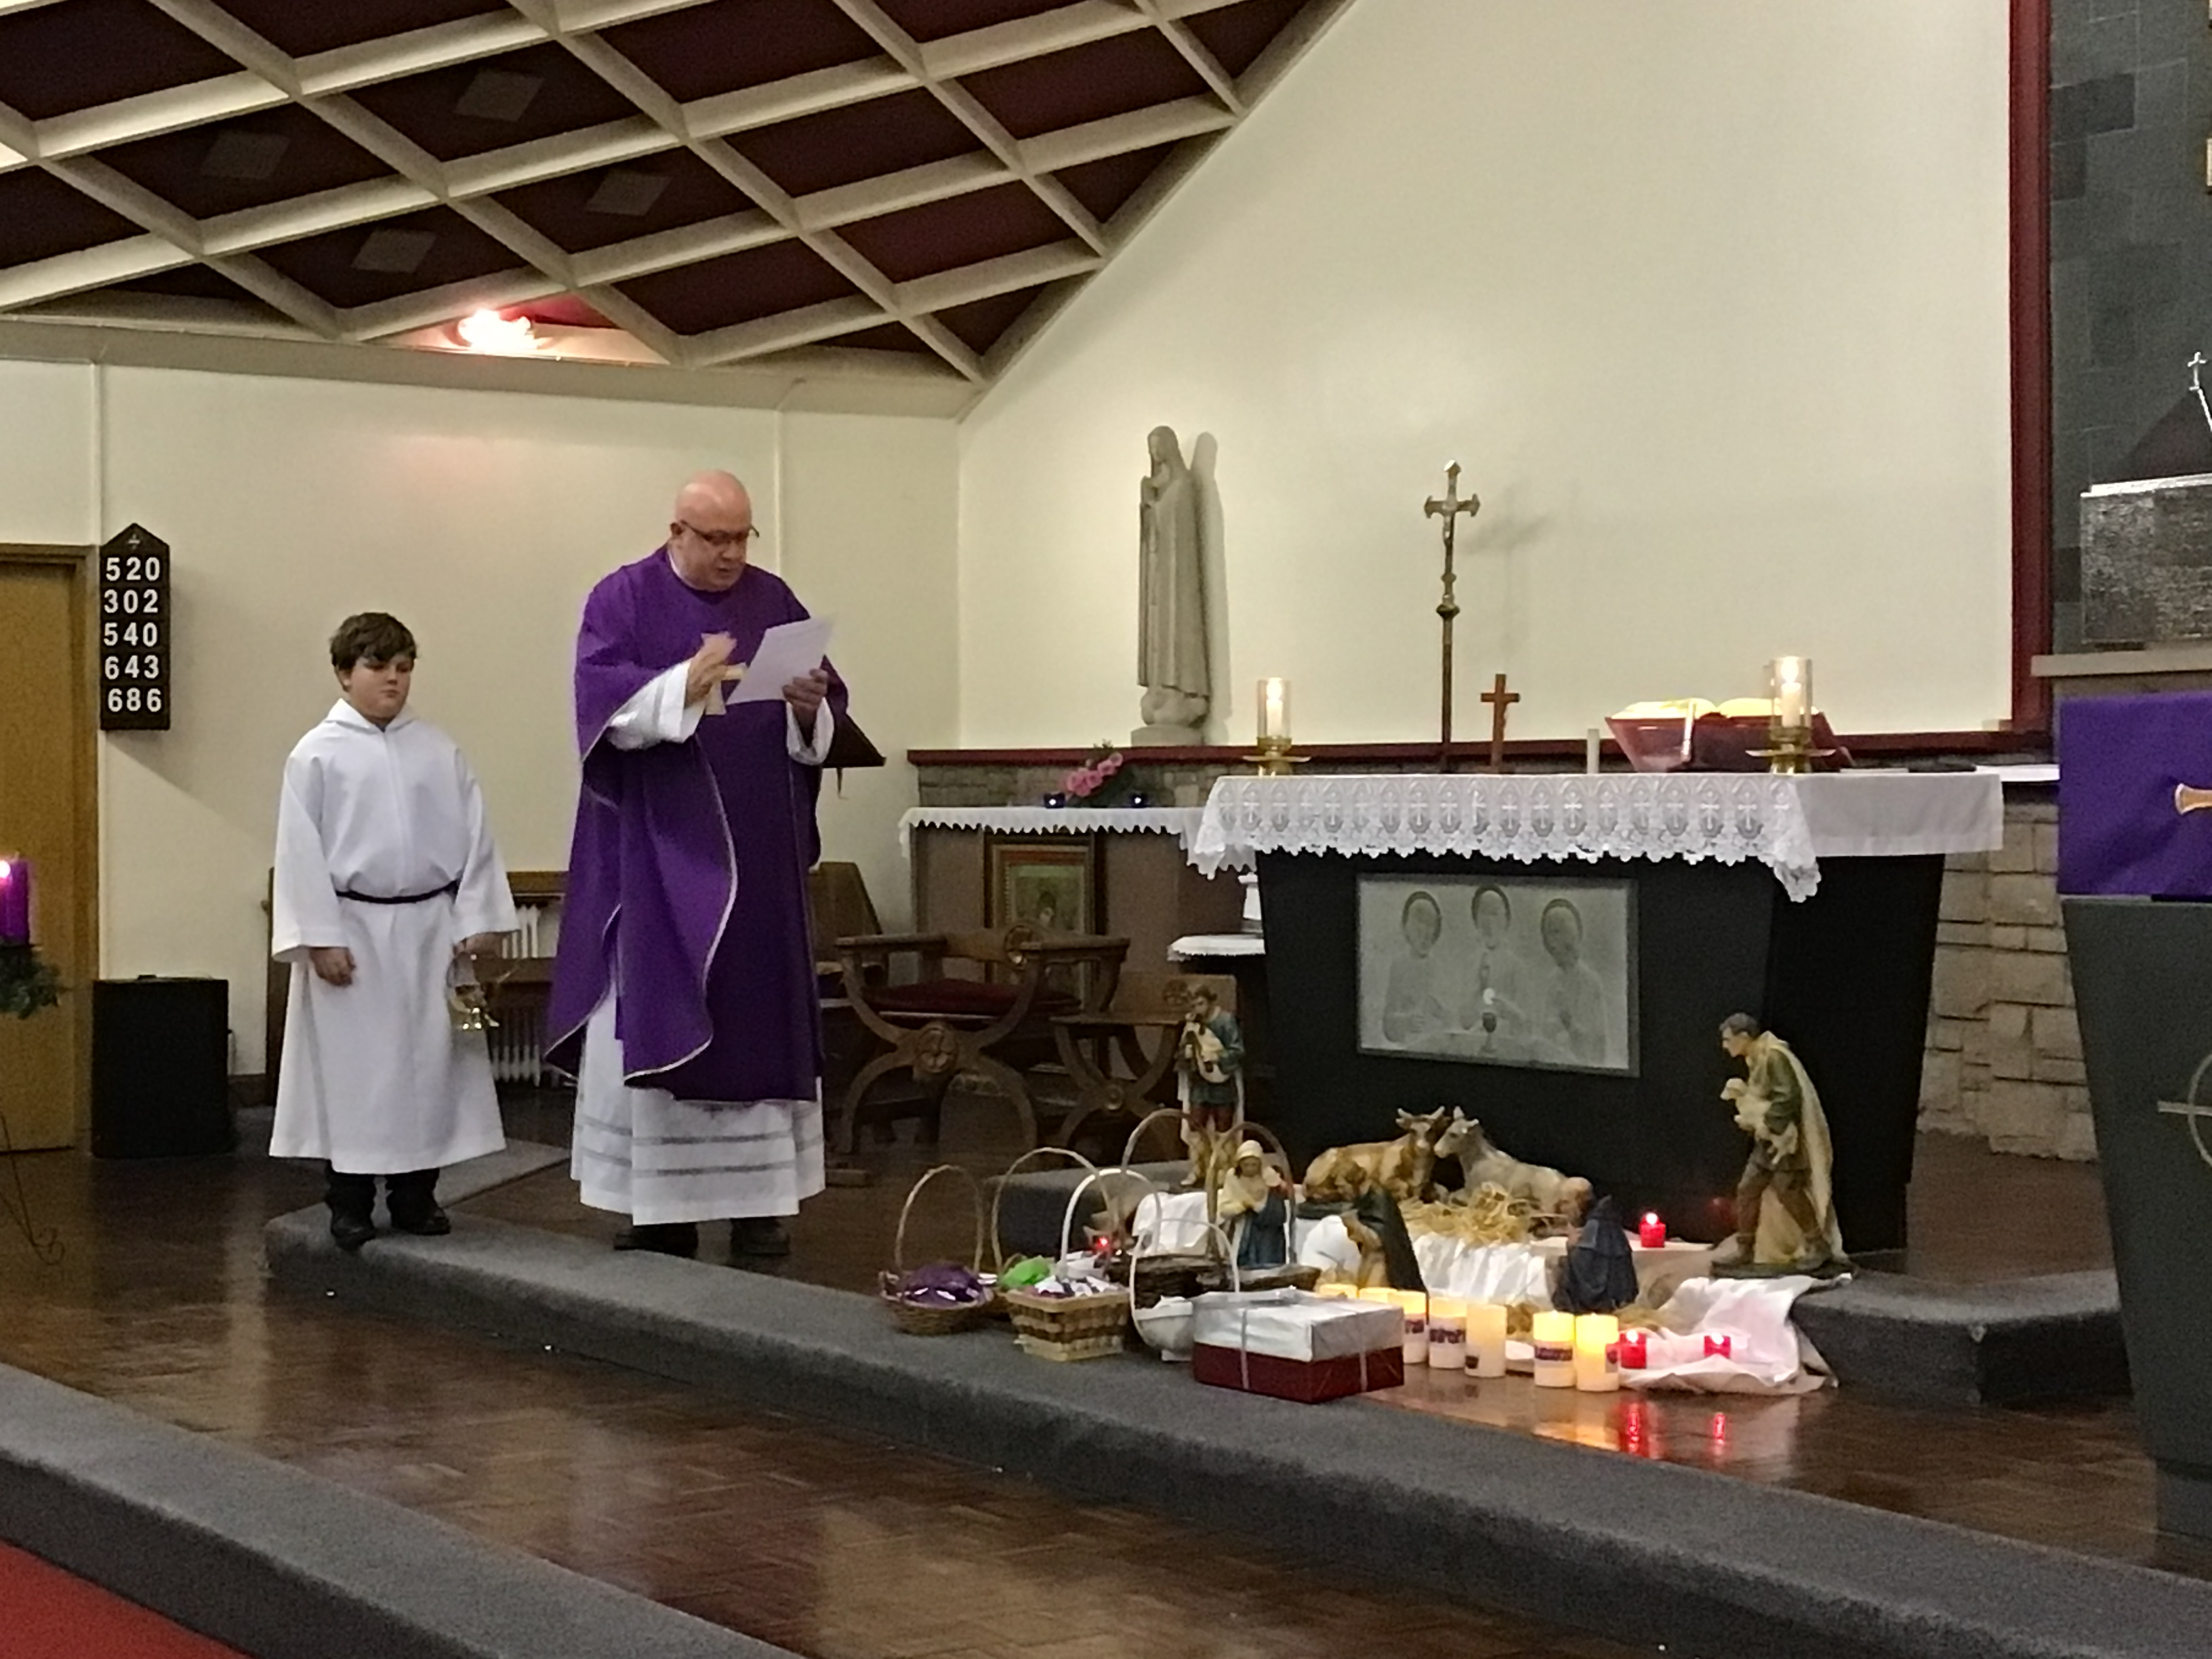
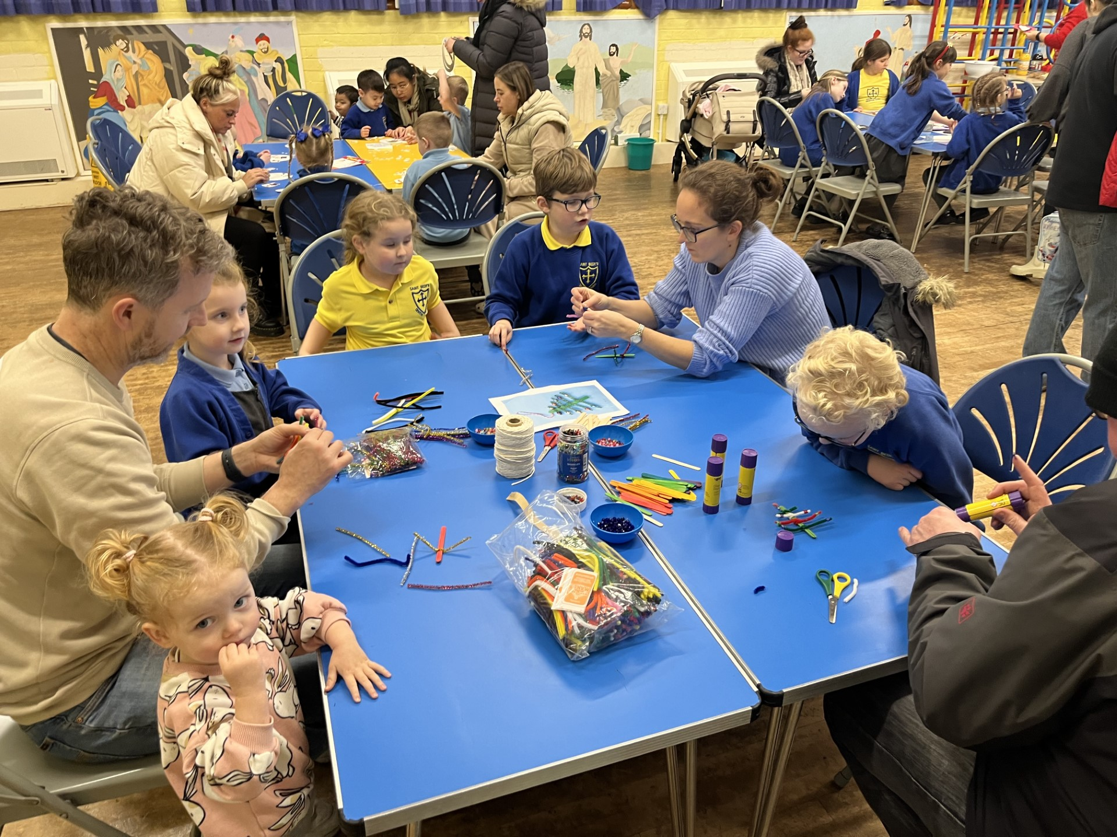
Family Christmas Crafts

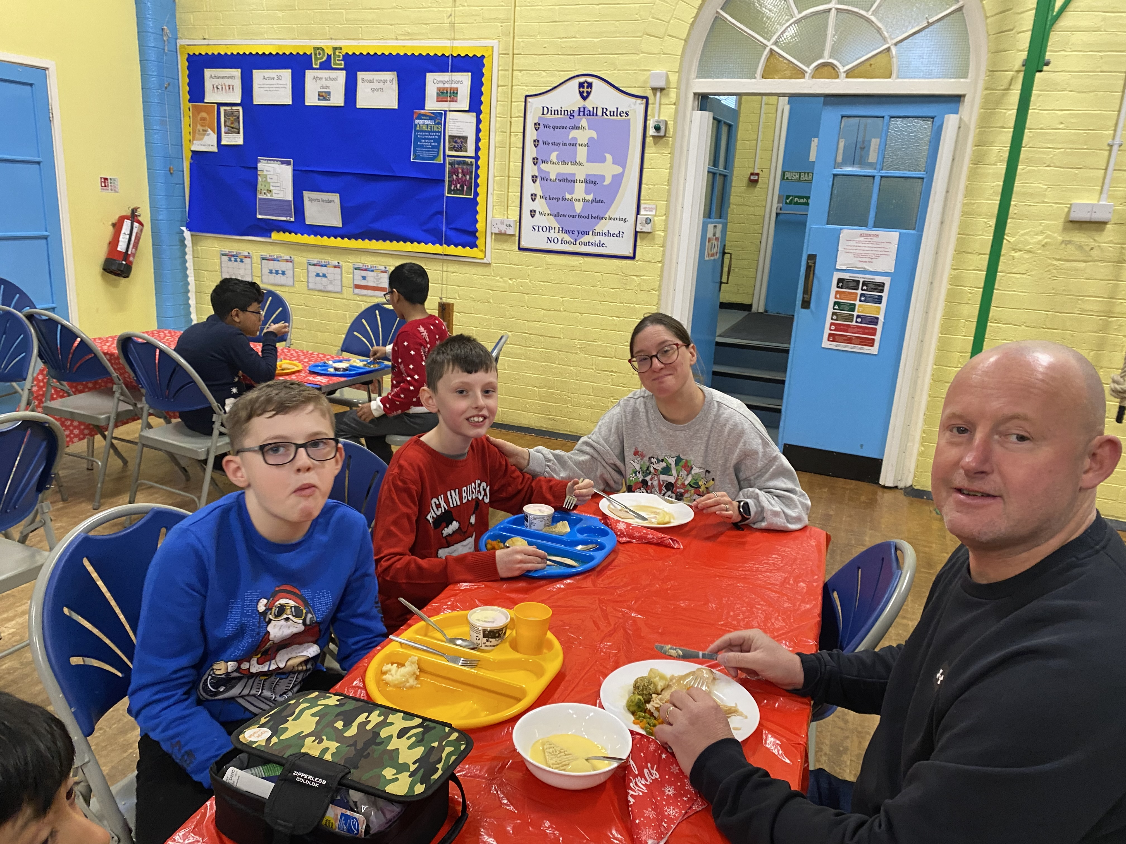

Christmas Dinner Day

We break up for the Christmas holidays at the end of the day on Friday 22nd December and return to school on Monday 8th January 2024.

Staffing Updates:
Mrs Weatherburn will not be returning to St Bede’s next term. Instead, Mrs Scott, who has been teaching Year 4, will be taking over as class teacher from January. On behalf of the staff and parent, I would like to thank Miss Smithies, who has been teaching Year 3 since September.

Miss Kay will be taking over officially as Year 4 class teacher, although we have been fortunate enough to have had her in school for a few weeks now so she is already settled in class with the children.

Mrs Morris has been appointed as Acting Deputy Headteacher for the rest of the academic year. I know that she will be a great support to both myself as Headteacher and the rest of the school and look forward to working with her in this capacity for the rest of this school year.

Parent Voice:
As we reach the end of our first term, I felt it was a good opportunity to review and seek some parent and pupil feedback. We will be gathering some pupil voice in school this week and if you could please take a few moments to complete the Microsoft forms questionnaire – any comments will help us to work closely together to shape our school moving forward.
Thank you in advance for your support.
https://forms.office.com/e/F9JK01vyLC

(click the link or scan the QR code with your smart device)

Safeguarding and Attendance:
Pupil absence: If your child is absent from school can you please contact school each day to update us.

Lateness: If your child arrives late, they must be signed in to school by an adult at the office. Please can you ensure that an adult comes to the office and signs them in on the electronic sign in.

Collection: If someone different is collecting your child, can you please inform the office prior to the end of the days o that we can notify staff (and the children) so that they know who to expect. Can I politely remind you that guidance states that older siblings under the age of 16 should not be collecting siblings without an adult being present.

Early collections: We have had a big increase in early collections. Can I politely remind parents that early collections should only happen in an emergency or rare situation and should not be a regular occurrence. From January, parents will be asked to produce appointment cards for medical appointments during school hours – we fully appreciate that hospital appointments must be taken when offered, however normal GP or dental appointments should eb organising outside of the school day.

Holidays in term time:
We still have a number of families who choose to take holidays during term time. Whilst we previously have accepted a holiday form and have taken no further action, you will be aware that there is a huge drive in the Local Authority to improve attendance. Moving forward, from the summer term (beginning in April), the Local Governing Committee will be working alongside the Local Authority with regard to term-time holidays and further action may be taken if you choose to book a holiday during term time. Please do not hesitate to contact school if you wish to discuss this further.

PTA:
Our PTA have been working hard to run a series of events this term. The most recent of these events were the Christmas pantomime and the Christmas stall. Unfortunately, the pantomime was not as well attended as we had hoped and ran at a loss however the Christmas stall seemed very successful. The PTA also introduced a personalised Christmas gifts project this year, and I know that lots of parents ordered cards, mugs and gifts.
We would appreciate any feedback linked to any of our PTA events with a view of making plans for next year.
During the Autumn term, the PTA have raised £1,700. All of these funds will be sued to support the children within school.

Reception / EYFS Parents - Tapestry:
EYFS have launched Tapestry as a new way of sharing school / home news. If you have not registered, please can you do so, please contact the EYFS staff if you need any help to do this. Tapestry is also a great way of you sharing some of the learning experiences which happen at home so please feel free to upload some of your own experiences and remember to comment on what is going on in school.

Swimming:
Year 3 will be beginning their swimming lessons on Friday 12th January. It is very important that you assist your child in practising dressing / undressing and drying themselves to support their independence.

After-school clubs:
The timetable for the new afterschool clubs will soon be released. There will be no after-school clubs during the first week of term. Please look out for a Microsoft forms to express interest in the after-school offer.

Please do not hesitate to contact me if you require any further information regarding this newsletter.

On behalf of myself and the whole staff team, can I wish you all a very happy and Holy Christmas.

Mrs Young
(Headteacher)

